Bildschirm 🡪 9020  
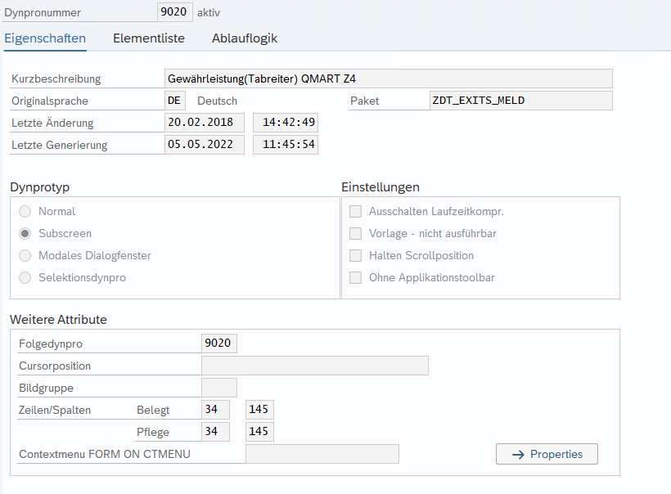  
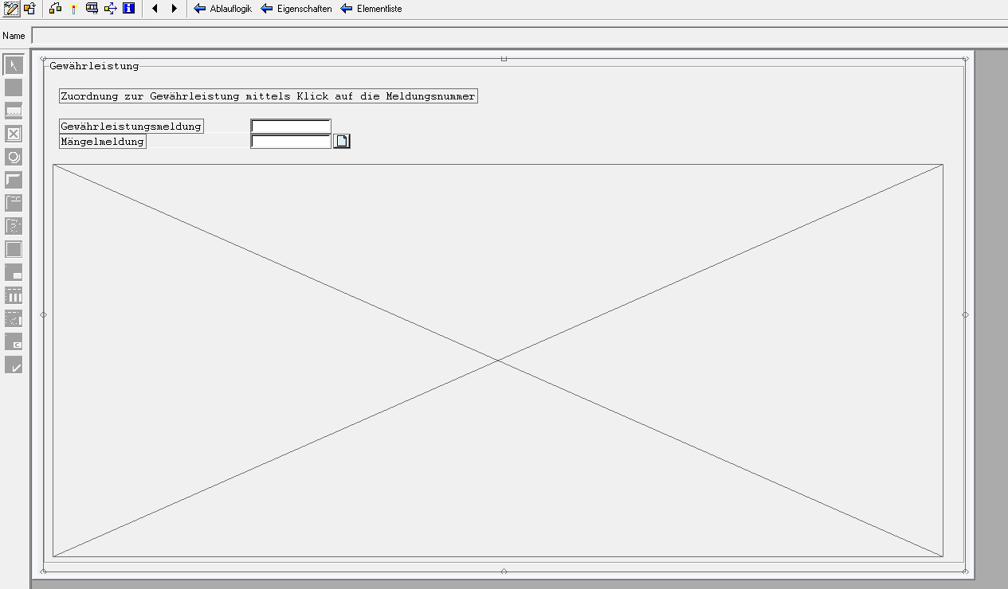  
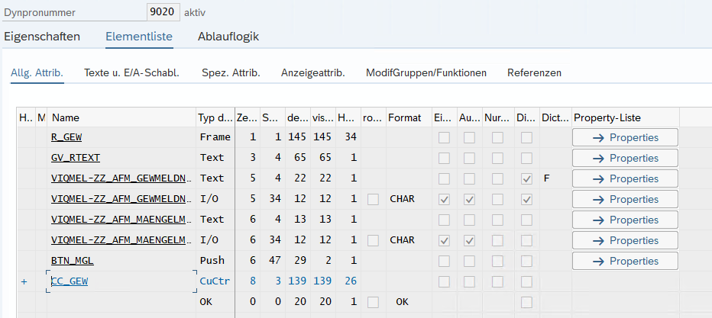

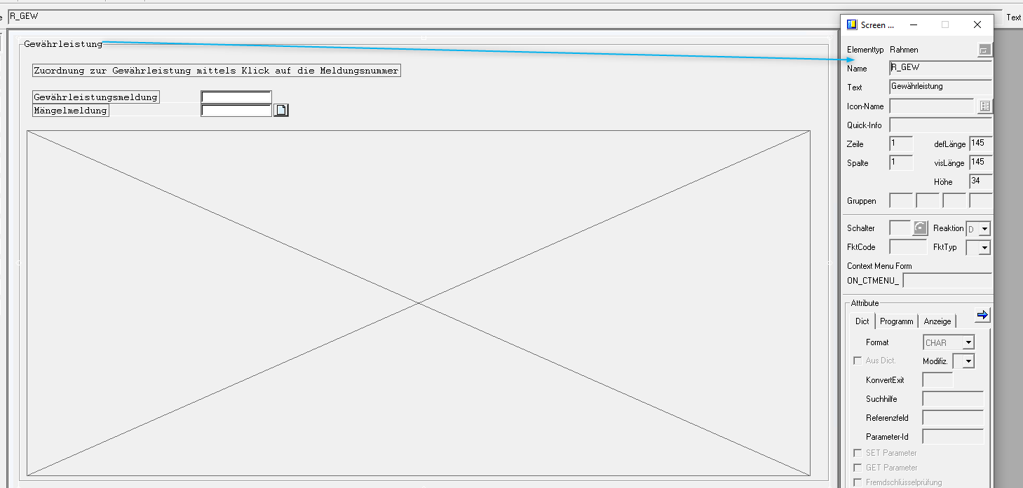

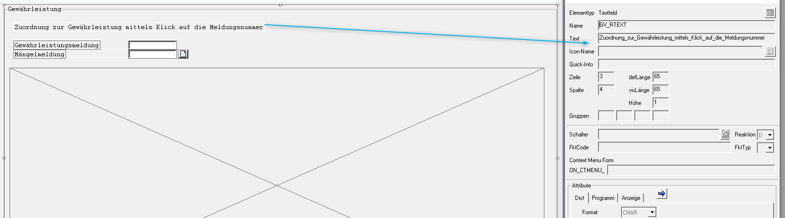

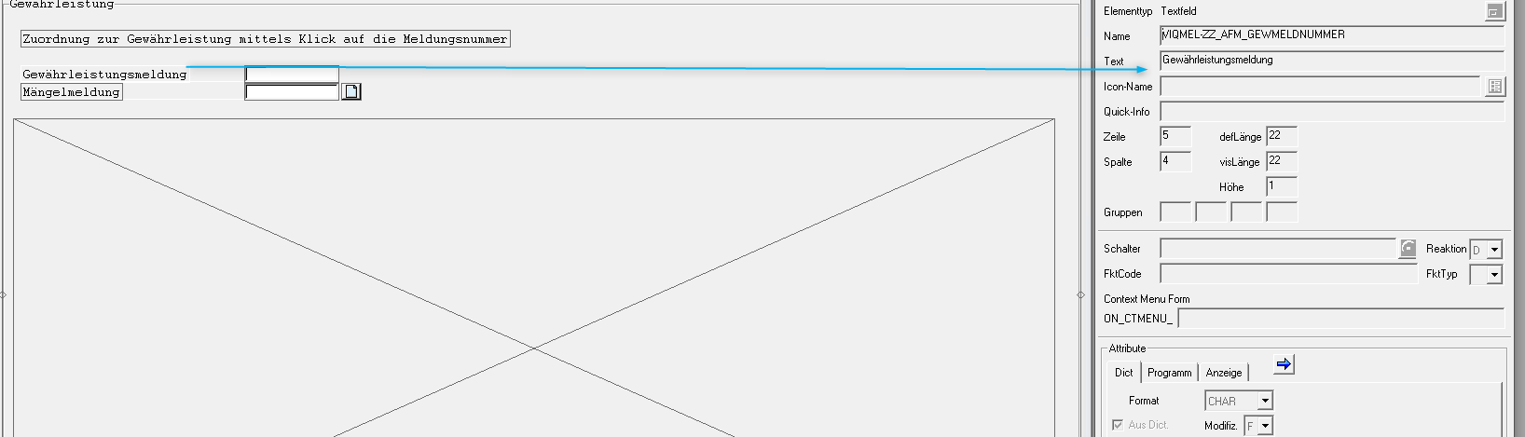 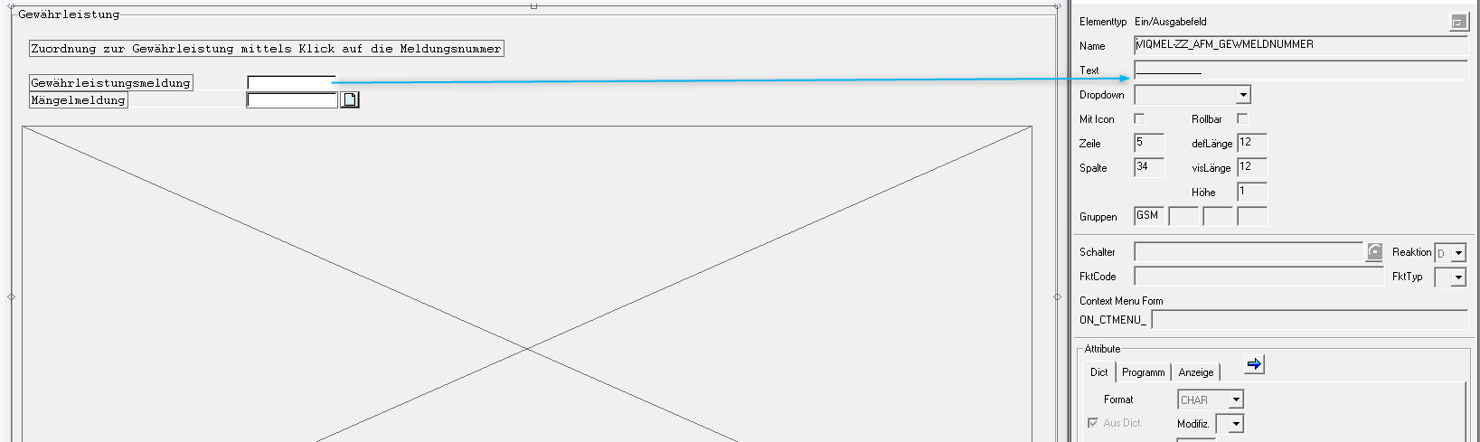

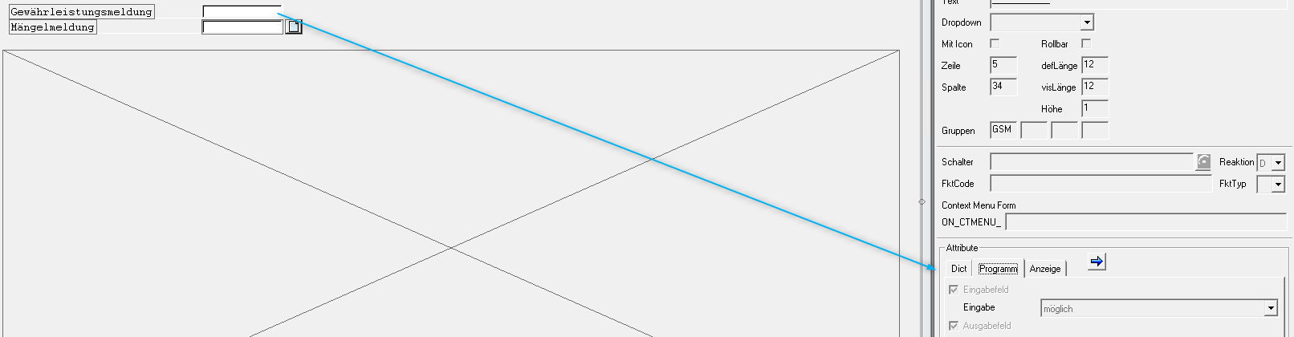 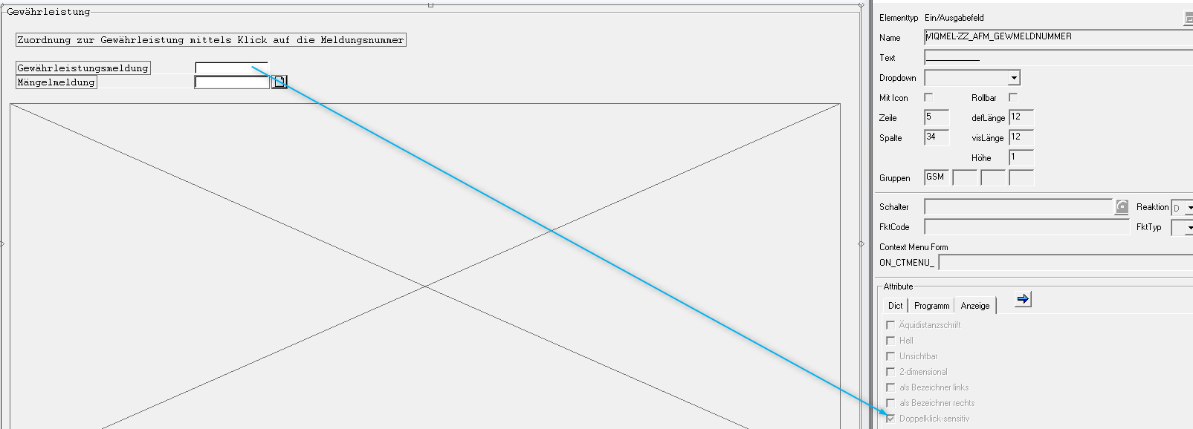

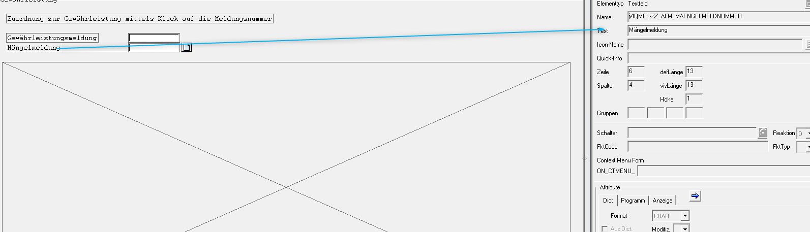

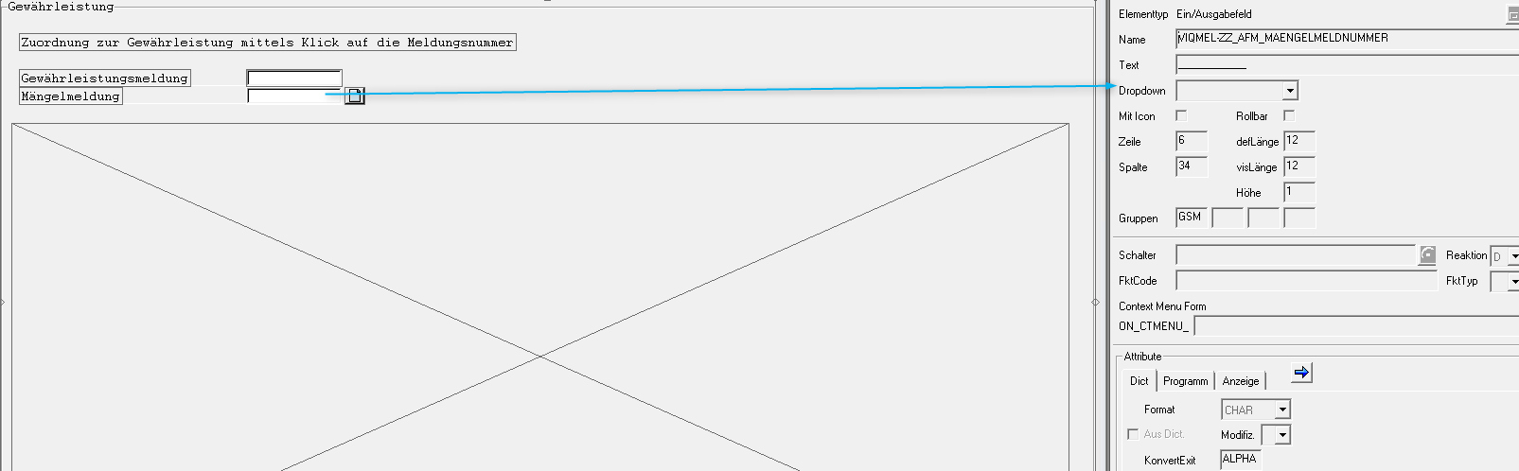

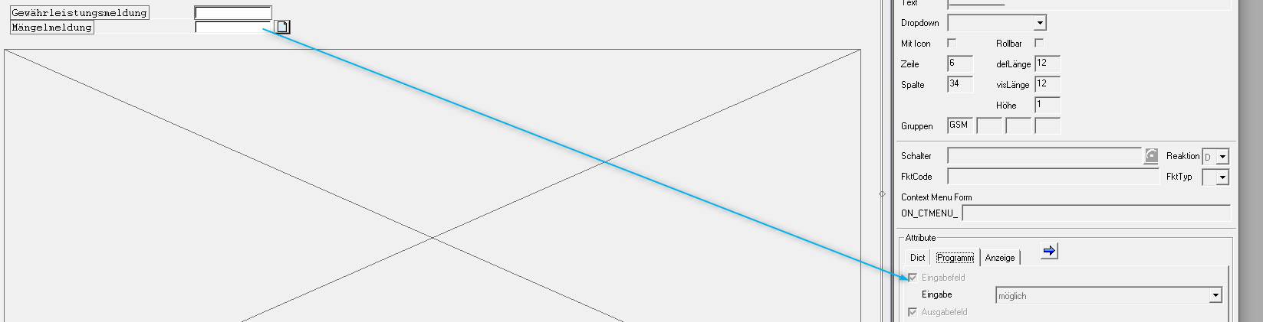 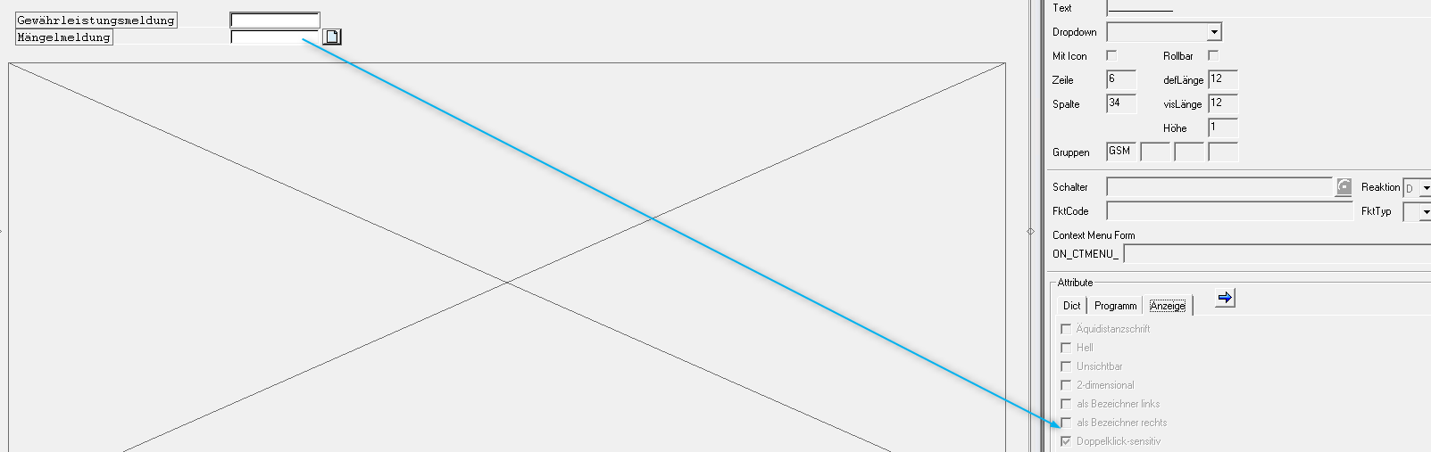

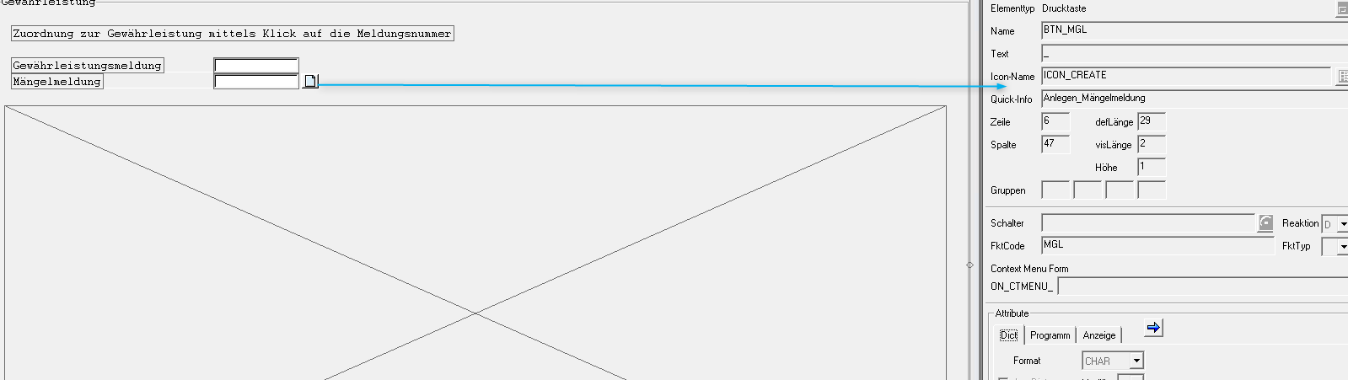

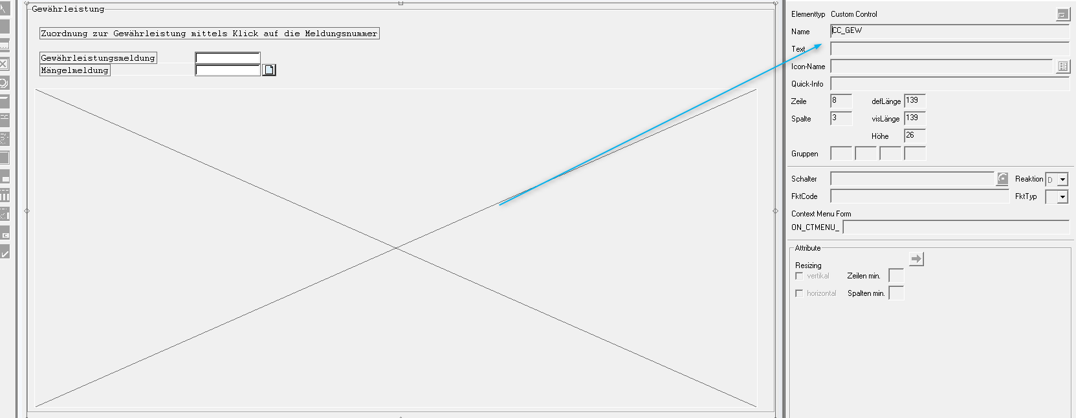

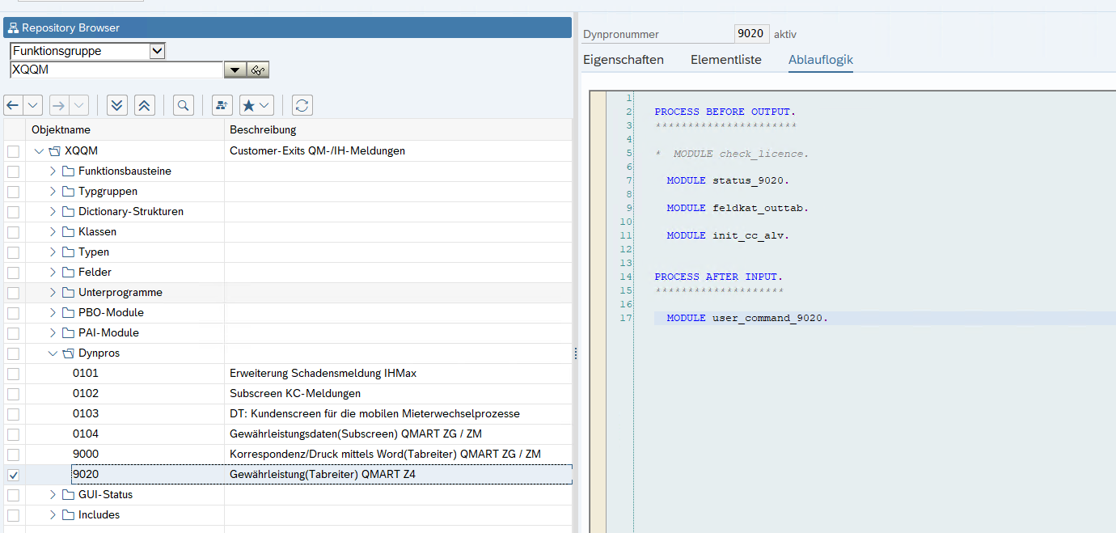

PROCESS BEFORE OUTPUT.  
*\*\*\*\*\*\*\*\*\*\*\*\*\*\*\*\*\*\*\*\*\*\**  
  
*\* MODULE check_licence.*  
  
 MODULE status_9020.  
  
 MODULE feldkat_outtab.  
  
 MODULE init_cc_alv.  
  
  
PROCESS AFTER INPUT.  
*\*\*\*\*\*\*\*\*\*\*\*\*\*\*\*\*\*\*\*\**  
  
 MODULE user_command_9020.

*\*----------------------------------------------------------------------\**  
*\*\*\*INCLUDE ZXQQMO20 .*  
*\*----------------------------------------------------------------------\**  
  
*\*&---------------------------------------------------------------------\**  
*\*& Module STATUS_9020 OUTPUT*  
*\*&---------------------------------------------------------------------\**  
MODULE status_9020 OUTPUT.  
  
*\* SET PF-STATUS 'xxxxxxxx'.*  
*\* SET TITLEBAR 'xxx'.*  
  
 LOOP AT SCREEN.  
 IF screen-group1 EQ 'GSM'.  
 screen-input = 0.  
 ENDIF.  
 MODIFY SCREEN.  
 ENDLOOP.  
  
*\* Drucktaste im Anzeigemodus ausgeschaltet werden*  
 IF g_aktyp = 'A' OR viqmel-zz_afm_gewmeldnummer IS INITIAL.  
 LOOP AT SCREEN.  
 IF screen-name EQ 'BTN_MGL'.  
 screen-active = 0.  
 ENDIF.  
 MODIFY SCREEN.  
 ENDLOOP.  
 ENDIF.  
  
*\* Import die Mängelmeldungsnummer von ABAP Memory*  
 IF flag_mglm = '1'.  
 GET PARAMETER ID 'IQM' FIELD gv_newmel.  
 IF gv_newmel NE gv_oldmel.  
 IF gv_newmel NE viqmel-zz_afm_gewmeldnummer.  
*\* viqmel-z_smmeldnummer = gv_newmel.*  
 viqmel-zz_afm_maengelmeldnummer = gv_newmel.  
 ENDIF.  
 ENDIF.  
 CLEAR flag_mglm.  
 ENDIF.  
  
ENDMODULE. *" STATUS_9020 OUTPUT*

*\*----------------------------------------------------------------------\**  
*\*\*\*INCLUDE ZXQQMO21 .*  
*\*----------------------------------------------------------------------\**  
  
*\*&---------------------------------------------------------------------\**  
*\*& Module FELDKAT_OUTTAB OUTPUT*  
*\*&---------------------------------------------------------------------\**  
MODULE feldkat_outtab OUTPUT.  
  
 DATA lv_gw_qmart TYPE qmel-qmart.  
  
*\*Feldkatalog ist gebaut.*  
 PERFORM build_gt_gw_fcat.  
  
*\*Füllt die GW interne tabelle mit Dateien*  
 PERFORM fill_gt_gw_fields.  
  
ENDMODULE. *" FELDKAT_OUTTAB OUTPUT*

*\*----------------------------------------------------------------------\**  
*\*\*\*INCLUDE ZXQQMF02.*  
*\*----------------------------------------------------------------------\**  
  
*\*&---------------------------------------------------------------------\**  
*\*& Form BUILD_GT_GW_FCAT*  
*\*&---------------------------------------------------------------------\**  
FORM build_gt_gw_fcat .  
  
 IF gt_gw_fcat IS INITIAL.  
*\* The following function module generates a fieldcatalog according*  
*\* to a given structure.*  
 CALL FUNCTION 'LVC_FIELDCATALOG_MERGE'  
 EXPORTING  
 i_structure_name = 'ZST_AFM_ZGEW_ALV'  
 CHANGING  
 ct_fieldcat = gt_gw_fcat.  
 DATA: ls_fieldcat TYPE lvc_s_fcat.  
  
 CLEAR ls_fieldcat.  
  
 ls_fieldcat-fieldname = 'ICON'.  
 APPEND ls_fieldcat TO gt_gw_fcat.  
  
*\* Now change the fieldcatalog to hide fields and to determine*  
*\* some initial calculations for chosen fields.*  
 LOOP AT gt_gw_fcat INTO gs_gw_fcat.  
 CASE gs_gw_fcat-fieldname.  
*\* hide columns which are already displayed in our tree*  
 WHEN 'OBJNR' OR 'QMART' OR 'ZZ_AFM_HIERARCHIE' .  
 gs_gw_fcat-no_out = 'X'.  
 WHEN 'PARNR'.  
 gs_gw_fcat-col_pos = 3.  
 WHEN 'EQUNR'.  
 gs_gw_fcat-col_pos = 7.  
 gs_gw_fcat-outputlen = '10'.  
 WHEN 'TPLNR'.  
 gs_gw_fcat-outputlen = '20'.  
 WHEN 'ZZ_AFM_GEWBEGINN' OR 'ZZ_AFM_GEWENDE'.  
 gs_gw_fcat-outputlen = '20'.  
 WHEN 'ICON'.  
*\* gs_gw_fcat-no_out = 'X'.*  
 gs_gw_fcat-col_pos = 4.  
 gs_gw_fcat-icon = 'X'.  
 gs_gw_fcat-outputlen = '4'.  
 WHEN 'QMNUM'.  
 gs_gw_fcat-hotspot = 'X'.  
 ENDCASE.  
 MODIFY gt_gw_fcat FROM gs_gw_fcat.  
 ENDLOOP.  
 ENDIF.  
  
ENDFORM.

*\*----------------------------------------------------------------------\**  
*\*\*\*INCLUDE ZXQQMF07.*  
*\*----------------------------------------------------------------------\**  
  
*\*&---------------------------------------------------------------------\**  
*\*& Form FILL_GT_GW_FIELDS*  
*\*&---------------------------------------------------------------------\**  
FORM fill_gt_gw_fields .  
  
 TYPES: BEGIN OF ty_tplnr,  
 tplnr TYPE tplnr,  
 kat TYPE i,  
 END OF ty_tplnr.  
  
 DATA lt_tplnr TYPE TABLE OF ty_tplnr.  
 DATA ls_tplnr TYPE ty_tplnr.  
 DATA lt_tp TYPE TABLE OF iflo.  
 DATA ls_tp TYPE iflo.  
 DATA lt_htp TYPE TABLE OF rihiflo.  
 DATA ls_htp TYPE rihiflo.  
 DATA lt_equi TYPE TABLE OF rihequi.  
 DATA ls_equi TYPE rihequi.  
 DATA lv_qmart TYPE qmart.  
 DATA ls_outab LIKE LINE OF gt_gw_fields.  
  
*\*Entkopplung von den Kunden Meldungsarten Bezeichnungen*  
 SELECT SINGLE zkunde_qmart FROM /afm/kundeqmart INTO lv_qmart  
 WHERE /afm/kundeqmart~qmart = 'SG'.  
  
*\* Die Hierarchie des ausgewählten Tech.Platz in eigenen ITABs besorgt ist*  
 CALL FUNCTION 'PM_PREDECESSOR_IFLO'  
 EXPORTING  
*\* PLTXT = ' '*  
 selmod = 'D'  
*\* TPLMA = ' '*  
 tplnr = viqmel-tplnr  
 TABLES  
 iflo_tab = lt_tp  
 EXCEPTIONS  
 no_predecessor = 1  
 no_valid_tplnr = 2  
 OTHERS = 3.  
 IF sy-subrc <> 0.  
*\* MESSAGE ID SY-MSGID TYPE SY-MSGTY NUMBER SY-MSGNO*  
*\* WITH SY-MSGV1 SY-MSGV2 SY-MSGV3 SY-MSGV4.*  
 ENDIF.  
  
 CALL FUNCTION 'PM_HIERARCHY_CALL'  
 EXPORTING  
*\* DATUM = SY-DATUM*  
*\* EQUNR = ' '*  
*\* GRAFICS = ' '*  
*\* LEVDO = '01'*  
*\* LEVUP = '00'*  
*\* MATNR = ' '*  
*\* READ_NEW = ' '*  
*\* SANIN = 'X'*  
 select_equi = 'X'  
*\* SELECT_IFLO = 'X'*  
*\* SELECT_STPO = ' '*  
 selmod = 'D'  
*\* STKKZ = ' '*  
*\* TECHV = ' '*  
 tplnr = viqmel-tplnr  
*\* WERKS = ' '*  
 with_equi = 'X'  
*\* WITH_EQUI_HIER = 'X'*  
 with_iflo_hier = 'X'  
*\* WITH_BTYP = 'X'*  
*\* WITH_MARA = ' '*  
*\* WITH_IBASE_HIER = ' '*  
*\* CAPID = ' '*  
*\* EMENG = 0*  
*\* ARBPL_INT = ' '*  
*\* AUTHORITY_CHECK = 'X'*  
*\* I_GRBOM =*  
 TABLES  
 equi_tab = lt_equi  
 iflo_tab = lt_htp  
*\* STPO_TAB =*  
 EXCEPTIONS  
 no_hierarchy = 1  
 no_object_defined = 2  
 no_selection = 3  
 no_valid_equnr = 4  
 no_valid_matnr = 5  
 no_valid_selmod = 6  
 no_valid_tplnr = 7  
 no_valid_grbom_werks = 8  
 OTHERS = 9.  
 IF sy-subrc <> 0.  
*\* MESSAGE ID SY-MSGID TYPE SY-MSGTY NUMBER SY-MSGNO*  
*\* WITH SY-MSGV1 SY-MSGV2 SY-MSGV3 SY-MSGV4.*  
 ENDIF.  
  
*\*die Über und Unten-geordneten tech.Platz Tabellen sind in einem ITAB zusammengepackt und ein Zeichen ist definiert.*  
*\*Das Zeichen identifiziert in die neue Tabelle welche TPLNR sind untergeordnete und welche sind übergeordnete*  
 LOOP AT lt_tp INTO ls_tp.  
 ls_tplnr-tplnr = ls_tp-tplnr.  
 ls_tplnr-kat = '1'.  
 APPEND ls_tplnr TO lt_tplnr.  
 ENDLOOP.  
  
 LOOP AT lt_htp INTO ls_htp.  
 ls_tplnr-tplnr = ls_htp-tplnr.  
 ls_tplnr-kat = '2'.  
 APPEND ls_tplnr TO lt_tplnr.  
 ENDLOOP.  
  
*\*Dopple Einträge sind gelöscht*  
 SORT lt_tplnr BY tplnr.  
 DELETE ADJACENT DUPLICATES FROM lt_tplnr.  
  
 LOOP AT lt_tplnr INTO ls_tplnr WHERE tplnr = viqmel-tplnr.  
 ls_tplnr-kat = 0.  
 MODIFY lt_tplnr FROM ls_tplnr TRANSPORTING kat.  
 ENDLOOP.  
  
 IF viqmel-equnr IS NOT INITIAL.  
 READ TABLE lt_equi INTO ls_equi WITH KEY tplnr = viqmel-tplnr equnr = viqmel-equnr TRANSPORTING NO FIELDS.  
 IF sy-subrc = 0 .  
 LOOP AT lt_tplnr INTO ls_tplnr.  
 IF ls_tplnr-kat = '2'.  
 DELETE lt_tplnr WHERE tplnr = ls_tplnr-tplnr.  
 ENDIF.  
 ENDLOOP.  
 ENDIF.  
 ENDIF.  
  
*\*Die outtab Tabelle für den ALV ist gefüllt*  
  
 SELECT qmnum  
 viqmelst~qmart  
 viqmelst~qmtxt  
 viqmelst~objnr  
*\* ihpa~parnr*  
 zz_afm_gewbeginn  
 zz_afm_gewende  
 zz_afm_geweurobetrag  
 viqmelst~tplnr  
 viqmelst~equnr  
 pltxt FROM viqmelst  
 INNER JOIN iflotx ON iflotx~tplnr = viqmelst~tplnr  
*\* Info Meldenderdaten (Partner) entfällt hier !*  
*\* INNER JOIN ihpa ON ihpa~objnr = viqmelst~objnr*  
 INTO CORRESPONDING FIELDS OF TABLE gt_gw_fields FOR ALL ENTRIES IN lt_tplnr  
 WHERE viqmelst~tplnr = lt_tplnr-tplnr  
*\* Vorbereitung für den Fall die Equipments eingeplant sind*  
*\* WHERE ( viqmelst~tplnr = viqmel-tplnr ) OR ( viqmelst~equnr = viqmel-equnr )*  
 AND viqmelst~qmart = lv_qmart.  
  
 LOOP AT gt_gw_fields INTO ls_outab.  
 LOOP AT lt_tplnr INTO ls_tplnr.  
 IF ls_tplnr-tplnr = ls_outab-tplnr.  
 ls_outab-zz_afm_hierarchie = ls_tplnr-kat.  
 ENDIF.  
 ENDLOOP.  
 MODIFY gt_gw_fields FROM ls_outab TRANSPORTING zz_afm_hierarchie.  
 ENDLOOP.  
  
*\*Die Ikonen Spalte ist mit entsprechenden Ikonen ausgefüllt.*  
 CLEAR ls_outab.  
 LOOP AT gt_gw_fields INTO ls_outab.  
 CASE ls_outab-zz_afm_hierarchie.  
 WHEN 0.  
 ls_outab-icon = '@0E@'.  
 WHEN 1.  
 ls_outab-icon = '@0I@'.  
 WHEN 2.  
 ls_outab-icon = '@0H@'.  
 ENDCASE.  
 MODIFY gt_gw_fields FROM ls_outab TRANSPORTING icon.  
 ENDLOOP.  
  
 CLEAR ls_outab.  
 LOOP AT gt_gw_fields INTO ls_outab WHERE equnr IS NOT INITIAL.  
 IF ls_outab-equnr NE viqmel-equnr.  
 DELETE gt_gw_fields WHERE tplnr = viqmel-tplnr AND equnr = ls_outab-equnr.  
 ENDIF.  
 ENDLOOP.  
  
*\*Dopple Einträge sind gelöscht*  
 SORT gt_gw_fields BY qmnum.  
 DELETE ADJACENT DUPLICATES FROM gt_gw_fields COMPARING qmnum.  
  
*\* Die outtab Tabelle ist über den Tech.Platz Nummer sortiert.*  
 SORT gt_gw_fields BY tplnr.  
  
ENDFORM.

*\*----------------------------------------------------------------------\**  
*\*\*\*INCLUDE ZXQQMO22 .*  
*\*----------------------------------------------------------------------\**  
  
*\*&---------------------------------------------------------------------\**  
*\*& Module INIT_CC_ALV OUTPUT*  
*\*&---------------------------------------------------------------------\**  
MODULE init_cc_alv OUTPUT.  
  
 IF go_gw_cont_alv IS INITIAL.  
 CREATE OBJECT go_gw_cont_alv  
 EXPORTING  
*\* PARENT =*  
 container_name = 'CC_GEW'  
*\* STYLE =*  
*\* LIFETIME = lifetime_default*  
*\* REPID =*  
*\* DYNNR =*  
*\* NO_AUTODEF_PROGID_DYNNR =*  
 EXCEPTIONS  
 cntl_error = 1  
 cntl_system_error = 2  
 create_error = 3  
 lifetime_error = 4  
 lifetime_dynpro_dynpro_link = 5  
 OTHERS = 6  
 .  
 IF sy-subrc <> 0.  
 MESSAGE ID sy-msgid TYPE sy-msgty NUMBER sy-msgno  
 WITH sy-msgv1 sy-msgv2 sy-msgv3 sy-msgv4.  
 ENDIF.  
 ENDIF.  
  
 IF go_gw_alv IS INITIAL.  
 CREATE OBJECT go_gw_alv  
 EXPORTING  
*\* I_SHELLSTYLE = 0*  
*\* I_LIFETIME =*  
 i_parent = go_gw_cont_alv  
*\* I_APPL_EVENTS = space*  
*\* I_PARENTDBG =*  
*\* I_APPLOGPARENT =*  
*\* I_GRAPHICSPARENT =*  
*\* I_NAME =*  
*\* I_FCAT_COMPLETE = SPACE*  
 EXCEPTIONS  
 error_cntl_create = 1  
 error_cntl_init = 2  
 error_cntl_link = 3  
 error_dp_create = 4  
 OTHERS = 5  
 .  
 IF sy-subrc <> 0.  
 MESSAGE ID sy-msgid TYPE sy-msgty NUMBER sy-msgno  
 WITH sy-msgv1 sy-msgv2 sy-msgv3 sy-msgv4.  
 ENDIF.  
  
 PERFORM exc_functions CHANGING gt_toolbar.  
 PERFORM set_layout CHANGING gt_layo.  
  
*\*Ereignisse registrieren*  
 SET HANDLER lcl_gui_alv_grid=>on_toolbar FOR go_gw_alv.  
 SET HANDLER lcl_gui_alv_grid=>on_doubleclick FOR go_gw_alv.  
 SET HANDLER lcl_gui_alv_grid=>on_usercommand FOR go_gw_alv.  
 SET HANDLER lcl_gui_alv_grid=>on_click_row FOR go_gw_alv.  
  
 CALL METHOD go_gw_alv->set_table_for_first_display  
 EXPORTING  
*\* I_BUFFER_ACTIVE =*  
*\* I_BYPASSING_BUFFER =*  
*\* I_CONSISTENCY_CHECK =*  
*\* I_STRUCTURE_NAME =*  
*\* IS_VARIANT =*  
*\* I_SAVE =*  
*\* I_DEFAULT = 'X'*  
 is_layout = gt_layo  
*\* IS_PRINT =*  
*\* IT_SPECIAL_GROUPS =*  
 it_toolbar_excluding = gt_toolbar  
*\* IT_HYPERLINK =*  
*\* IT_ALV_GRAPHICS =*  
*\* IT_EXCEPT_QINFO =*  
*\* IR_SALV_ADAPTER =*  
 CHANGING  
 it_outtab = gt_gw_fields  
 it_fieldcatalog = gt_gw_fcat  
*\* IT_SORT =*  
*\* IT_FILTER =*  
*\* EXCEPTIONS*  
*\* INVALID_PARAMETER_COMBINATION = 1*  
*\* PROGRAM_ERROR = 2*  
*\* TOO_MANY_LINES = 3*  
*\* others = 4*  
 .  
 IF sy-subrc <> 0.  
*\* MESSAGE ID SY-MSGID TYPE SY-MSGTY NUMBER SY-MSGNO*  
*\* WITH SY-MSGV1 SY-MSGV2 SY-MSGV3 SY-MSGV4.*  
 ENDIF.  
  
 ELSE.  
  
 DATA ls_stable TYPE lvc_s_stbl.  
  
 ls_stable-row = 'X'.  
 ls_stable-col = 'X'.  
 CALL METHOD go_gw_alv->refresh_table_display  
 EXPORTING  
 is_stable = ls_stable  
*\* I_SOFT_REFRESH =*  
*\* EXCEPTIONS*  
*\* FINISHED = 1*  
*\* others = 2*  
 .  
 IF sy-subrc <> 0.  
*\* MESSAGE ID SY-MSGID TYPE SY-MSGTY NUMBER SY-MSGNO*  
*\* WITH SY-MSGV1 SY-MSGV2 SY-MSGV3 SY-MSGV4.*  
 ENDIF.  
  
 CALL METHOD go_gw_alv->set_selected_rows  
 EXPORTING  
 it_index_rows = gt_rowid  
*\* IT_ROW_NO =*  
*\* IS_KEEP_OTHER_SELECTIONS =*  
 .  
 ENDIF.  
  
ENDMODULE. *" INIT_CC_ALV OUTPUT*

*\*----------------------------------------------------------------------\**  
*\*\*\*INCLUDE ZXQQMF05.*  
*\*----------------------------------------------------------------------\**  
  
*\*&---------------------------------------------------------------------\**  
*\*& Form EXC_FUNCTIONS*  
*\*&---------------------------------------------------------------------\**  
*\* <--P_GT_TOOLBAR text*  
*\*----------------------------------------------------------------------\**  
FORM exc_functions CHANGING p_gt_toolbar TYPE ui_functions.  
  
 DATA ls_exclude TYPE ui_func.  
  
 ls_exclude = cl_gui_alv_grid=>mc_fc_maximum .  
 APPEND ls_exclude TO p_gt_toolbar.  
 ls_exclude = cl_gui_alv_grid=>mc_fc_minimum .  
 APPEND ls_exclude TO p_gt_toolbar.  
 ls_exclude = cl_gui_alv_grid=>mc_fc_subtot .  
 APPEND ls_exclude TO p_gt_toolbar.  
 ls_exclude = cl_gui_alv_grid=>mc_fc_sum .  
 APPEND ls_exclude TO p_gt_toolbar.  
 ls_exclude = cl_gui_alv_grid=>mc_fc_average .  
 APPEND ls_exclude TO p_gt_toolbar.  
 ls_exclude = cl_gui_alv_grid=>mc_mb_sum .  
 APPEND ls_exclude TO p_gt_toolbar.  
 ls_exclude = cl_gui_alv_grid=>mc_mb_subtot .  
 APPEND ls_exclude TO p_gt_toolbar.  
 ls_exclude = cl_gui_alv_grid=>mc_fc_print.  
 APPEND ls_exclude TO p_gt_toolbar.  
 ls_exclude = cl_gui_alv_grid=>mc_fc_graph.  
 APPEND ls_exclude TO p_gt_toolbar.  
 ls_exclude = cl_gui_alv_grid=>mc_fc_info.  
 APPEND ls_exclude TO p_gt_toolbar.  
 ls_exclude = cl_gui_alv_grid=>mc_fc_views.  
 APPEND ls_exclude TO p_gt_toolbar.  
  
ENDFORM.

*\*----------------------------------------------------------------------\**  
*\*\*\*INCLUDE ZXQQMF06.*  
*\*----------------------------------------------------------------------\**  
  
*\*&---------------------------------------------------------------------\**  
*\*& Form SET_LAYOUT*  
*\*&---------------------------------------------------------------------\**  
*\* <--P_GT_LAYO text*  
*\*----------------------------------------------------------------------\**  
FORM set_layout CHANGING p_gt_layo TYPE lvc_s_layo.  
  
 p_gt_layo-col_opt = 'X'.  
 p_gt_layo-zebra = 'X'.  
 p_gt_layo-sel_mode = 'A'.  
 p_gt_layo-no_rowmark = ' '.  
  
ENDFORM.

Include🡪 ZXQQMI02

*\*&---------------------------------------------------------------------\**  
*\*& Module USER_COMMAND_9020 INPUT*  
*\*&---------------------------------------------------------------------\**  
MODULE user_command_9020 INPUT.  
  
 CASE sy-ucomm.  
  
 WHEN 'ZUR'.  
 IF g_aktyp <> 'A'.  
 CLEAR viqmel-zz_afm_gewmeldnummer.  
 ENDIF.  
  
 WHEN 'ARCH1'.  
 IF g_aktyp <> 'A'.  
 fl_rueck = '1'.  
 EXPORT fl_rueck TO MEMORY ID 'SCHLIESSEN'.  
 PERFORM go_to_maengelmeld.  
 PERFORM clear_fields.  
 ENDIF.  
  
 WHEN 'GEW'.  
 IF g_aktyp <> 'A'.  
 viqmel-zz_afm_gewmeldnummer = gw_meldnumm.  
 ENDIF.  
  
 WHEN 'MGL'.  
 PERFORM create_maengel_meldung.  
  
 WHEN 'FWD'.  
 PERFORM forward_to_meld.  
  
 ENDCASE.  
  
 IF sy-ucomm = 'ZUR' OR sy-ucomm = 'GEW' OR sy-ucomm = 'MGL' OR sy-ucomm = 'ARCH1' OR sy-ucomm = 'FWD'.  
 PERFORM supress_f31(sapliqs0).  
 ENDIF.  
  
 PERFORM go_to_meld USING 'VIQMEL-ZZ_AFM_GEWMELDNUMMER' viqmel-zz_afm_gewmeldnummer.  
*\* PERFORM go_to_meld USING 'VIQMEL-Z_SMMELDNUMMER' viqmel-z_smmeldnummer.*  
 PERFORM go_to_meld USING 'VIQMEL-ZZ_AFM_MAENGELMELDNUMMER' viqmel-zz_afm_maengelmeldnummer.  
  
ENDMODULE. *" USER_COMMAND_9020 INPUT*

*Include🡪* *ZXQQMF09*

*\*&---------------------------------------------------------------------\**  
*\*& Form GO_TO_MAENGELMELD*  
*\*&---------------------------------------------------------------------\**  
FORM go_to_maengelmeld .  
  
 DATA wa_bdcdata TYPE bdcdata.  
 DATA lt_bdcdata TYPE TABLE OF bdcdata.  
  
 CLEAR: wa_bdcdata,  
 lt_bdcdata.  
 wa_bdcdata-program = 'SAPLIQS0'.  
 wa_bdcdata-dynpro = '0100'.  
 wa_bdcdata-dynbegin = 'X'.  
 APPEND wa_bdcdata TO lt_bdcdata.  
  
 CLEAR wa_bdcdata.  
 wa_bdcdata-fnam = 'RIWO00-QMNUM'.  
*\* wa_bdcdata-fval = viqmel-z_smmeldnummer.*  
 wa_bdcdata-fval = viqmel-zz_afm_maengelmeldnummer.  
 APPEND wa_bdcdata TO lt_bdcdata.  
  
 CLEAR wa_bdcdata.  
 wa_bdcdata-fnam = 'BDC_OKCODE'.  
 wa_bdcdata-fval = 'MELD'.  
 APPEND wa_bdcdata TO lt_bdcdata.  
  
 CALL TRANSACTION 'IW22' USING lt_bdcdata MODE 'E'.  
  
ENDFORM.

*Include🡪* *ZXQQMF03*

*\*&---------------------------------------------------------------------\**  
*\*& Form CLEAR_FIELDS*  
*\*&---------------------------------------------------------------------\**  
FORM clear_fields .  
  
 DATA lv_qmdab TYPE qmel-qmdab.  
  
 SELECT SINGLE qmdab FROM qmel INTO lv_qmdab  
 WHERE qmnum = viqmel-zz_afm_maengelmeldnummer.  
  
 IF lv_qmdab IS NOT INITIAL.  
*\* CLEAR viqmel-z_smmeldnummer.*  
 CLEAR viqmel-zz_afm_maengelmeldnummer.  
 CLEAR viqmel-zz_afm_gewmeldnummer.  
 ENDIF.  
  
ENDFORM.

Include🡪 ZXQQMF04

*\*&---------------------------------------------------------------------\**  
*\*& Form CREATE_MAENGEL_MELDUNG*  
*\*&---------------------------------------------------------------------\**  
FORM create_maengel_meldung .  
  
 TYPES:BEGIN OF ty_ls_gew.  
 INCLUDE TYPE viqmel.  
 TYPES parnr TYPE i_parnr.  
 TYPES END OF ty_ls_gew.  
  
 DATA ls_viqmel TYPE ty_ls_gew.  
  
 DATA wa_bdcdata TYPE bdcdata.  
 DATA lt_bdcdata TYPE TABLE OF bdcdata.  
  
 DATA lv_qmart TYPE qmart.  
 DATA flag TYPE c LENGTH 1.  
 DATA ls_params TYPE ctu_params.  
  
*\*&---------------------------------------------------------------------\**  
  
 SELECT SINGLE zz_afm_ebeln  
 zz_afm_ebelp  
 zz_afm_gewbestellsum  
 zz_afm_gewprozent  
 zz_afm_geweurobetrag  
 zz_afm_gewbeginn  
 zz_afm_gewende  
*\* ihpa~parnr*  
 FROM viqmel  
*\* INNER JOIN ihpa ON ihpa~objnr = viqmel~objnr*  
 INTO CORRESPONDING FIELDS OF ls_viqmel  
 WHERE qmnum = viqmel-zz_afm_gewmeldnummer.  
  
 IF sy-subrc = 0.  
*\* Entkopplung von den Kunden Meldungsarten Bezeichnungen*  
 SELECT SINGLE zkunde_qmart FROM /afm/kundeqmart INTO lv_qmart  
 WHERE /afm/kundeqmart~qmart = 'SM'.  
 ls_viqmel-qmtxt = viqmel-qmtxt.  
 ls_viqmel-tplnr = viqmel-tplnr.  
 ls_viqmel-equnr = viqmel-equnr.  
 ls_viqmel-zz_afm_gewmeldnummer = viqmel-zz_afm_gewmeldnummer.  
  
*\* Übernahme Störmeldungsnummer*  
 ls_viqmel-zz_afm_stoermeldnummer = viqmel-qmnum.  
  
*\* Übernahme Prio aus Z4(Störmeldungsnummer) in ZM*  
 ls_viqmel-priok = viqmel-priok.  
  
*\* Zeichen um den Mängelmeldungs Feld ist gefüllt nur wenn die Drucktatste Anlegen ist betätigt*  
*\* und eine neue Mängelmeldung ist angelegt*  
 flag_mglm = '1'.  
 GET PARAMETER ID 'IQM' FIELD gv_oldmel.  
*\* Speichert die Daten von der Gewährleistungsmeldung in ABAP Memory*  
*\* um sie in der neue angelegte Mängelmeldung zu kopieren*  
 EXPORT ls_viqmel TO MEMORY ID 'NEUE_MÄNGELMELDUNG'.  
  
 wa_bdcdata-program = 'SAPLIQS0'.  
 wa_bdcdata-dynpro = '0100'.  
 wa_bdcdata-dynbegin = 'X'.  
 APPEND wa_bdcdata TO lt_bdcdata. CLEAR wa_bdcdata.  
  
 wa_bdcdata-fnam = 'RIWO00-QMART'.  
 wa_bdcdata-fval = lv_qmart.  
 APPEND wa_bdcdata TO lt_bdcdata. CLEAR wa_bdcdata.  
 SET PARAMETER ID 'QMR' FIELD lv_qmart.  
  
 wa_bdcdata-fnam = 'BDC_OKCODE'.  
 wa_bdcdata-fval = 'MELD'.  
 APPEND wa_bdcdata TO lt_bdcdata. CLEAR wa_bdcdata.  
  
 ls_params-nobinpt = 'X'.  
 ls_params-dismode = 'E'.  
 ls_params-updmode = 'A'.  
  
 CALL TRANSACTION 'IW21' USING lt_bdcdata  
 OPTIONS FROM ls_params.  
  
 ENDIF.  
  
ENDFORM.

*Include🡪* *ZXQQMF08*

*\*&---------------------------------------------------------------------\**  
*\*& Form FORWARD_TO_MELD*  
*\*&---------------------------------------------------------------------\**  
FORM forward_to_meld .  
  
 DATA wa_bdcdata TYPE bdcdata.  
 DATA lt_bdcdata TYPE TABLE OF bdcdata.  
  
*\*&---------------------------------------------------------------------\**  
  
 CLEAR: wa_bdcdata, lt_bdcdata.  
 wa_bdcdata-program = 'SAPLIQS0'.  
 wa_bdcdata-dynpro = '0100'.  
 wa_bdcdata-dynbegin = 'X'.  
 APPEND wa_bdcdata TO lt_bdcdata.  
  
 CLEAR wa_bdcdata.  
 wa_bdcdata-fnam = 'RIWO00-QMNUM'.  
 wa_bdcdata-fval = gw_meldnumm.  
 APPEND wa_bdcdata TO lt_bdcdata.  
  
 CLEAR wa_bdcdata.  
 wa_bdcdata-fnam = 'BDC_OKCODE'.  
 wa_bdcdata-fval = 'MELD'.  
 APPEND wa_bdcdata TO lt_bdcdata.  
  
 CALL TRANSACTION 'IW23' USING lt_bdcdata MODE 'E'.  
  
ENDFORM.

*Include🡪* *ZXQQMF10*

*\*&---------------------------------------------------------------------\**  
*\*& Form GO_TO_MELD*  
*\*&---------------------------------------------------------------------\**  
*\* -->P_0080 text*  
*\* -->P_VIQMEL_ZZ_AFM_GEWMELDNUMMER text*  
*\*----------------------------------------------------------------------\**  
FORM go_to_meld USING p_qmart TYPE string  
 p_qmnum TYPE qmnum.  
  
 DATA lcurso TYPE string. *"LIKE riwo1-curso.*  
 DATA ls_qmel LIKE qmel.  
 DATA lt_bdcdata TYPE TABLE OF bdcdata.  
 DATA wa_bdcdata TYPE bdcdata.  
  
*\*----------------------------------------------------------------------\**  
  
 GET CURSOR FIELD lcurso.  
  
 IF lcurso = p_qmart.  
  
 IF p_qmnum IS NOT INITIAL.  
 SELECT SINGLE qmnum FROM qmel INTO CORRESPONDING FIELDS OF ls_qmel  
 WHERE qmnum = p_qmnum.  
  
 IF sy-dbcnt <> 0 AND ls_qmel-qmnum IS NOT INITIAL.  
  
 CLEAR: wa_bdcdata,  
 lt_bdcdata.  
 wa_bdcdata-program = 'SAPLIQS0'.  
 wa_bdcdata-dynpro = '0100'.  
 wa_bdcdata-dynbegin = 'X'.  
 APPEND wa_bdcdata TO lt_bdcdata.  
  
 CLEAR wa_bdcdata.  
 wa_bdcdata-fnam = 'RIWO00-QMNUM'.  
 wa_bdcdata-fval = p_qmnum.  
 APPEND wa_bdcdata TO lt_bdcdata.  
  
 CLEAR wa_bdcdata.  
 wa_bdcdata-fnam = 'BDC_OKCODE'.  
 wa_bdcdata-fval = 'MELD'.  
 APPEND wa_bdcdata TO lt_bdcdata.  
  
 CALL TRANSACTION 'IW22' USING lt_bdcdata MODE 'E'.  
  
 ENDIF.  
 ENDIF.  
 ENDIF.  
  
ENDFORM.

*Class and Methods and Data declarations are in TOP include ZXQQMTOP  
*&---------------------------------------------------------------------\**  
*\*& Include ZXQQMTOP*  
*\*&---------------------------------------------------------------------\**  
  
TYPE-POOLS: slis.  
CONSTANTS:  
 gc_anwendung TYPE /datrain/al_de_anwendung VALUE 'KC',  
 gc_netto(1) VALUE 'N',  
 gc_brutto(1) VALUE 'B'.  
  
DATA lt_sel_rows TYPE lvc_t_row.  
DATA ls_sel_rows LIKE LINE OF lt_sel_rows.  
  
DATA lt_rows TYPE lvc_t_row.  
DATA ls_selected_line TYPE lvc_s_row.  
DATA lv_row_index TYPE lvc_index.  
  
DATA: gv_fehler TYPE c,  
 gv_qmnum TYPE qmnum.  
  
DATA: gv_aktyp TYPE akttyp,  
 gv_appid TYPE /datrain/al_de_appid,  
 gs_scr_prop TYPE /datrain/al_st_scr_prop,  
 gs_infl_data TYPE zdt_st_infl_data_xqqm,  
 gv_fld_name(30), *" Feldname für get cursor field*  
 gv_hwp_ekorg TYPE ekorg,  
 gv_lif TYPE parvw,  
*\* Versicherungsfall*  
 gv_ver TYPE ila_ver,  
  
 gv_gar TYPE ila_gar, *" Garantiefall*  
 gv_mbl TYPE ila,  
 gv_lv_flag TYPE flag, *" LV eingebunden*  
 gv_fobl_flag TYPE flag, *" Folgebelege bereits generiert*  
 gv_init TYPE flag,  
 gv_hwp_flag TYPE flag, *" Handwerker ist portalintegriert*  
 gv_set_flag TYPE boolean,  
 gv_portal_lifnr TYPE boolean,  
 gv_old_ila TYPE ila,  
 gv_amt_gross_old TYPE dmbrt, *" Zwischenspeicherung des vorherigen Bruttowertes*  
 gv_vera_flag TYPE flag, *" VERA-Position zugeordnet*  
 gv_info TYPE text50,  
 gv_reinfo TYPE text100,  
 gv_recninfo TYPE recntxt,  
 gv_recninfo_mbl TYPE recntxt,  
 gv_snunr TYPE snunr,  
 gv_rexmbez TYPE xmbez,  
 gv_chr_part TYPE text50,  
 gv_wgbez TYPE wgbez,  
 gv_chr_ilatx TYPE ilatx,  
 gv_smart TYPE qmart,  
 gv_sinstbez TYPE sinstbez,  
 gv_fb_psp_name TYPE funcname,  
 gv_parvw_rg TYPE parvw,  
 gv_parvw_re TYPE parvw,  
 gv_dh_role_type TYPE rebprole,  
 gv_lifnr_old TYPE lifnr,  
 gv_tplnr_old TYPE tplnr,  
 gv_manum TYPE /datrain/vl_de_manum,  
 gv_identkey TYPE recaidentkey,  
 gv_lelim TYPE wrbtr,  
  
 gs_xihpa TYPE ihpavb,  
 gs_redata TYPE /datrain/fl_st_redata,  
 gs_liflst TYPE /datrain/kc_st_lifdata,  
 gs_mat TYPE /datrain/kc_st_mat,  
 gs_stlvpos TYPE /datrain/sc_st_stlvlist,  
 gs_return TYPE bapiret2,  
 gs_comm_data TYPE /datrain/pa_st_comm_data,  
 gs_po_buff TYPE /datrain/po_buff,  
  
 gt_liflst TYPE TABLE OF /datrain/kc_st_lifdata,  
 gt_mat TYPE TABLE OF /datrain/kc_st_mat,  
 gt_stlvpos TYPE TABLE OF /datrain/sc_st_stlvlist,  
 gt_return TYPE bapiret2_t,  
  
*\* Versicherungsparameter*  
 gt_vers TYPE TABLE OF /datrain/vl_st_f4,  
  
  
  
 gx_relation TYPE REF TO /datrain/fl_cl_ba_relation,  
 gx_log TYPE REF TO /datrain/al_cl_log,  
 gx_partner TYPE REF TO /datrain/pa_cl_partner.  
  
*\* BEKO-Bestellungen*  
DATA: gs_beko TYPE zdt_beko,  
 gt_su TYPE /datrain/bb_tt_su,  
 gv_txt_sempsl1 TYPE rescxsu,  
 gv_txt_sempsl2 TYPE rescxsu.  
  
*\*\*\*\*\*\*\*\*\*\*\*\*\*\*\*\*\*\*\*\*\*\*\*\*\*\*\*\*\*\*\*\*\*\*\*\*\*\*\*\*\*\*\*\*\*\*\*\*\*\*\*\*\*\*\*\*\*\*\*\*\*\*\*\*\*\*\*\*\*\*\*\**  
*\* Danilo Bock, Datatrain GmbH 07.01.16*  
*\* Erweiterungen für mobile Mieterwechselprozesse*  
*\* Meldungsart MW*  
*\*\*\*\*\*\*\*\*\*\*\*\*\*\*\*\*\*\*\*\*\*\*\*\*\*\*\*\*\*\*\*\*\*\*\*\*\*\*\*\*\*\*\*\*\*\*\*\*\*\*\*\*\*\*\*\*\*\*\*\*\*\*\*\*\*\*\*\*\*\*\*\**  
DATA: gv_mv_intreno TYPE recaintreno,  
 gv_mv_partner TYPE bu_partner,  
 gs_vicncn TYPE vicncn,  
 gs_contract TYPE bapi_re_contract_int,  
 gs_contract_object TYPE bapi_re_object_rel_int,  
 gt_contract_object TYPE bapi_re_t_object_rel_int,  
 gv_ntreason TYPE recnxntreason,  
 gv_visit_date TYPE qmdat,  
 gv_visit_date_txt TYPE char40,  
 gv_visit_time TYPE mzeit,  
 gv_visit_time_txt TYPE char40,  
 gv_datetext TYPE char40,  
 gt_partner TYPE TABLE OF bapi_re_partner,  
 gs_tenant_comm_data TYPE zdt_wa_st_tenant_comm_data.  
  
CONSTANTS:  
 gc_anwendung_wa TYPE /datrain/al_de_anwendung VALUE 'WA',  
 gc_appid_wa TYPE /datrain/al_de_appid VALUE 'DK'.  
  
  
*\*\*\*\*\*\*\*\*\*\*\*\*\*\*\*\*\*\*\*\*\*\*\*\*\*\*\*\*\*\*\*\*\*\*\*\*\*\*\*\*\*\*\*\*\*\*\*\*\*\*\*\*\*\*\*\*\*\*\*\*\*\*\*\*\*\*\*\*\*\*\*\**  
*\* O.Meyer(Begis) 02.18*  
*\* /AFM/Gewährleistung - Meldungsarten Z4; ZG; ZM*  
*\*\*\*\*\*\*\*\*\*\*\*\*\*\*\*\*\*\*\*\*\*\*\*\*\*\*\*\*\*\*\*\*\*\*\*\*\*\*\*\*\*\*\*\*\*\*\*\*\*\*\*\*\*\*\*\*\*\*\*\*\*\*\*\*\*\*\*\*\*\*\*\**  
  
*\*\*\*\*\*\*\*\*\*\*\*\*\**  
*\* Dynpro 0104*  
*\*\*\*\*\*\*\*\*\*\*\*\*\**  
DATA z_qmtxt LIKE qmel-qmtxt.  
DATA z_txz01 LIKE ekpo-txz01.  
  
*\*Variables für die Berechnung des Gewährleistungsbetrags.*  
DATA gv_effrwert TYPE ekpo-effwr.  
  
DATA wa_ekpo TYPE bapiekpo.  
DATA it_ekpo TYPE TABLE OF bapiekpo.  
  
DATA flag_gew TYPE c LENGTH 1.  
DATA fl_chkba TYPE c LENGTH 1.  
DATA fl_chkgw TYPE c LENGTH 1.  
  
DATA gv_parnr TYPE i_parnr.  
  
*\* DATA z_act LIKE t365-aktyp.*  
  
*\*\*\*\*\*\*\*\*\*\*\*\*\**  
*\* Dynpro 9000*  
*\*\*\*\*\*\*\*\*\*\*\*\*\**  
TYPE-POOLS soi.  
TYPE-POOLS vrm.  
  
INCLUDE <icon>.  
  
*\*CONSTANTS c_class TYPE bds_clsnam VALUE 'ZGWL_MAENGELMELDUNG'.*  
*\*CONSTANTS c_cltyp TYPE bds_clstyp VALUE 'OT'.*  
*\*CONSTANTS c_objkey TYPE bds_typeid VALUE 'KORRESPONDENZVORLAGEN'.*  
  
  
CONSTANTS c_class_mangel1 TYPE bds_clsnam VALUE 'ZKORR_MAENGEL_1'.  
CONSTANTS c_cltyp_mangel1 TYPE bds_clstyp VALUE 'OT'.  
CONSTANTS c_objkey_mangel1 TYPE bds_typeid VALUE 'ZKORR_MAENGEL_1'.  
CONSTANTS c_class_mangel2 TYPE bds_clsnam VALUE 'ZKORR_MAENGEL_2'.  
CONSTANTS c_cltyp_mangel2 TYPE bds_clstyp VALUE 'OT'.  
CONSTANTS c_objkey_mangel2 TYPE bds_typeid VALUE 'ZKORR_MAENGEL_2'.  
CONSTANTS c_class_mangel_info_1 TYPE bds_clsnam VALUE 'ZKORR_MAENGEL_INFO_1'.  
CONSTANTS c_cltyp_mangel_info_1 TYPE bds_clstyp VALUE 'OT'.  
CONSTANTS c_objkey_mangel_info_1 TYPE bds_typeid VALUE 'ZKORR_MAENGEL_INFO_1'.  
CONSTANTS c_class_mangel_info_2 TYPE bds_clsnam VALUE 'ZKORR_MAENGEL_INFO_2'.  
CONSTANTS c_cltyp_mangel_info_2 TYPE bds_clstyp VALUE 'OT'.  
CONSTANTS c_objkey_mangel_info_2 TYPE bds_typeid VALUE 'ZKORR_MAENGEL_INFO_2'.  
  
CONSTANTS c_classmass TYPE bds_clsnam VALUE 'ZMASSNAHME_KORRESPONDENZ'.  
CONSTANTS c_cltypmass TYPE bds_clstyp VALUE 'OT'.  
CONSTANTS c_objkeymass TYPE bds_typeid VALUE 'MASSNAHME'.  
CONSTANTS c_zweitemass TYPE bds_typeid VALUE 'MASSNAHME_ZWEITE_FRIST'.  
  
*\*Dokument ID für Mängelmeldung Maßnahme Vorlagen*  
CONSTANTS c_sm1frmass TYPE bds_typeid VALUE '1FR'.  
CONSTANTS c_sm2frmass TYPE bds_typeid VALUE '2FR'.  
CONSTANTS c_smersmass TYPE bds_typeid VALUE 'ERS'.  
CONSTANTS c_smuermass TYPE bds_typeid VALUE 'UER'.  
  
  
DATA gv_newnam TYPE bds_typeid. *"Nimmt den neuen Objektschlüssel auf, wenn geänderte Vorlage*  
*"zur Meldung gespeichert werden soll*  
  
  
*\* Globale Instanzvariablen Office*  
DATA go_container TYPE REF TO cl_gui_custom_container.  
DATA go_control TYPE REF TO i_oi_container_control.  
DATA go_document TYPE REF TO i_oi_document_proxy.  
*\*DATA go_spreadsheet TYPE REF TO i_oi_spreadsheet.*  
DATA go_worddoc TYPE REF TO i_oi_word_processor_document. *"Word-Interface*  
DATA go_formular TYPE REF TO i_oi_form. *"Formular-Interface*  
  
*\* Globale Instanzvariablen ALV-Grid Vorlagenauswahl*  
DATA go_cont_alv TYPE REF TO cl_gui_custom_container.  
DATA go_alv TYPE REF TO cl_gui_alv_grid.  
  
*\* Struktur der im Grid anzuzeigenden Felder bzgl. Vorlagendateien*  
DATA: BEGIN OF gs_vorl,  
 doc_id TYPE bds_docid,  
 prop_name TYPE bds_propna,  
 prop_value TYPE bds_propva,  
 comp_id TYPE bds_compid,  
 uri TYPE bds_uri,  
 datum(10) TYPE c,  
 type TYPE bds_clsnam,  
 doc(1) TYPE c,  
 END OF gs_vorl.  
DATA gt_vorl LIKE TABLE OF gs_vorl.  
DATA ls_vorl LIKE LINE OF gt_vorl.  
  
*\* Daten bzgl. Feldkatalog/Layout/Variante*  
DATA gs_fcat TYPE lvc_s_fcat.  
DATA gt_fcat TYPE lvc_t_fcat.  
DATA gs_outtab LIKE gs_vorl.  
DATA gt_outtab LIKE gt_vorl.  
DATA gs_layout TYPE lvc_s_layo.  
DATA gs_variant TYPE disvariant.  
  
DATA gs_signature TYPE bapisignat.  
DATA gt_signatures TYPE STANDARD TABLE OF bapisignat.  
DATA gt_sign_vorl TYPE STANDARD TABLE OF bapisignat.  
DATA gs_sign_vorl TYPE bapisignat.  
DATA gs_component TYPE bapicompon.  
DATA gt_components TYPE STANDARD TABLE OF bapicompon.  
DATA gt_components_upd TYPE STANDARD TABLE OF bapicompon.  
DATA gs_uri TYPE bapiuri.  
DATA gt_uris TYPE STANDARD TABLE OF bapiuri.  
DATA gt_uris_vorl TYPE STANDARD TABLE OF bapiuri.  
DATA gs_properties TYPE sbdst_properties.  
DATA gt_properties TYPE STANDARD TABLE OF sbdst_properties.  
  
DATA lt_uris2 TYPE STANDARD TABLE OF bapiuri.  
*\* DATA ls_uri TYPE bapiuri.*  
DATA lv_object_key2 TYPE bapibds01-objkey.  
*\* DATA lt_data2 TYPE STANDARD TABLE OF bapiconten.*  
*\* DATA lv_doc_size2 TYPE i.*  
DATA lt_signature2 TYPE STANDARD TABLE OF bapisignat.  
DATA ls_signature2 TYPE bapisignat.  
*\* DATA lt_sign_copy2 TYPE STANDARD TABLE OF bapisignat.*  
*\* DATA ls_sign_copy TYPE bapisignat.*  
DATA lt_sign_sort_r2 TYPE STANDARD TABLE OF bapisignat WITH HEADER LINE.  
*\* DATA lt_sign_sort_v TYPE STANDARD TABLE OF bapisignat WITH HEADER LINE.*  
DATA lt_components2 TYPE STANDARD TABLE OF bapicompon.  
DATA ls_component2 TYPE bapicompon.  
  
DATA gv_url TYPE bds_uri.  
DATA gv_objektschl TYPE bapibds01-objkey. *"Objektschlüssel*  
  
DATA gv_doc_open. *"Kennzeichen Dok. geöffnet*  
DATA gv_is_open TYPE i.  
DATA gv_changed TYPE i. *"Dokument geändert?*  
DATA gv_selected. *"Kennzeichen Dokument wurde ausgewählt*  
DATA gv_get_vorl. *"Kennzeichen Vorlagen eingelesen*  
DATA gv_inplace VALUE '1'. *"Kennzeichen intern oder im externen Modus öffnen*  
DATA rb_inplace VALUE 'X'.  
DATA rb_outplace.  
DATA gv_exist.  
DATA gv_version(10) TYPE c.  
DATA gv_docnr(1) TYPE n. *"Zähler der Dokumentvorlagen: Rüge1 , Rüge2 etc.*  
DATA gv_ruege TYPE fieldname. *"Listbox Rüge-Nr.-Auswahl*  
DATA gv_sel_vorl TYPE bds_dcount. *"doc_count der ausgewählten Vorlage*  
DATA gv_vorl. *"Kennzeichen: eine Vorlage wurde geöffnet*  
DATA gv_saved TYPE c LENGTH 1.  
  
DATA gt_fields TYPE STANDARD TABLE OF soi_form_item.  
  
DATA gv_string_new(50) TYPE c.  
DATA gv_string_old(50) TYPE c.  
  
TYPES: BEGIN OF t_repl,  
 string_new(150) TYPE c,  
 string_old(150) TYPE c,  
 END OF t_repl.  
  
DATA gt_replaces TYPE TABLE OF t_repl WITH HEADER LINE.  
DATA gs_repl TYPE t_repl.  
  
DATA gt_param TYPE TABLE OF /afm/formpar.  
DATA gs_param TYPE /afm/formpar.  
  
DATA gt_mgpar TYPE TABLE OF /afm/formpar.  
DATA gs_mgpar TYPE /afm/formpar.  
  
DATA gt_gmpar TYPE TABLE OF /afm/formpar.  
DATA gs_gmpar TYPE /afm/formpar.  
  
*\*----globale Variable Typ QMART um die QMART Bezeichnung zwischen Code und*  
*\*----Kunden zu entkopplen*  
DATA gv_qmart TYPE qmart.  
  
*\*Flags für die Maßnahme Details dynamische Anzeige*  
DATA fl_massn TYPE i.  
DATA fl_txtma TYPE i.  
*\*Globale Variablen für die Maßnahme Details*  
DATA gv_txtma TYPE wqmsm-matxt.  
DATA gv_txcdsm TYPE qtxtcdgrsm.  
DATA gv_mncod TYPE wqmsm-mncod.  
  
TABLES qpct.  
  
DATA gt_oaer TYPE TABLE OF /afm/oaer.  
DATA gs_oaer TYPE /afm/oaer.  
  
DATA: BEGIN OF bdcdata OCCURS 0.  
 INCLUDE STRUCTURE bdcdata.  
DATA: END OF bdcdata.  
  
*\*\*\*\*\*\*\*\*\*\*\*\*\**  
*\* Dynpro 9020*  
*\*\*\*\*\*\*\*\*\*\*\*\*\**  
DATA: g_aktyp TYPE t365-aktyp. *"Aufrufmodus der Transaktion für Q-Meldungen*  
DATA flag_mglm TYPE c LENGTH 1.  
  
*\* Globale Instanzvariablen ALV-Grid BA Meldung in Gewähleistung Tabreiter*  
DATA go_gw_cont_alv TYPE REF TO cl_gui_custom_container.  
DATA go_gw_alv TYPE REF TO cl_gui_alv_grid.  
DATA go_gw_toolbar TYPE REF TO cl_gui_toolbar.  
DATA gt_toolbar TYPE ui_functions.  
DATA gt_layo TYPE lvc_s_layo.  
  
DATA gs_gw_fcat TYPE lvc_s_fcat.  
DATA gt_gw_fcat TYPE lvc_t_fcat.  
  
*\*Itab und wa für die ALV Grid BA Meldung in Gewähleistung Tabreiter*  
TYPES: BEGIN OF ty_zgew_alv.  
 INCLUDE TYPE zst_afm_zgew_alv.  
TYPES: icon TYPE icon-id,  
 END OF ty_zgew_alv.  
  
DATA gt_gw_fields TYPE TABLE OF ty_zgew_alv.  
DATA gs_gw_fields LIKE LINE OF gt_gw_fields.  
  
DATA gw_meldnumm TYPE qmnum.  
  
DATA gt_rowid TYPE lvc_t_row.  
DATA gs_rowid TYPE lvc_s_row.  
  
*\*Wenn den Anwender die neue Mängel Meldung nicht speichert, das entsprechende*  
*\*Feld in Gewährleistung Tabreiter (BA Meldung) sollte leer sein.*  
DATA gv_oldmel TYPE qmnum.  
DATA gv_newmel TYPE qmnum.  
*\*Flag für die Zurücksetzen Funktionalität, um die Mängemeldung zu schließen*  
DATA fl_rueck TYPE c LENGTH 1.  
*\*Work Area um die Daten von die Mängelmeldung zu speichern*  
DATA gs_maengl TYPE viqmel.  
  
*\*Hilfestrukturen um die Maßnahmentabelle und die markierte Maßnahme*  
*\*von Mängelmeldung - Fristsetzung Tabreiter zu holen*  
DATA: BEGIN OF inxsm OCCURS 10.  
 INCLUDE STRUCTURE inxx.  
DATA: END OF inxsm.  
  
DATA: BEGIN OF iviqmsm OCCURS 10.  
 INCLUDE STRUCTURE wqmsm.  
DATA: END OF iviqmsm.  
  
*\*----------------------------------------------------------------------\**  
*\* CLASS lcl_gui_alv_grid - D E F I N I T I O N*  
*\*----------------------------------------------------------------------\**  
  
CLASS lcl_gui_alv_grid DEFINITION.  
  
 PUBLIC SECTION.  
  
 CLASS-METHODS on_toolbar FOR EVENT toolbar OF cl_gui_alv_grid  
 IMPORTING e_object.  
  
 CLASS-METHODS on_doubleclick FOR EVENT double_click OF cl_gui_alv_grid  
 IMPORTING es_row_no.  
 CLASS-METHODS on_click_row FOR EVENT hotspot_click OF cl_gui_alv_grid  
 IMPORTING es_row_no.  
 CLASS-METHODS on_usercommand FOR EVENT user_command OF cl_gui_alv_grid  
 IMPORTING e_ucomm.  
  
ENDCLASS. *"lcl_gui_alv_grid DEFINITION*  
  
*\*----------------------------------------------------------------------\**  
*\* CLASS lcl_gui_alv_grid - I M P L E M E N T A T I O N*  
*\*----------------------------------------------------------------------\**  
CLASS lcl_gui_alv_grid IMPLEMENTATION.  
  
 METHOD on_toolbar.  
  
 DATA l_wa_button TYPE stb_button.  
  
 l_wa_button-function = 'ZUR'.  
 l_wa_button-icon = icon_refresh.  
 l_wa_button-butn_type = cntb_btype_button.  
 l_wa_button-text = 'Zurücksetzen'.  
  
 INSERT l_wa_button INTO TABLE e_object->mt_toolbar.  
  
 ENDMETHOD. *"on_toolbar*  
  
 METHOD on_doubleclick.  
 DATA ls_gw_fields TYPE zst_afm_zgew_alv.  
 READ TABLE gt_gw_fields INTO ls_gw_fields INDEX es_row_no-row_id.  
  
 IF sy-subrc NE 0.  
 EXIT.  
 ENDIF.  
  
 gw_meldnumm = ls_gw_fields-qmnum.  
*\**  
 CALL METHOD cl_gui_cfw=>set_new_ok_code  
 EXPORTING  
 new_code = 'FWD'.  
  
 ENDMETHOD. *"on_doubleclick*  
  
 METHOD on_click_row.  
  
 DATA ls_gw_fields1 TYPE zst_afm_zgew_alv.  
 READ TABLE gt_gw_fields INTO ls_gw_fields1 INDEX es_row_no-row_id.  
  
 IF sy-subrc NE 0.  
 EXIT.  
 ENDIF.  
 CLEAR gs_rowid.  
 CLEAR gt_rowid.  
 gs_rowid-index = es_row_no-row_id.  
 APPEND gs_rowid TO gt_rowid.  
 gw_meldnumm = ls_gw_fields1-qmnum.  
*\**  
 CALL METHOD cl_gui_cfw=>set_new_ok_code  
 EXPORTING  
 new_code = 'GEW'.  
  
 ENDMETHOD. *"on_click_row*  
  
 METHOD on_usercommand.  
  
*\* IF viqmel-z_smmeldnummer IS NOT INITIAL.*  
 IF viqmel-zz_afm_maengelmeldnummer IS NOT INITIAL.  
 CALL METHOD cl_gui_cfw=>set_new_ok_code  
 EXPORTING  
 new_code = 'ARCH1'.  
 ELSE.  
 CALL METHOD cl_gui_cfw=>set_new_ok_code  
 EXPORTING  
 new_code = 'ZUR'.  
 ENDIF.  
 ENDMETHOD.  
 *"on_usercommand*  
ENDCLASS. *"lcl_gui_alv_grid IMPLEMENTATION*

*Bildschirm🡪9000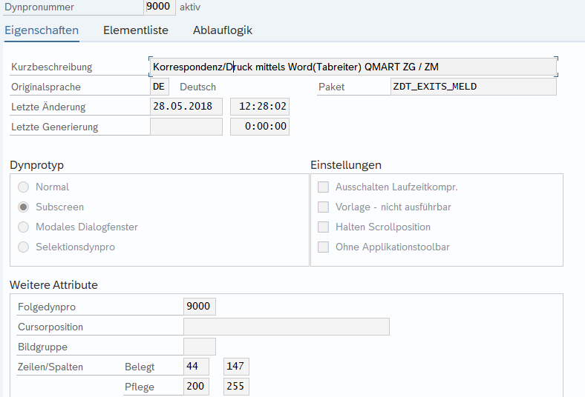*

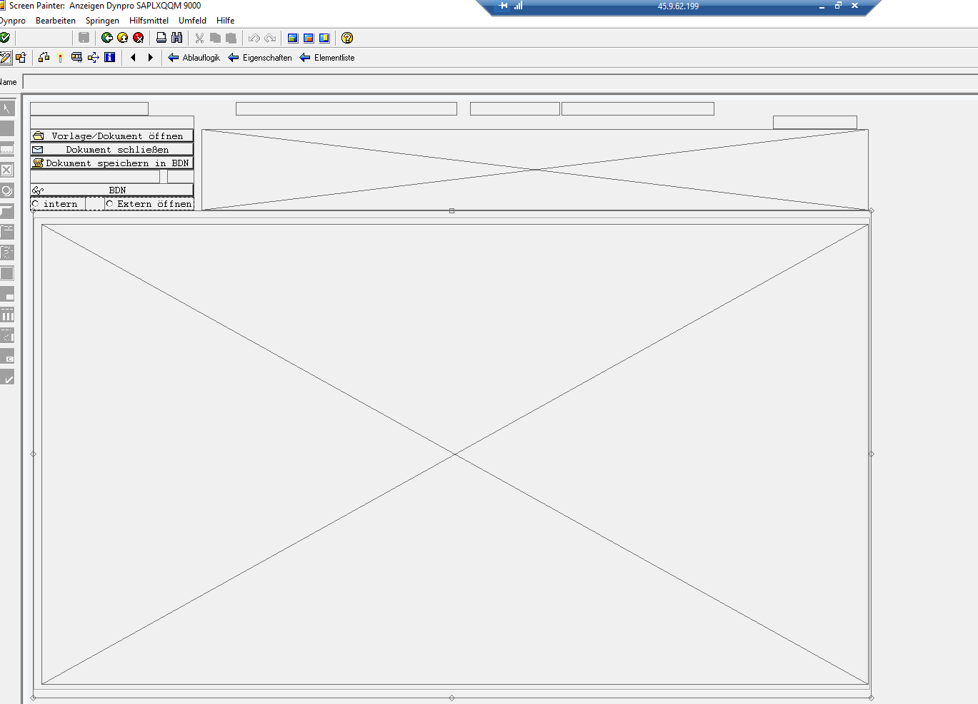

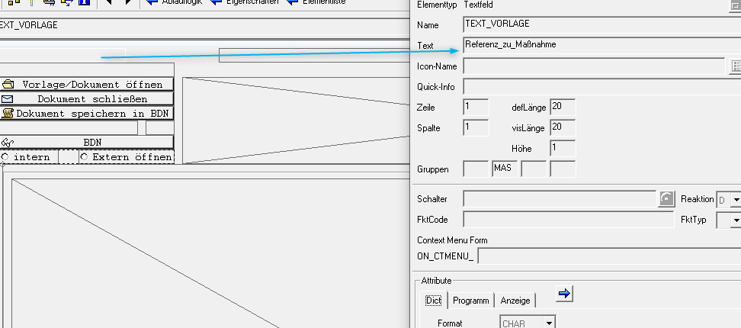 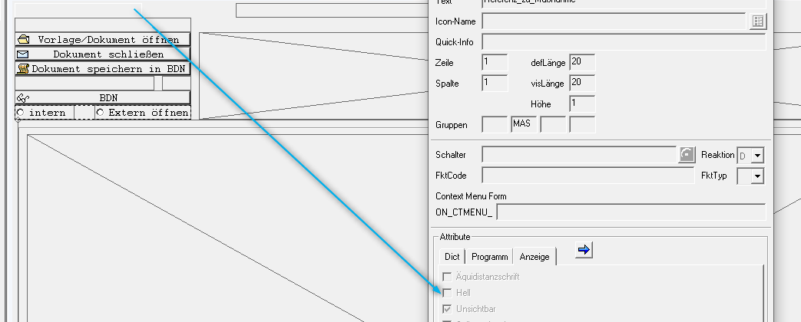 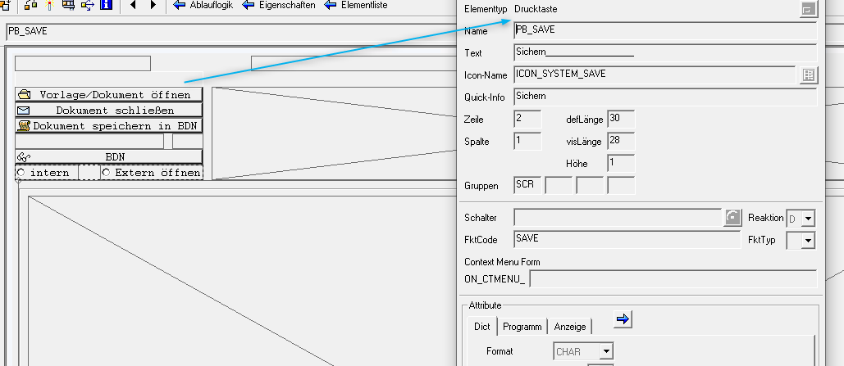 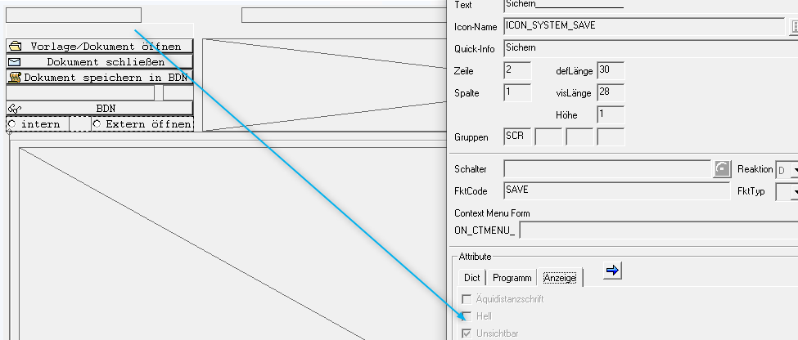

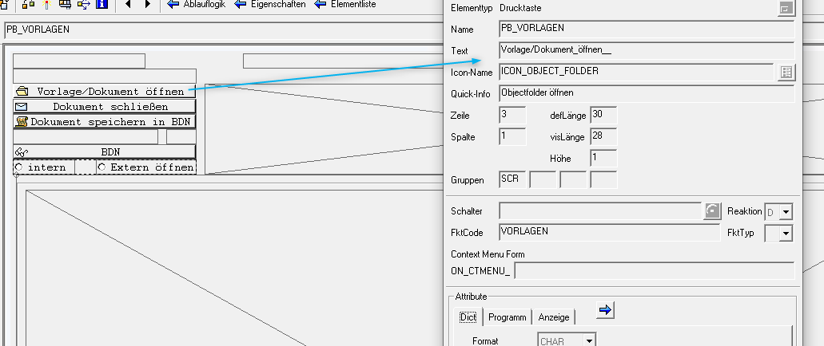

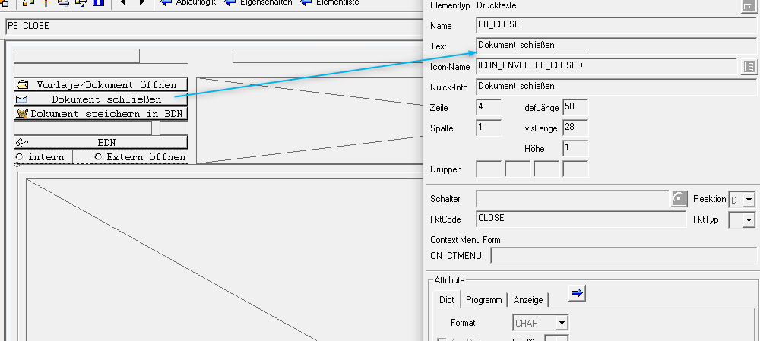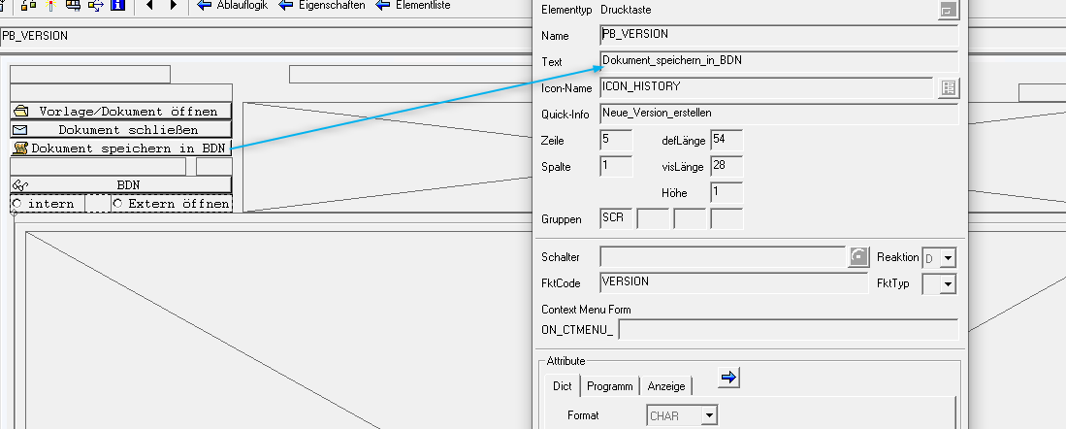 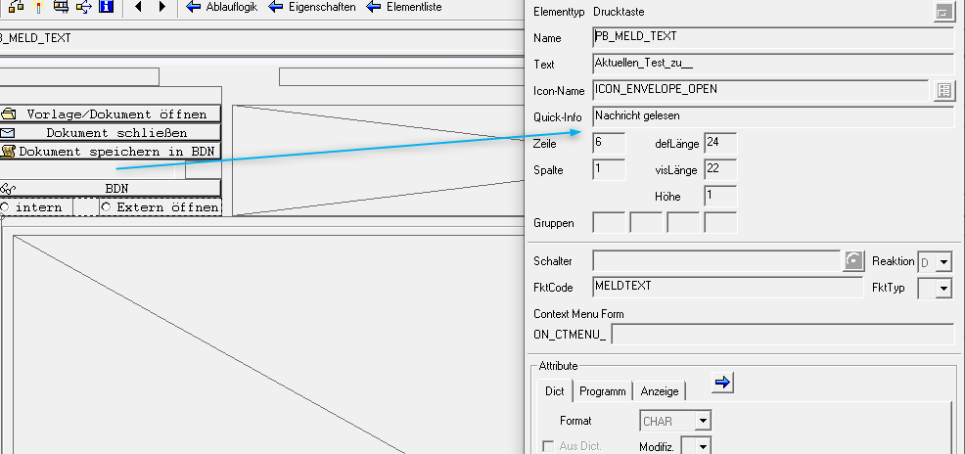

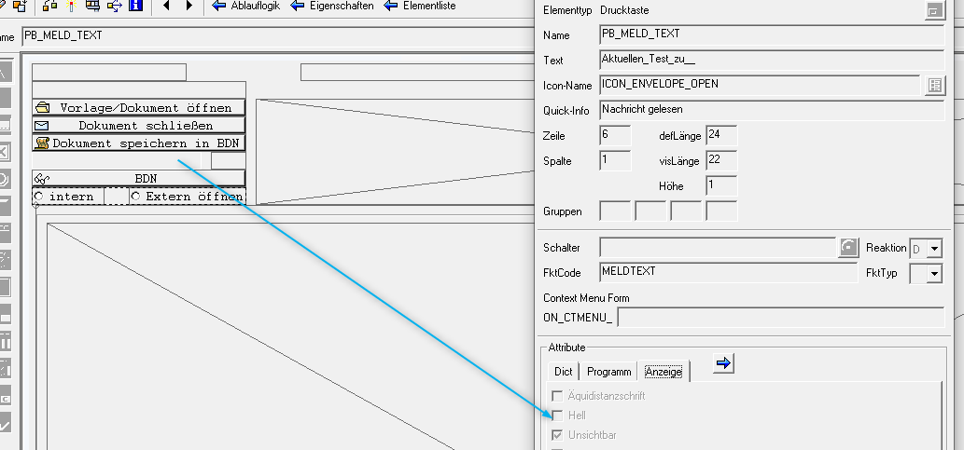

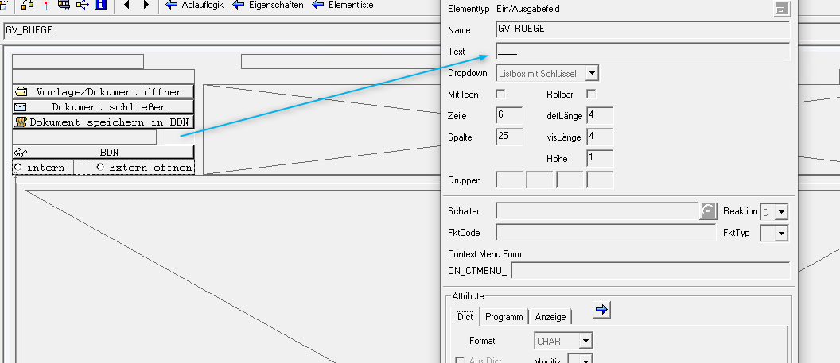 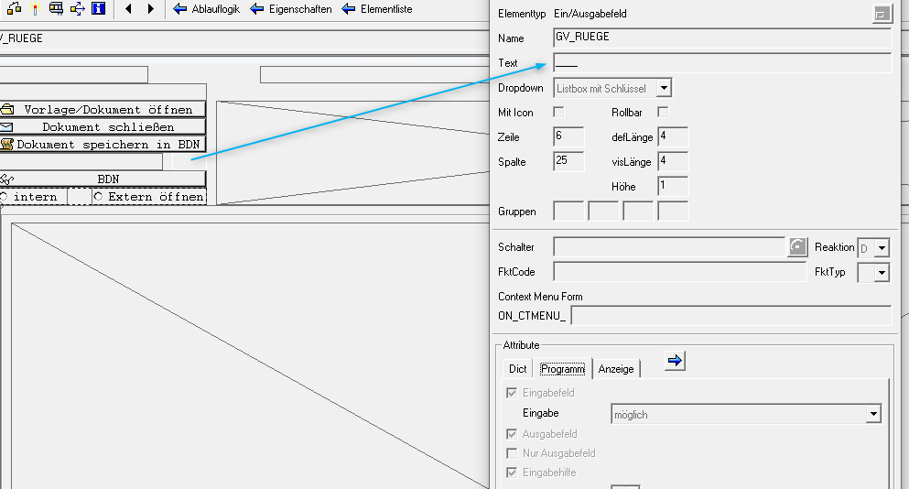

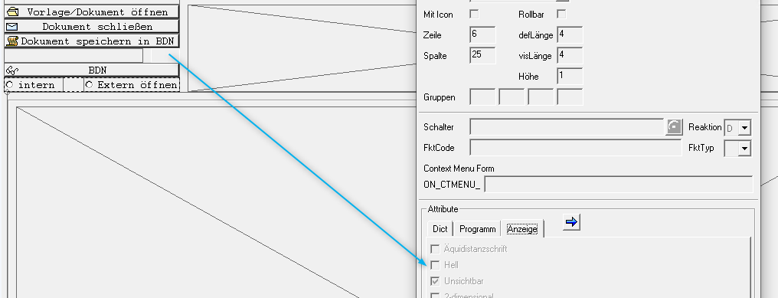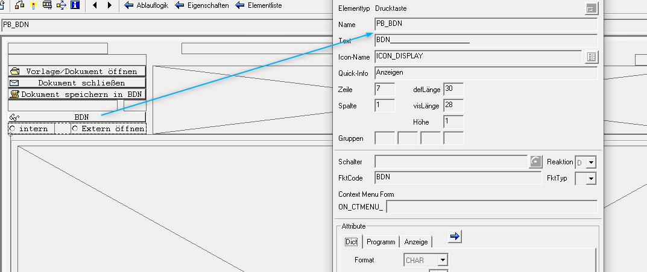 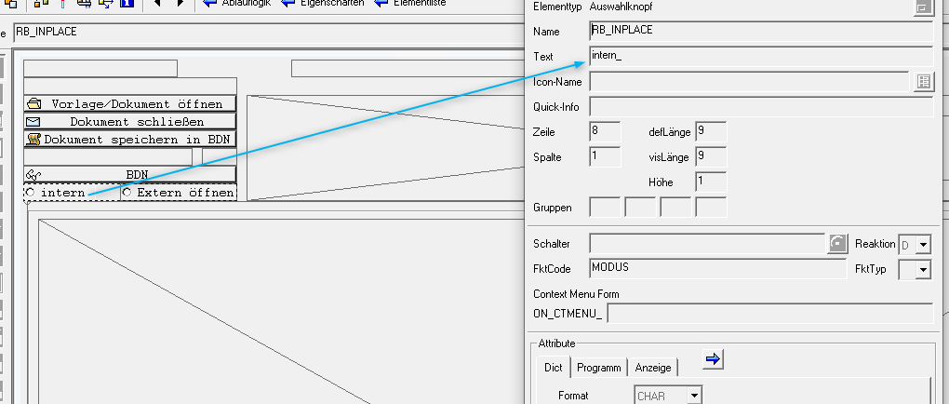 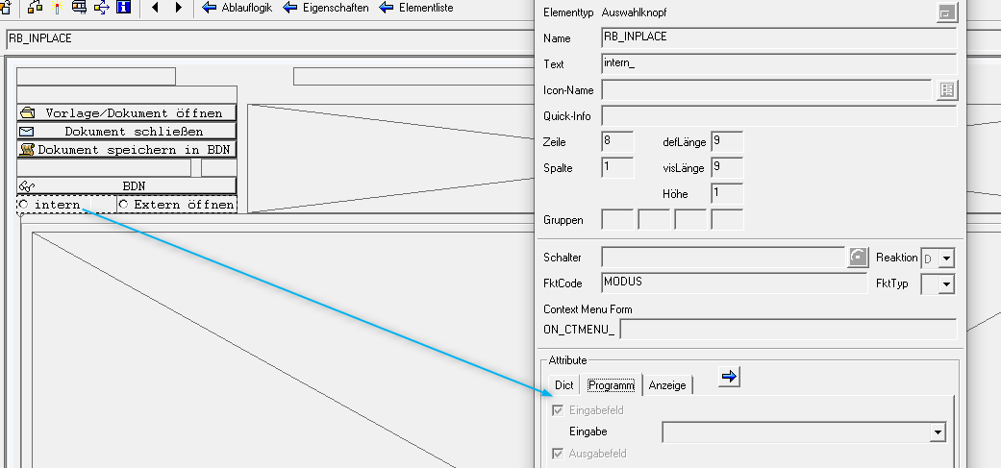

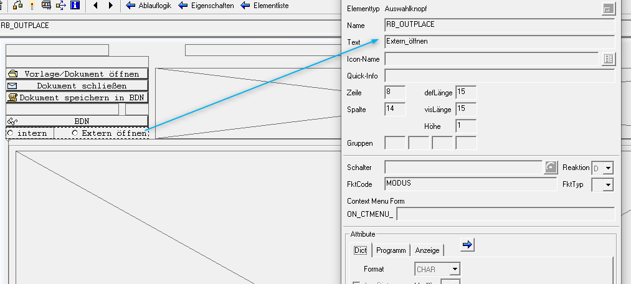 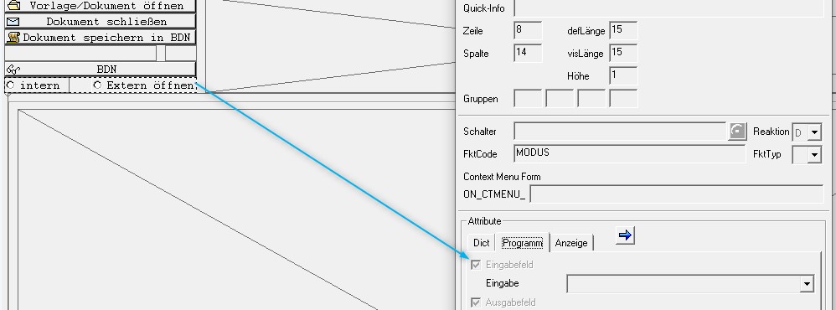 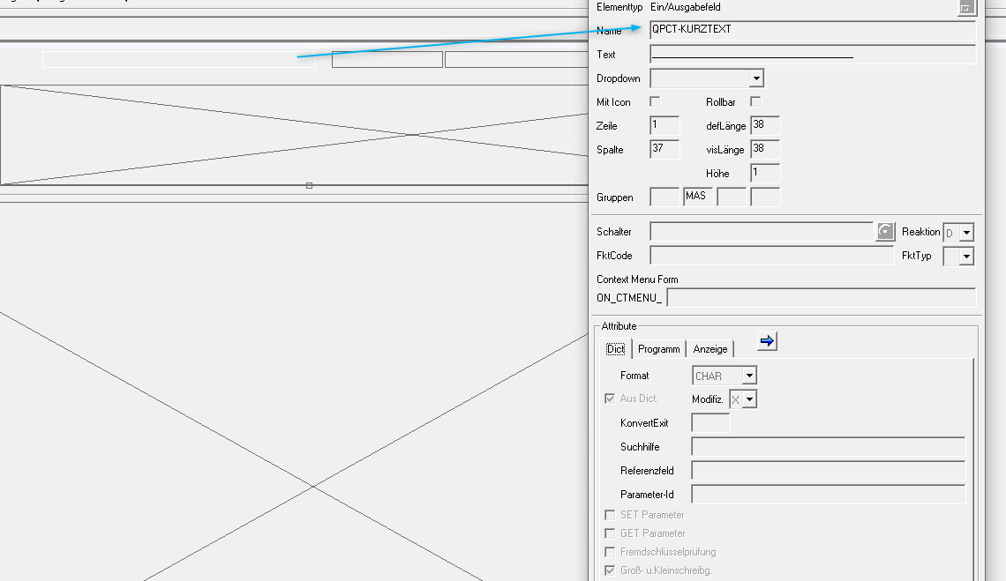

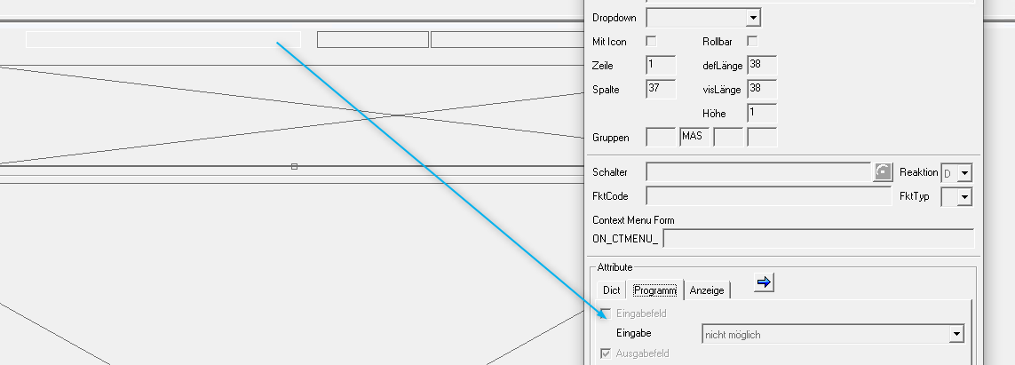 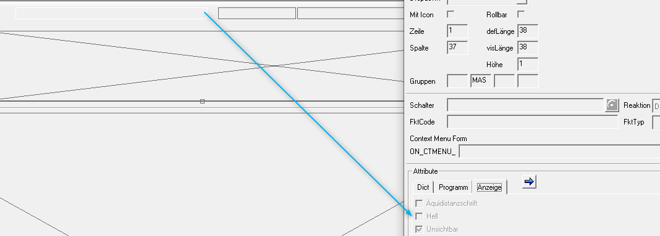 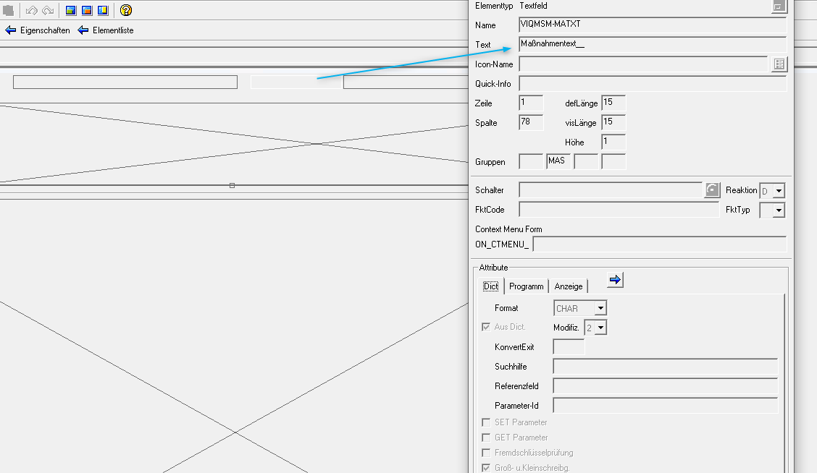

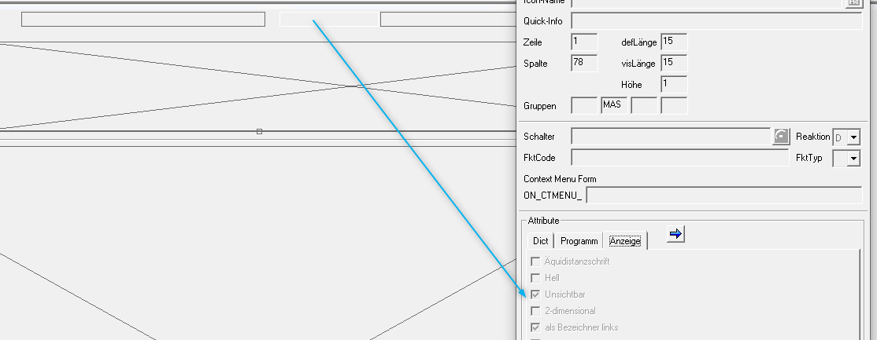 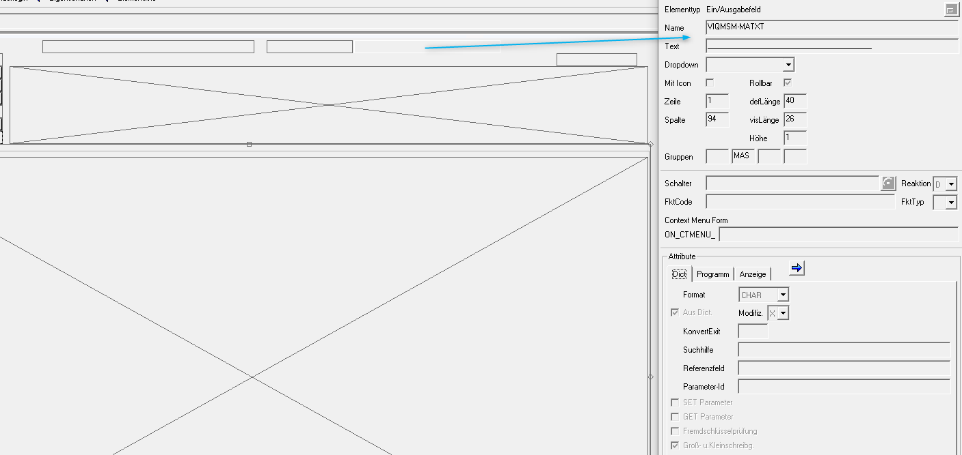 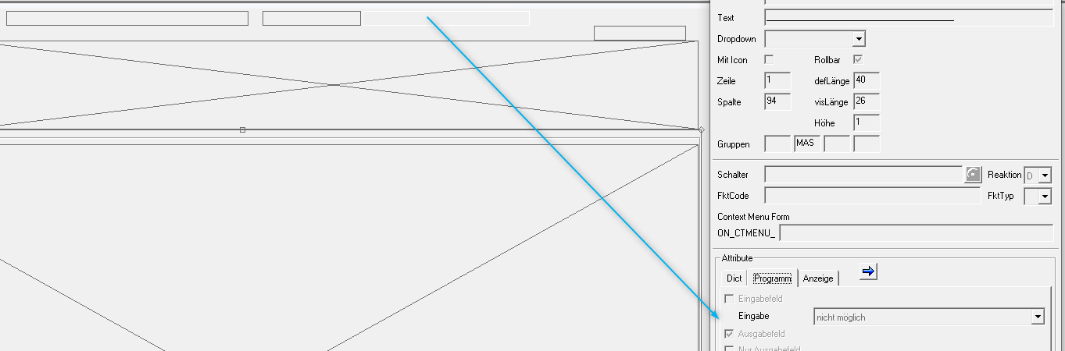 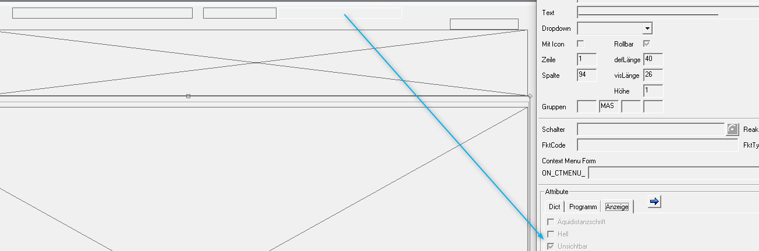

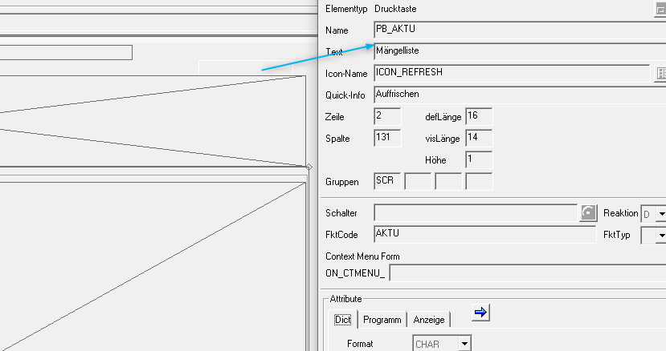 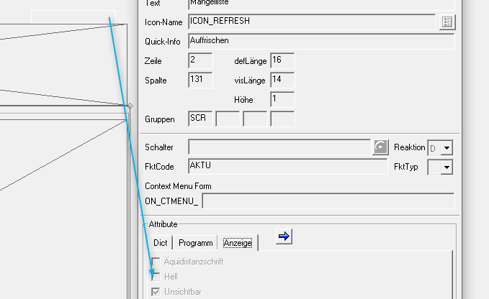 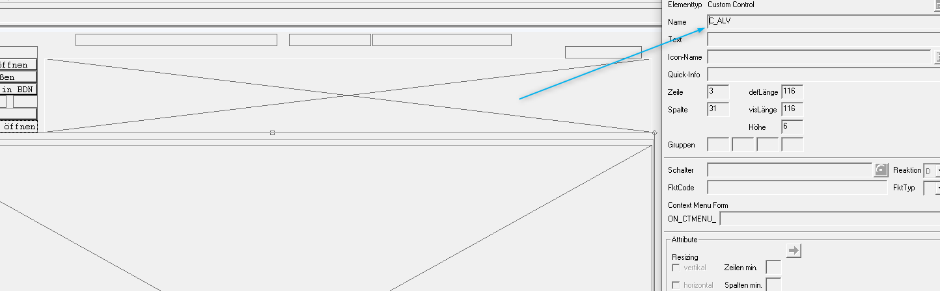

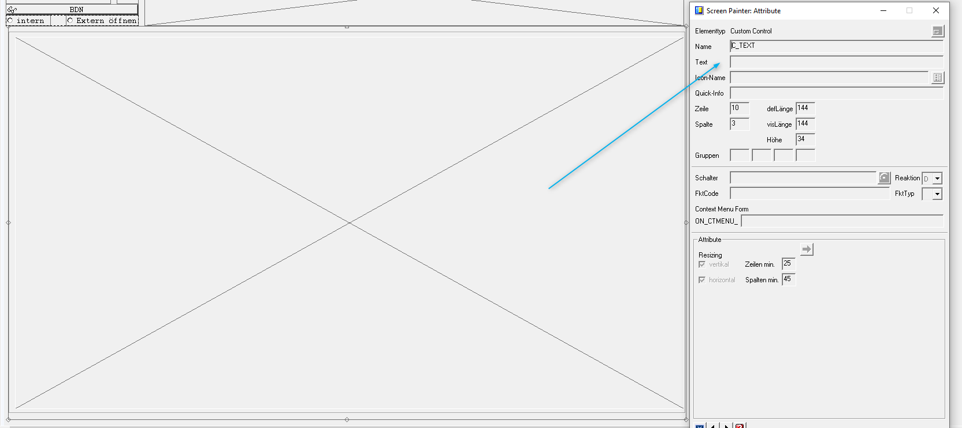   
PROCESS BEFORE OUTPUT.  
*\*\*\*\*\*\*\*\*\*\*\*\*\*\*\*\*\*\*\*\*\*\**  
  
 MODULE status_9000. *" <-- LOAD_DOCUMENT*  
  
 MODULE alv.  
  
 MODULE fieldcat.  
  
 MODULE display.  
  
  
PROCESS AFTER INPUT.  
*\*\*\*\*\*\*\*\*\*\*\*\*\*\*\*\*\*\*\*\**  
  
 MODULE selekt_vorlage.  
  
 MODULE user_command_9000.  
  
  
PROCESS ON VALUE-REQUEST.  
*\*\*\*\*\*\*\*\*\*\*\*\*\*\*\*\*\*\*\*\*\*\*\*\*\**  
  
 FIELD gv_ruege MODULE create_auswahl.

Include🡪 ZXQQMO08

*\*&---------------------------------------------------------------------\**  
*\*& Module STATUS_9000 OUTPUT*  
*\*&---------------------------------------------------------------------\**  
MODULE status_9000 OUTPUT.  
  
*\* SET PF-STATUS 'xxxxxxxx'.*  
*\* SET TITLEBAR 'xxx'.*  
  
*\*&---------------------------------------------------------------------\**  
  
 DATA lv_error TYPE c.  
 IMPORT lv_error FROM MEMORY ID 'ZZ_ERROR'.  
 IF sy-subrc = 0.  
*\* MESSAGE i000(/afm/bau) WITH 'Achtung: ' 'Bitte die Mängelmeldung ' viqmel-qmnum ' erst speichern!'.*  
 DATA lv_txt1 TYPE sta_text.  
 CLEAR lv_txt1.  
 gv_qmnum = viqmel-qmnum.  
 SHIFT gv_qmnum LEFT DELETING LEADING '0'.  
 CONCATENATE  
 'Bitte die Mängelmeldung:' gv_qmnum 'erst speichern!' INTO lv_txt1 SEPARATED BY space .  
 CALL FUNCTION 'POPUP_TO_INFORM'  
 EXPORTING  
 titel = 'Warnung: '  
 txt1 = lv_txt1  
 txt2 = ''  
*\* TXT3 = ' '*  
*\* TXT4 = ' '*  
 .  
 gv_fehler = 'X'.  
 EXIT.  
 ENDIF.  
  
*\*&---------------------------------------------------------------------\**  
  
*\*Entkopplung von den Kunden Meldungsarten Bezeichnungen*  
 SELECT SINGLE qmart FROM /afm/kundeqmart INTO gv_qmart  
 WHERE /afm/kundeqmart~zkunde_qmart = viqmel-qmart.  
  
 IF gv_qmart = 'SG' OR gv_qmart = 'SM'. *"Gewährleistung-/ Mängelmeldung*  
*\* Felder im Anzeigemodus auf dunkel schalten*  
 IF sy-tcode EQ 'IW53' OR sy-tcode EQ 'IW23'.  
 LOOP AT SCREEN.  
 IF screen-group1 EQ 'SCR'.  
 screen-input = 0.  
 ENDIF.  
 MODIFY SCREEN.  
 ENDLOOP.  
 ELSE.  
 ENDIF.  
  
*\*Holt von SAP Memory die Maßnahmen Tabelle und die ausgewählte Maßnahme*  
*\*um weiter dem entsprechenden Korrespondez Anwendungs Objekt von BDN zu zeigen*  
 CLEAR inxsm.  
 CLEAR iviqmsm.  
 CLEAR fl_txtma.  
  
 IMPORT inxsm FROM MEMORY ID 'INXSM'.  
 IMPORT iviqmsm FROM MEMORY ID 'IVIQMSM'.  
  
*\*Übernimmt die Maßnahme Details von den entprechenden Tabellen*  
 PERFORM get_massnahme_details.  
  
 IF ( gv_qmart = 'SM' OR gv_qmart = 'SG' ) AND fl_txtma = 1.  
 LOOP AT SCREEN.  
 IF screen-group2 EQ 'MAS'.  
 screen-invisible = 0.  
 screen-active = 1.  
 ENDIF.  
 MODIFY SCREEN.  
 ENDLOOP.  
 qpct-kurztext = gv_txcdsm.  
 viqmsm-matxt = gv_txtma.  
 ELSE.  
 LOOP AT SCREEN.  
 IF screen-group2 EQ 'MAS'.  
 screen-invisible = 1.  
 screen-active = 0.  
 ENDIF.  
 MODIFY SCREEN.  
 ENDLOOP.  
 qpct-kurztext = '' .  
 viqmsm-matxt = '' .  
 ENDIF.  
  
*\* Vorlagen holen*  
 IF gv_get_vorl EQ space.  
 PERFORM get_template_url CHANGING gv_url.  
 ELSEIF ( gv_get_vorl NE space AND gv_qmart = 'SM' ) OR ( gv_get_vorl NE space AND gv_qmart = 'SG' ).  
 PERFORM get_template_url CHANGING gv_url.  
 ENDIF.  
  
 IF gv_init EQ space. *"nur beim ersten Aufruf*  
*\* Existiert bereits ein Dokument zur Meldungsnummer, soll diese direkt geladen werden:*  
 DATA lt_uris TYPE STANDARD TABLE OF bapiuri.  
 DATA ls_uri TYPE bapiuri.  
 DATA lv_object_key TYPE bapibds01-objkey.  
*\* DATA lt_data TYPE STANDARD TABLE OF bapiconten.*  
 DATA lv_doc_size TYPE i.  
 DATA lt_signature TYPE STANDARD TABLE OF bapisignat.  
 DATA ls_signature TYPE bapisignat.  
 DATA lt_sign_copy TYPE STANDARD TABLE OF bapisignat.  
 DATA ls_sign_copy TYPE bapisignat.  
 DATA lt_sign_sort_r TYPE STANDARD TABLE OF bapisignat WITH HEADER LINE.  
 DATA lt_sign_sort_v TYPE STANDARD TABLE OF bapisignat WITH HEADER LINE.  
 DATA lt_components TYPE STANDARD TABLE OF bapicompon.  
 DATA ls_component TYPE bapicompon.  
  
 IF gv_doc_open NE 'X'.  
 CLEAR gt_components_upd.  
 REFRESH gt_components_upd.  
 CLEAR gt_signatures.  
 REFRESH gt_signatures.  
  
 lv_object_key = viqmel-qmnum.  
  
 CASE gv_qmart.  
  
 WHEN 'SG'.  
 IF sy-tcode EQ 'IW22' OR sy-tcode EQ 'IW23'.  
 IF fl_txtma = 1.  
 CLEAR lv_object_key.  
 CONCATENATE viqmel-qmnum gv_mncod INTO lv_object_key.  
  
 CALL FUNCTION 'BDS_BUSINESSDOCUMENT_GET_URL'  
 EXPORTING  
 classname = c_classmass  
 classtype = c_cltypmass  
*\* OBJECT_KEY = gv_objektschl*  
 object_key = lv_object_key  
 TABLES  
 uris = lt_uris  
 signature = lt_signature  
 components = lt_components  
 EXCEPTIONS  
 nothing_found = 1  
 parameter_error = 2  
 not_allowed = 3  
 error_kpro = 4  
 internal_error = 5  
 not_authorized = 6  
 OTHERS = 7.  
 ELSE.  
 CALL FUNCTION 'BDS_BUSINESSDOCUMENT_GET_URL'  
 EXPORTING  
 classname = c_class_mangel1  
 classtype = c_cltyp_mangel1  
*\* OBJECT_KEY = gv_objektschl*  
 object_key = lv_object_key  
 TABLES  
 uris = lt_uris  
 signature = lt_signature  
 components = lt_components  
 EXCEPTIONS  
 nothing_found = 1  
 parameter_error = 2  
 not_allowed = 3  
 error_kpro = 4  
 internal_error = 5  
 not_authorized = 6  
 OTHERS = 7.  
 ENDIF.  
 ELSE.  
 CALL FUNCTION 'BDS_BUSINESSDOCUMENT_GET_URL'  
 EXPORTING  
 classname = c_class_mangel1  
 classtype = c_cltyp_mangel1  
*\* OBJECT_KEY = gv_objektschl*  
 object_key = lv_object_key  
 TABLES  
 uris = lt_uris  
 signature = lt_signature  
 components = lt_components  
 EXCEPTIONS  
 nothing_found = 1  
 parameter_error = 2  
 not_allowed = 3  
 error_kpro = 4  
 internal_error = 5  
 not_authorized = 6  
 OTHERS = 7.  
 ENDIF.  
  
 WHEN 'SM'.  
 IF sy-tcode EQ 'IW22' OR sy-tcode EQ 'IW23'.  
 IF fl_txtma = 1.  
 CLEAR lv_object_key.  
 CONCATENATE viqmel-qmnum gv_mncod INTO lv_object_key.  
  
 CALL FUNCTION 'BDS_BUSINESSDOCUMENT_GET_URL'  
 EXPORTING  
 classname = c_classmass  
 classtype = c_cltypmass  
*\* OBJECT_KEY = gv_objektschl*  
 object_key = lv_object_key  
 TABLES  
 uris = lt_uris  
 signature = lt_signature  
 components = lt_components  
 EXCEPTIONS  
 nothing_found = 1  
 parameter_error = 2  
 not_allowed = 3  
 error_kpro = 4  
 internal_error = 5  
 not_authorized = 6  
 OTHERS = 7.  
 ELSE.  
 CALL FUNCTION 'BDS_BUSINESSDOCUMENT_GET_URL'  
 EXPORTING  
 classname = c_class_mangel1  
 classtype = c_cltyp_mangel1  
*\* OBJECT_KEY = gv_objektschl*  
 object_key = lv_object_key  
 TABLES  
 uris = lt_uris  
 signature = lt_signature  
 components = lt_components  
 EXCEPTIONS  
 nothing_found = 1  
 parameter_error = 2  
 not_allowed = 3  
 error_kpro = 4  
 internal_error = 5  
 not_authorized = 6  
 OTHERS = 7.  
 ENDIF.  
 ELSE.  
 CALL FUNCTION 'BDS_BUSINESSDOCUMENT_GET_URL'  
 EXPORTING  
 classname = c_class_mangel1  
 classtype = c_cltyp_mangel1  
*\* OBJECT_KEY = gv_objektschl*  
 object_key = lv_object_key  
 TABLES  
 uris = lt_uris  
 signature = lt_signature  
 components = lt_components  
 EXCEPTIONS  
 nothing_found = 1  
 parameter_error = 2  
 not_allowed = 3  
 error_kpro = 4  
 internal_error = 5  
 not_authorized = 6  
 OTHERS = 7.  
 ENDIF.  
  
 WHEN OTHERS.  
*\* CALL FUNCTION 'BDS_BUSINESSDOCUMENT_GET_URL'*  
*\* EXPORTING*  
*\* classname = c_class*  
*\* classtype = c_cltyp*  
*\* object_key = lv_object_key*  
*\* TABLES*  
*\* uris = lt_uris*  
*\* signature = lt_signature*  
*\* components = lt_components*  
*\* EXCEPTIONS*  
*\* nothing_found = 1*  
*\* parameter_error = 2*  
*\* not_allowed = 3*  
*\* error_kpro = 4*  
*\* internal_error = 5*  
*\* not_authorized = 6*  
*\* OTHERS = 7.*  
  
 ENDCASE.  
  
 CASE sy-subrc.  
 WHEN 0.  
*\* beim Start soll zunächst die aktuellste Version des "höchsten" Rüge-Schreibens angezeigt werden*  
*\* Attribut BDS_KEYWORD enthält die Nr. der Rüge mit vorangestelltem "document"*  
*\* Attribut BDS_STATE enthält die "Versions-Nr."*  
  
 lt_sign_copy = lt_signature.  
*\* Aktuellste Rüge-Nr. ziehen <=> höchster Eintrag in BDS_KEYWORD*  
 LOOP AT lt_signature INTO ls_signature  
 WHERE prop_name EQ 'BDS_KEYWORD'.  
 IF ls_signature-prop_value CP 'document*'.  
 ls_signature-prop_value = ls_signature-prop_value.  
 APPEND ls_signature TO lt_sign_sort_r.  
 ENDIF.  
 ENDLOOP.  
 SORT lt_sign_sort_r DESCENDING BY prop_value.  
  
 READ TABLE lt_sign_sort_r INDEX 1. *" => höchste Rüge-Nr.*  
  
*\* höchste Versions-Nr. zur Rüge mit höchster Nr. holen:*  
*\* erst alle Einträge zur Rügen-Nr. in die lt_sign_sort_v einlesen*  
 CLEAR ls_signature.  
 CLEAR ls_sign_copy.  
  
 LOOP AT lt_signature INTO ls_signature  
 WHERE prop_name = 'BDS_KEYWORD'  
 AND prop_value = lt_sign_sort_r-prop_value.  
*\* => jeweilige doc_count zum Dkument mit höchster Rüge-Nr. bekannt*  
 READ TABLE lt_sign_copy INTO ls_sign_copy  
 WITH KEY doc_count = ls_signature-doc_count  
 prop_name = 'BDS_STATE'.  
 IF sy-subrc = 0.  
 APPEND ls_sign_copy TO lt_sign_sort_v.  
 ENDIF.  
 ENDLOOP.  
  
 SORT lt_sign_sort_v DESCENDING BY prop_value.  
 READ TABLE lt_sign_sort_v INDEX 1. *" => höchste Versions-Nr.*  
  
 CLEAR ls_signature.  
 LOOP AT lt_signature INTO ls_signature  
 WHERE doc_id EQ lt_sign_sort_v-doc_id.  
 APPEND ls_signature TO gt_signatures.  
  
 READ TABLE lt_uris INTO ls_uri WITH KEY doc_count = ls_signature-doc_count.  
 gv_url = ls_uri-uri.  
 gs_signature = ls_signature.  
  
 ENDLOOP.  
  
 READ TABLE lt_components INTO ls_component WITH KEY doc_count = ls_signature-doc_count.  
 ls_component-doc_count = ls_signature-doc_count.  
 APPEND ls_component TO gt_components_upd.  
  
 PERFORM load_document USING gv_url gs_vorl-doc.  
 gv_init = 'X'.  
 gv_exist = 'X'.  
 gv_objektschl = lv_object_key.  
  
 WHEN OTHERS.  
*\* noch kein Dokument zur Meldung vorhanden*  
 ENDCASE.  
 ENDIF.  
  
 ELSE.  
  
 IF sy-ucomm = 'VORLAGEN'.  
 READ TABLE gt_vorl INTO gs_vorl INDEX ls_selected_line-index.  
 IF gs_vorl-comp_id+0(12) = viqmel-qmnum. *" gespeichertes Dokument ist geöffnet!*  
 LOOP AT SCREEN.  
 IF screen-name EQ 'PB_VERSION'. *" Button " Neue Version anlegen" deaktivieren!*  
 screen-intensified = 1.  
 screen-input = 0.  
 ENDIF.  
 MODIFY SCREEN.  
 ENDLOOP.  
 ENDIF.  
 ENDIF.  
  
 ENDIF. *" gv_init EQ space. "nur beim ersten Aufruf*  
  
 ENDIF.  
  
 IF sy-ucomm = 'BAUVERTRAG'.  
 PERFORM supress_f31(sapliqs0).  
 ENDIF.  
  
ENDMODULE.

Include🡪 ZXQQMF15

*\*----------------------------------------------------------------------\**  
*\*\*\*INCLUDE ZXQQMF15.*  
*\*----------------------------------------------------------------------\**  
  
*\*&---------------------------------------------------------------------\**  
*\*& Form GET_MASSNAHME_DETAILS*  
*\*&---------------------------------------------------------------------\**  
FORM get_massnahme_details .  
  
 DATA lv_index TYPE sy-index.  
 DATA ls_viqmsm TYPE wqmsm.  
 DATA lv_txcdsm TYPE qtxtcdgrsm. *" Kurztext Maßnahmecode*  
  
 LOOP AT inxsm.  
 IF inxsm-mark = 'X'.  
 fl_txtma = fl_txtma + 1.  
 lv_index = inxsm-tabpt.  
 ENDIF.  
 ENDLOOP.  
  
 READ TABLE iviqmsm INTO ls_viqmsm INDEX lv_index.  
  
 SELECT SINGLE kurztext FROM qpct INTO lv_txcdsm  
 WHERE qpct~code = ls_viqmsm-mncod  
 AND sprache = sy-langu.  
 IF sy-subrc = 0.  
 gv_mncod = ls_viqmsm-mncod.  
 gv_txtma = ls_viqmsm-matxt.  
 gv_txcdsm = lv_txcdsm.  
 ELSE.  
 CLEAR: gv_mncod, gv_txtma, gv_txcdsm.  
 ENDIF.  
  
ENDFORM.

Include🡪 ZXQQMF16

*\*----------------------------------------------------------------------\**  
*\*\*\*INCLUDE ZXQQMF16.*  
*\*----------------------------------------------------------------------\**  
  
*\*&---------------------------------------------------------------------\**  
*\*& Form GET_TEMPLATE_URL*  
*\*&---------------------------------------------------------------------\**  
*\* <--P_GV_URL text*  
*\*----------------------------------------------------------------------\**  
FORM get_template_url CHANGING cv_url.  
  
 DATA lt_uris TYPE STANDARD TABLE OF bapiuri.  
 DATA ls_uri TYPE bapiuri.  
 DATA lv_object_key TYPE bapibds01-objkey.  
 DATA lt_data TYPE STANDARD TABLE OF bapiconten.  
 DATA lv_doc_size TYPE i.  
 DATA lt_signature TYPE STANDARD TABLE OF bapisignat.  
 DATA ls_signature TYPE bapisignat.  
 DATA lt_sign_copy TYPE STANDARD TABLE OF bapisignat.  
 DATA ls_sign_copy TYPE bapisignat.  
 DATA lt_sign_sort_r TYPE STANDARD TABLE OF bapisignat WITH HEADER LINE.  
 DATA lt_sign_sort_v TYPE STANDARD TABLE OF bapisignat WITH HEADER LINE.  
  
 DATA lv_classname TYPE bds_clsnam.  
 DATA lv_classtype TYPE bds_clstyp.  
*\* DATA: begin of lt_sign_sort_v occurs 0. "alle Signaturtabs müssen bei Versionen > 9 noch mit weiterem*  
*\* include structure bapisignat. "Zähler versehen werden (prop_value2), damit danach RICHTI sortiert werden kann.*  
*\* data prop_value2(3) type n.*  
*\* DATA: end of lt_sign_sort_v.*  
 DATA lt_components TYPE STANDARD TABLE OF bapicompon.  
 DATA ls_component TYPE bapicompon.  
 DATA lv_lines TYPE n.  
  
 DATA gt_vorlagen TYPE TABLE OF /afm/oaer.  
 DATA ls_vorlagen TYPE /afm/oaer.  
  
*\*----------------------------------------------------------------------\**  
  
 CLEAR gt_components_upd.  
 REFRESH gt_components_upd.  
 REFRESH gt_signatures.  
  
 CLEAR fl_massn.  
  
 CASE sy-ucomm.  
*\* ----------------------------------------------*  
 WHEN '10'. *"Vorlagendaten holen*  
*\* ----------------------------------------------*  
 IF gv_qmart = 'SG' OR gv_qmart = 'SM'.  
 LOOP AT inxsm.  
 IF inxsm-mark = 'X'.  
 fl_massn = fl_massn + 1.  
 ENDIF.  
 ENDLOOP.  
  
 DATA lv_vorlage TYPE /afm/oaer-vorlage.  
 CLEAR lv_vorlage.  
 DATA gt_vorlagen_save TYPE TABLE OF /afm/oaer.  
 CLEAR gt_vorlagen_save.  
 FREE: gt_vorlagen, gt_vorl.  
  
*\* Laden der abhänigen Dokumente (mit und ohne Vorlagen)*  
 IF fl_massn > 0.  
*\* Vorlage zu Maßnahmen und Meldungsart laden*  
 SELECT * FROM /afm/oaer INTO TABLE gt_vorlagen WHERE qmart = gv_qmart AND mncod = gv_mncod.  
 gt_vorlagen_save = gt_vorlagen.  
*\* + Dokumente zur Meldungsart laden ohne Maßnahmenbezug - mit Vorlagen!*  
 LOOP AT gt_vorlagen INTO ls_vorlagen.  
 CONCATENATE viqmel-qmnum ls_vorlagen-mncod INTO lv_vorlage.  
 ls_vorlagen-vorlage = lv_vorlage.  
 APPEND ls_vorlagen TO gt_vorlagen_save.  
 CLEAR lv_vorlage.  
 ENDLOOP.  
 gt_vorlagen = gt_vorlagen_save.  
 ELSE.  
*\* Dokumente zur Meldungsart laden ohne Maßnahmenbezug - ohne Vorlagen!*  
 SELECT * FROM /afm/oaer INTO TABLE gt_vorlagen WHERE qmart = gv_qmart.  
 LOOP AT gt_vorlagen INTO ls_vorlagen.  
 CONCATENATE viqmel-qmnum ls_vorlagen-mncod INTO lv_vorlage.  
 ls_vorlagen-vorlage = lv_vorlage.  
 MODIFY gt_vorlagen FROM ls_vorlagen INDEX sy-tabix.  
 CLEAR lv_vorlage.  
 ENDLOOP.  
 ENDIF.  
  
*\* Über bestehende Vorlagen iterieren*  
 LOOP AT gt_vorlagen INTO ls_vorlagen.  
*\* Objektschlüssel ist bei Vorlage immer aus Customizing zu ziehen*  
 lv_object_key = ls_vorlagen-vorlage. *" <-- Z.B. ZKORR_MAENGEL_1*  
  
*\* prüfen ob es eine Vorlage oder ein bestehendes Document ist*  
 If lv_object_key cs viqmel-qmnum.  
 gs_vorl-doc = 'X'.  
 else.  
 gs_vorl-doc = ''.  
 endif.  
*\* Mehr als eine Maßnahme selektiert?!?*  
 IF fl_massn > 1.  
 CALL FUNCTION 'POPUP_TO_INFORM'  
 EXPORTING  
 titel = 'Maßname Korrespondenz'  
 txt1 = 'Bitte nur eine Maßnahme markieren !'(103)  
 txt2 = ''  
*\* TXT3 = ' '*  
*\* TXT4 = ' '*  
 .  
 EXIT.  
 ENDIF.  
  
*\* Tabellen leeren*  
 FREE: lt_uris, lt_signature, lt_components.  
  
*\* Dokument abhänig zu selektierten Vorlagen laden*  
 CALL FUNCTION 'BDS_BUSINESSDOCUMENT_GET_URL'  
 EXPORTING  
*\* LOGICAL_SYSTEM =*  
 classname = ls_vorlagen-cls_nam  
 classtype = ls_vorlagen-clstyp  
*\* CLIENT = SY-MANDT*  
 object_key = lv_object_key  
*\* URL_LIFETIME =*  
*\* STANDARD_URL_ONLY =*  
*\* DATA_PROVIDER_URL_ONLY =*  
*\* WEB_APPLIC_SERVER_URL_ONLY =*  
*\* URL_USED_AT =*  
 TABLES  
 uris = lt_uris  
 signature = lt_signature  
 components = lt_components  
 EXCEPTIONS  
 nothing_found = 1  
 parameter_error = 2  
 not_allowed = 3  
 error_kpro = 4  
 internal_error = 5  
 not_authorized = 6  
 OTHERS = 7.  
  
 CASE sy-subrc.  
 WHEN 0.  
*\* Nur die Vorlagen zur Systemsprache einlesen.*  
 LOOP AT lt_uris INTO ls_uri.  
 READ TABLE lt_signature INTO ls_signature  
 WITH KEY doc_count = ls_uri-doc_count  
 prop_name = 'LANGUAGE'  
 prop_value = sy-langu.  
 IF sy-subrc NE 0.  
 DELETE lt_uris.  
 READ TABLE lt_components INTO ls_component  
 WITH KEY doc_count = ls_uri-doc_count.  
 IF sy-subrc = 0.  
 DELETE lt_components INDEX sy-tabix.  
 ENDIF.  
 LOOP AT lt_signature INTO ls_signature WHERE doc_count = ls_uri-doc_count.  
 DELETE lt_signature INDEX sy-tabix.  
 ENDLOOP.  
 ENDIF.  
 ENDLOOP.  
 DESCRIBE TABLE lt_uris LINES lv_lines.  
 IF lv_lines GT 0.  
 gv_get_vorl = 'X'.  
 ENDIF.  
 WHEN OTHERS.  
*\* MESSAGE w000(38) WITH 'Keinen Text gefunden'(m09).*  
 ENDCASE.  
  
*\* Sichern der eingelesenen Daten*  
 MOVE: lt_uris[] TO gt_uris[],  
 lt_uris[] TO gt_uris_vorl[],  
 lt_signature[] TO gt_sign_vorl[].  
  
*\* Daten fürs ALV bereitstellen*  
 DATA lv_datum TYPE dats.  
 CLEAR lv_datum.  
 CLEAR gs_vorl.  
 CLEAR ls_uri.  
 CLEAR ls_signature.  
 CLEAR ls_component.  
  
*\* Daten aus Vorlage übernehmen und sichern*  
 LOOP AT lt_uris INTO ls_uri.  
  
 MOVE-CORRESPONDING ls_uri TO gs_vorl.  
  
 READ TABLE lt_components INTO ls_component INDEX sy-tabix.  
 MOVE-CORRESPONDING ls_component TO gs_vorl.  
  
 READ TABLE lt_signature INTO ls_signature WITH KEY doc_count = ls_uri-doc_count  
 prop_name = 'DESCRIPTION'.  
 MOVE-CORRESPONDING ls_signature TO gs_vorl.  
  
 READ TABLE lt_signature INTO ls_signature WITH KEY doc_count = ls_uri-doc_count  
 prop_name = 'CREATED_AT'.  
 lv_datum = ls_signature-prop_value+0(8).  
 CALL FUNCTION 'CONVERT_DATE_TO_EXTERNAL'  
 EXPORTING  
 date_internal = lv_datum  
 IMPORTING  
 date_external = gs_vorl-datum  
 EXCEPTIONS  
 date_internal_is_invalid = 1  
 OTHERS = 2.  
 IF sy-subrc <> 0.  
*\* Implement suitable error handling here*  
 ENDIF.  
  
*\* Übernahme der Dokumenteklasse (ZKORR_MAENGEL etc...)*  
 gs_vorl-type = ls_vorlagen-CLS_NAM.  
  
 APPEND gs_vorl TO gt_vorl.  
 ENDLOOP.  
 ENDLOOP.  
 ENDIF. *" gv_qmart = 'SG' OR gv_qmart = 'SM'*  
  
*\* --------------------------------------*  
 WHEN 'MELDTEXT'.  
*\* --------------------------------------*  
 DATA ls_vorl LIKE LINE OF gt_vorl.  
*\* Wenn Text geladen wird*  
 lv_object_key = viqmel-qmnum.  
  
 CASE gv_qmart.  
  
 WHEN 'SM'.  
  
*\* Wie kann erkannt werden welche Vorlage ausgewählt wurde?!?*  
 FREE lt_sel_rows.  
 CALL METHOD go_alv->get_selected_rows  
 IMPORTING  
 et_index_rows = lt_sel_rows.  
 LOOP AT lt_sel_rows INTO ls_sel_rows.  
 READ TABLE gt_vorl INTO ls_vorl INDEX ls_sel_rows-index.  
 ENDLOOP.  
  
 lv_object_key = c_class_mangel1.  
  
*\* IF gv_qmart = 'SM' AND fl_txtma = 1 .*  
*\* CLEAR lv_object_key.*  
*\* CONCATENATE viqmel-qmnum gv_mncod INTO lv_object_key.*  
 CALL FUNCTION 'BDS_BUSINESSDOCUMENT_GET_URL'  
 EXPORTING  
*\* LOGICAL_SYSTEM =*  
 classname = c_class_mangel1  
 classtype = c_cltyp_mangel1  
*\* CLIENT = SY-MANDT*  
 object_key = lv_object_key  
*\* URL_LIFETIME =*  
*\* STANDARD_URL_ONLY =*  
*\* DATA_PROVIDER_URL_ONLY =*  
*\* WEB_APPLIC_SERVER_URL_ONLY =*  
*\* URL_USED_AT =*  
 TABLES  
 uris = lt_uris  
 signature = lt_signature  
 components = lt_components  
 EXCEPTIONS  
 nothing_found = 1  
 parameter_error = 2  
 not_allowed = 3  
 error_kpro = 4  
 internal_error = 5  
 not_authorized = 6  
 OTHERS = 7.  
*\* ELSE.*  
*\* CALL FUNCTION 'BDS_BUSINESSDOCUMENT_GET_URL'*  
*\* EXPORTING*  
*\*\* LOGICAL_SYSTEM =*  
*\* classname = c_class500*  
*\* classtype = c_cltyp500*  
*\*\* CLIENT = SY-MANDT*  
*\* object_key = lv_object_key*  
*\*\* URL_LIFETIME =*  
*\*\* STANDARD_URL_ONLY =*  
*\*\* DATA_PROVIDER_URL_ONLY =*  
*\*\* WEB_APPLIC_SERVER_URL_ONLY =*  
*\*\* URL_USED_AT =*  
*\* TABLES*  
*\* uris = lt_uris*  
*\* signature = lt_signature*  
*\* components = lt_components*  
*\* EXCEPTIONS*  
*\* nothing_found = 1*  
*\* parameter_error = 2*  
*\* not_allowed = 3*  
*\* error_kpro = 4*  
*\* internal_error = 5*  
*\* not_authorized = 6*  
*\* OTHERS = 7.*  
*\* ENDIF.*  
*\**  
*\* WHEN 'SG'.*  
*\**  
*\* IF gv_qmart = 'SG' AND fl_txtma = 1 .*  
*\* CLEAR lv_object_key.*  
*\* CONCATENATE viqmel-qmnum gv_mncod INTO lv_object_key.*  
*\* CALL FUNCTION 'BDS_BUSINESSDOCUMENT_GET_URL'*  
*\* EXPORTING*  
*\*\* LOGICAL_SYSTEM =*  
*\* classname = c_classmass*  
*\* classtype = c_cltypmass*  
*\*\* CLIENT = SY-MANDT*  
*\* object_key = lv_object_key*  
*\*\* URL_LIFETIME =*  
*\*\* STANDARD_URL_ONLY =*  
*\*\* DATA_PROVIDER_URL_ONLY =*  
*\*\* WEB_APPLIC_SERVER_URL_ONLY =*  
*\*\* URL_USED_AT =*  
*\* TABLES*  
*\* uris = lt_uris*  
*\* signature = lt_signature*  
*\* components = lt_components*  
*\* EXCEPTIONS*  
*\* nothing_found = 1*  
*\* parameter_error = 2*  
*\* not_allowed = 3*  
*\* error_kpro = 4*  
*\* internal_error = 5*  
*\* not_authorized = 6*  
*\* OTHERS = 7.*  
*\* ELSE.*  
*\* CALL FUNCTION 'BDS_BUSINESSDOCUMENT_GET_URL'*  
*\* EXPORTING*  
*\*\* LOGICAL_SYSTEM =*  
*\* classname = c_class500*  
*\* classtype = c_cltyp500*  
*\*\* CLIENT = SY-MANDT*  
*\* object_key = lv_object_key*  
*\*\* URL_LIFETIME =*  
*\*\* STANDARD_URL_ONLY =*  
*\*\* DATA_PROVIDER_URL_ONLY =*  
*\*\* WEB_APPLIC_SERVER_URL_ONLY =*  
*\*\* URL_USED_AT =*  
*\* TABLES*  
*\* uris = lt_uris*  
*\* signature = lt_signature*  
*\* components = lt_components*  
*\* EXCEPTIONS*  
*\* nothing_found = 1*  
*\* parameter_error = 2*  
*\* not_allowed = 3*  
*\* error_kpro = 4*  
*\* internal_error = 5*  
*\* not_authorized = 6*  
*\* OTHERS = 7.*  
*\* ENDIF.*  
*\**  
*\* WHEN OTHERS.*  
*\* CALL FUNCTION 'BDS_BUSINESSDOCUMENT_GET_URL'*  
*\* EXPORTING*  
*\*\* LOGICAL_SYSTEM =*  
*\* classname = c_class*  
*\* classtype = c_cltyp*  
*\*\* CLIENT = SY-MANDT*  
*\* object_key = lv_object_key*  
*\*\* URL_LIFETIME =*  
*\*\* STANDARD_URL_ONLY =*  
*\*\* DATA_PROVIDER_URL_ONLY =*  
*\*\* WEB_APPLIC_SERVER_URL_ONLY =*  
*\*\* URL_USED_AT =*  
*\* TABLES*  
*\* uris = lt_uris*  
*\* signature = lt_signature*  
*\* components = lt_components*  
*\* EXCEPTIONS*  
*\* nothing_found = 1*  
*\* parameter_error = 2*  
*\* not_allowed = 3*  
*\* error_kpro = 4*  
*\* internal_error = 5*  
*\* not_authorized = 6*  
*\* OTHERS = 7.*  
  
 ENDCASE.  
  
 CASE sy-subrc.  
 WHEN 0.  
 lt_sign_copy = lt_signature.  
  
*\* --------------------------------------------------------------------------------------------------------------------------------*  
 IF gv_ruege IS INITIAL. *"wurde keine Nr.zum Rüge-Schreiben angegeben, den aktuellsten Text (Version + Rüge) ziehen*  
*\* --------------------------------------------------------------------------------------------------------------------------------*  
  
*\* Aktuellste Rüge-Nr. ziehen <=> höchster Eintrag in BDS_KEYWORD*  
 LOOP AT lt_signature INTO ls_signature  
 WHERE prop_name EQ 'BDS_KEYWORD'.  
  
 IF ls_signature-prop_value CP 'document*'.  
 ls_signature-prop_value = ls_signature-prop_value.  
 APPEND ls_signature TO lt_sign_sort_r.  
 ENDIF.  
 ENDLOOP.  
 SORT lt_sign_sort_r DESCENDING BY prop_value.  
  
 READ TABLE lt_sign_sort_r INDEX 1. *" => höchste Rüge-Nr.*  
*\* höchste Versions-Nr. zur Rüge mit höchster Nr. holen:*  
*\* erst alle Einträge zur Rügen-Nr. in die lt_sign_sort_v einlesen*  
 CLEAR ls_signature.  
 CLEAR ls_sign_copy.  
  
 LOOP AT lt_signature INTO ls_signature  
 WHERE prop_name = 'BDS_KEYWORD'  
 AND prop_value = lt_sign_sort_r-prop_value.  
*\* => jeweilige doc_count zum Dkument mit höchster Rüge-Nr. bekannt*  
 READ TABLE lt_sign_copy INTO ls_sign_copy  
 WITH KEY doc_count = ls_signature-doc_count  
 prop_name = 'BDS_STATE'.  
 IF sy-subrc = 0.  
*\* MOVE ls_sign_copy-prop_value TO*  
 APPEND ls_sign_copy TO lt_sign_sort_v.  
 ENDIF.  
 ENDLOOP.  
  
 SORT lt_sign_sort_v DESCENDING BY prop_value.  
 READ TABLE lt_sign_sort_v INDEX 1. *" => höchste Versions-Nr.*  
  
 CLEAR ls_signature.  
 LOOP AT lt_signature INTO ls_signature  
 WHERE doc_id EQ lt_sign_sort_v-doc_id.  
 APPEND ls_signature TO gt_signatures.  
 READ TABLE lt_uris INTO ls_uri WITH KEY doc_count = ls_signature-doc_count.  
 gv_url = ls_uri-uri.  
 gs_signature = ls_signature.  
 ENDLOOP.  
  
 READ TABLE lt_components INTO ls_component WITH KEY doc_count = ls_signature-doc_count.  
 APPEND ls_component TO gt_components_upd.  
  
*\* --------------------------------------------------------------------------------------------------------------------------------*  
 ELSE. *" Rüge-Nr. wurde aus der Listbox ausgewählt*  
*\* --------------------------------------------------------------------------------------------------------------------------------*  
  
 CLEAR ls_signature.  
 CLEAR ls_sign_copy.  
  
 DATA lv_doc(12) TYPE c.  
 CONCATENATE 'document' gv_ruege INTO lv_doc.  
  
 LOOP AT lt_signature INTO ls_signature  
 WHERE prop_name = 'BDS_KEYWORD'  
 AND prop_value = lv_doc.  
*\* => jeweilige doc_count zum Dkument mit höchster Rüge-Nr. bekannt*  
 READ TABLE lt_sign_copy INTO ls_sign_copy  
 WITH KEY doc_count = ls_signature-doc_count  
 prop_name = 'BDS_STATE'.  
 IF sy-subrc = 0.  
 APPEND ls_sign_copy TO lt_sign_sort_v.  
 ENDIF.  
 ENDLOOP.  
  
 SORT lt_sign_sort_v DESCENDING BY prop_value.  
*\* SORT lt_sign_sort_v DESCENDING BY prop_value2.*  
 READ TABLE lt_sign_sort_v INDEX 1. *" => höchste Versions-Nr.*  
  
 CLEAR ls_signature.  
 LOOP AT lt_signature INTO ls_signature  
 WHERE doc_id EQ lt_sign_sort_v-doc_id.  
 APPEND ls_signature TO gt_signatures.  
 READ TABLE lt_uris INTO ls_uri WITH KEY doc_count = ls_signature-doc_count.  
 gv_url = ls_uri-uri.  
 gs_signature = ls_signature.  
 ENDLOOP.  
  
 READ TABLE lt_components INTO ls_component WITH KEY doc_count = ls_signature-doc_count.  
 APPEND ls_component TO gt_components_upd.  
  
*\* --------------------------------------------------------------------------------------------------------------------------------*  
 ENDIF.  
*\* --------------------------------------------------------------------------------------------------------------------------------*  
  
 WHEN OTHERS.  
*\* MESSAGE w000(38) WITH 'Keinen Text gefunden'.*  
 ENDCASE.  
  
*\* Sichern der Daten des ausgewählten Dokumentes*  
 MOVE: ls_uri TO gs_uri,  
 ls_signature TO gs_signature,  
 ls_component TO gs_component,  
 lv_object_key TO gv_objektschl,  
 lt_uris[] TO gt_uris[].  
  
 ENDCASE.  
  
ENDFORM.

Include🡪 ZXQQMO09

*\*----------------------------------------------------------------------\**  
*\*\*\*INCLUDE ZXQQMO09.*  
*\*----------------------------------------------------------------------\**  
  
*\*&---------------------------------------------------------------------\**  
*\*& Module ALV OUTPUT*  
*\*&---------------------------------------------------------------------\**  
MODULE alv OUTPUT.  
  
 IF go_cont_alv IS INITIAL.  
  
 CREATE OBJECT go_cont_alv  
 EXPORTING  
*\* parent =*  
 container_name = 'C_ALV'  
*\* style =*  
*\* lifetime = lifetime_default*  
*\* repid =*  
*\* dynnr =*  
*\* no_autodef_progid_dynnr =*  
 EXCEPTIONS  
 cntl_error = 1  
 cntl_system_error = 2  
 create_error = 3  
 lifetime_error = 4  
 lifetime_dynpro_dynpro_link = 5  
 OTHERS = 6.  
 IF sy-subrc <> 0.  
 MESSAGE ID sy-msgid TYPE sy-msgty NUMBER sy-msgno  
 WITH sy-msgv1 sy-msgv2 sy-msgv3 sy-msgv4.  
 ENDIF.  
  
 CHECK NOT go_cont_alv IS INITIAL.  
  
 IF go_alv IS INITIAL.  
 CREATE OBJECT go_alv  
 EXPORTING  
*\* i_shellstyle = 0*  
*\* i_lifetime =*  
 i_parent = go_cont_alv  
*\* i_appl_events = space*  
*\* i_parentdbg =*  
*\* i_applogparent =*  
*\* i_graphicsparent =*  
*\* i_name =*  
*\* i_fcat_complete = space*  
 EXCEPTIONS  
 error_cntl_create = 1  
 error_cntl_init = 2  
 error_cntl_link = 3  
 error_dp_create = 4  
 OTHERS = 5.  
 IF sy-subrc <> 0.  
 MESSAGE ID sy-msgid TYPE sy-msgty NUMBER sy-msgno  
 WITH sy-msgv1 sy-msgv2 sy-msgv3 sy-msgv4.  
 ENDIF.  
 ENDIF. *"go_alv IS INITIAL*  
  
 ENDIF. *"go_cont_alv IS INITIAL*  
  
ENDMODULE.

Include🡪 ZXQQMO10

*\*----------------------------------------------------------------------\**  
*\*\*\*INCLUDE ZXQQMO10.*  
*\*----------------------------------------------------------------------\**  
  
*\*&---------------------------------------------------------------------\**  
*\*& Module FIELDCAT OUTPUT*  
*\*&---------------------------------------------------------------------\**  
MODULE fieldcat OUTPUT.  
  
 CLEAR: gt_fcat, gt_fcat[],  
 gs_fcat.  
  
 CALL FUNCTION 'LVC_FIELDCATALOG_MERGE'  
 EXPORTING  
*\* I_BUFFER_ACTIVE =*  
 i_structure_name = 'ZST_AFM_MELD_TEXT'  
*\* I_CLIENT_NEVER_DISPLAY = 'X'*  
*\* I_BYPASSING_BUFFER =*  
*\* I_INTERNAL_TABNAME =*  
 CHANGING  
 ct_fieldcat = gt_fcat  
 EXCEPTIONS  
 inconsistent_interface = 1  
 program_error = 2  
 OTHERS = 3.  
 IF sy-subrc <> 0.  
 MESSAGE ID sy-msgid TYPE sy-msgty NUMBER sy-msgno  
 WITH sy-msgv1 sy-msgv2 sy-msgv3 sy-msgv4.  
 ENDIF.  
  
 LOOP AT gt_fcat INTO gs_fcat.  
 IF gs_fcat-fieldname EQ 'DOC_ID' OR gs_fcat-fieldname EQ 'PROP_NAME'  
 OR gs_fcat-fieldname EQ 'URI'.  
 gs_fcat-no_out = 'X'.  
 ELSEIF gs_fcat-fieldname EQ 'PROP_VALUE'.  
 MOVE 1 TO gs_fcat-col_pos.  
 gs_fcat-outputlen = '50'.  
 gs_fcat-col_opt = 'X'.  
 ELSEIF gs_fcat-fieldname EQ 'COMP_ID'.  
 MOVE 3 TO gs_fcat-col_pos.  
 gs_fcat-outputlen = '60'.  
 gs_fcat-col_opt = 'X'.  
 ENDIF.  
 MODIFY gt_fcat FROM gs_fcat INDEX sy-tabix.  
 CLEAR gs_fcat.  
 ENDLOOP.  
  
*\* ab hier Zusatzfelder*  
 MOVE 2 TO gs_fcat-col_pos.  
 gs_fcat-col_opt = 'X'.  
 MOVE 'DATUM' TO gs_fcat-fieldname.  
 MOVE 'D' TO gs_fcat-inttype.  
 MOVE '10' TO gs_fcat-outputlen.  
 MOVE 'Erstellungsdatum' TO gs_fcat-seltext.  
 MOVE 'Erstellungsdatum' TO gs_fcat-scrtext_l.  
 MOVE 'Erst.Datum' TO gs_fcat-scrtext_m.  
 MOVE 'Datum' TO gs_fcat-scrtext_s.  
 APPEND gs_fcat TO gt_fcat.  
 CLEAR gs_fcat.  
  
ENDMODULE.

Include🡪 ZXQQMO11

*\*----------------------------------------------------------------------\**  
*\*\*\*INCLUDE ZXQQMO11.*  
*\*----------------------------------------------------------------------\**  
  
*\*&---------------------------------------------------------------------\**  
*\*& Module DISPLAY OUTPUT*  
*\*&---------------------------------------------------------------------\**  
MODULE display OUTPUT.  
  
 gs_layout-sel_mode = 'A'.  
  
 IF NOT go_alv IS INITIAL.  
  
 CALL METHOD go_alv->set_table_for_first_display  
 EXPORTING  
*\* i_buffer_active =*  
*\* i_bypassing_buffer =*  
*\* i_consistency_check =*  
 i_structure_name = 'ZST_AFM_MELD_TEXT'  
*\* is_variant =*  
 i_save = 'A'  
*\* i_default = 'X'*  
 is_layout = gs_layout  
*\* is_print =*  
*\* it_special_groups =*  
*\* it_toolbar_excluding =*  
*\* it_hyperlink =*  
*\* it_alv_graphics =*  
*\* it_except_qinfo =*  
*\* ir_salv_adapter =*  
 CHANGING  
 it_outtab = gt_vorl  
 it_fieldcatalog = gt_fcat  
*\* it_sort =*  
*\* it_filter =*  
 EXCEPTIONS  
 invalid_parameter_combination = 1  
 program_error = 2  
 too_many_lines = 3  
 OTHERS = 4.  
 IF sy-subrc <> 0.  
 MESSAGE ID sy-msgid TYPE sy-msgty NUMBER sy-msgno  
 WITH sy-msgv1 sy-msgv2 sy-msgv3 sy-msgv4.  
 ENDIF.  
  
*\*&---------------------------------------------------------------------\**  
  
*\*\*\* markierte Zeile weiterhin anzeigen*  
  
 DATA: lt_index_rows TYPE lvc_t_row,  
 ls_index_rows TYPE lvc_s_row.  
  
 CLEAR: lt_index_rows, ls_index_rows.  
 IF ls_sel_rows-index IS NOT INITIAL.  
 ls_index_rows-index = ls_sel_rows-index.  
 APPEND ls_index_rows TO lt_index_rows.  
  
 CALL METHOD go_alv->set_selected_rows  
 EXPORTING  
 it_index_rows = lt_index_rows  
*\* it_row_no =*  
*\* is_keep_other_selections =*  
 .  
  
 CALL METHOD go_alv->refresh_table_display  
*\* EXPORTING*  
*\* is_stable =*  
*\* i_soft_refresh =*  
 EXCEPTIONS  
 finished = 1  
 OTHERS = 2.  
 IF sy-subrc <> 0.  
*\* Implement suitable error handling here*  
 ENDIF.  
  
 ENDIF.  
  
  
 ENDIF. *" NOT go_alv IS INITIAL*  
  
ENDMODULE.

Include🡪 ZXQQMI12

*\*----------------------------------------------------------------------\**  
*\*\*\*INCLUDE ZXQQMI12.*  
*\*----------------------------------------------------------------------\**  
  
*\*&---------------------------------------------------------------------\**  
*\*& Module SELEKT_VORLAGE INPUT*  
*\*&---------------------------------------------------------------------\**  
MODULE selekt_vorlage INPUT.  
  
 CALL METHOD go_alv->get_selected_rows  
 IMPORTING  
 et_index_rows = lt_rows.  
  
 IF NOT lt_rows[] IS INITIAL.  
*\* GRID lediglich mit einzelner Zeilenauswahl konzipiert*  
 READ TABLE lt_rows INDEX 1 INTO ls_selected_line.  
 CALL METHOD cl_gui_cfw=>flush.  
 IF sy-subrc = 0.  
 READ TABLE gt_uris_vorl INDEX ls_selected_line-index INTO gs_uri.  
 IF sy-subrc = 0.  
 MOVE gs_uri-uri TO gv_url.  
 MOVE gs_uri-doc_count TO gv_sel_vorl.  
 gv_selected = 'X'.  
 ENDIF.  
 ENDIF.  
*\* CLEAR ls_selected_line-index.*  
 ENDIF.  
  
ENDMODULE.

Include🡪 ZXQQMI15

*\*----------------------------------------------------------------------\**  
*\*\*\*INCLUDE ZXQQMI15.*  
*\*----------------------------------------------------------------------\**  
  
*\*&---------------------------------------------------------------------\**  
*\*& Module USER_COMMAND_9000 INPUT*  
*\*&---------------------------------------------------------------------\**  
MODULE user_command_9000 INPUT.  
  
 IF gv_qmart = 'SG' OR gv_qmart = 'SM'. *"Mängelmeldung*  
  
 DATA: lv_ucomm TYPE sy-ucomm.  
 lv_ucomm = sy-ucomm. *"O.Meyer(Begis) 02.04.15*  
  
 CASE sy-ucomm.  
  
 WHEN 'VORLAGEN'.  
  
 IF gv_doc_open NE 'X'.  
 FREE lt_sel_rows.  
 CALL METHOD go_alv->get_selected_rows  
 IMPORTING  
 et_index_rows = lt_sel_rows.  
*\* ET_ROW_NO =*  
 .  
 LOOP AT lt_sel_rows INTO ls_sel_rows.  
 READ TABLE gt_vorl INTO ls_vorl INDEX ls_sel_rows-index.  
 ENDLOOP.  
 gv_url = ls_vorl-uri.  
 IF gv_url IS INITIAL.  
 MESSAGE i000(38) WITH TEXT-007. *" Bitte erst eine Vorlage auswählen!*  
 ELSE.  
 PERFORM load_document USING gv_url ls_vorl-doc.  
 ENDIF.  
 ELSE.  
 MESSAGE e000(38) WITH TEXT-008. *" Bitte erst die geöffnete Datei schliessen*  
 ENDIF.  
  
 CASE gv_qmart.  
 WHEN 'SM'.  
 IF fl_txtma = 1.  
*\* BDN Adresse Details für die Vorlage ermitteln*  
 SELECT SINGLE cls_nam clstyp typeid FROM /afm/oaer INTO CORRESPONDING FIELDS OF gs_oaer  
 WHERE mncod = gv_mncod  
 AND sprache = sy-langu.  
 IF sy-subrc = 0.  
 gv_objektschl = gs_oaer-typeid.  
 ENDIF.  
 ELSE.  
*\* BDN Adresse Details für die Vorlage ermitteln*  
 SELECT SINGLE cls_nam clstyp typeid FROM /afm/oaer INTO CORRESPONDING FIELDS OF gs_oaer  
 WHERE mncod = 'ALLG'  
 AND sprache = sy-langu.  
 IF sy-subrc = 0.  
 gv_objektschl = gs_oaer-typeid.  
 ENDIF.  
 gv_objektschl = 'MAENGELSBESEITIGUNG'.  
 ENDIF.  
 WHEN 'SG'.  
 IF fl_txtma = 1.  
*\* BDN Adresse Details für die Vorlage ermitteln*  
 SELECT SINGLE cls_nam clstyp typeid FROM /afm/oaer INTO CORRESPONDING FIELDS OF gs_oaer  
 WHERE mncod = gv_mncod  
 AND sprache = sy-langu.  
 IF sy-subrc = 0.  
 gv_objektschl = gs_oaer-typeid.  
 ENDIF.  
 gv_objektschl = 'MASSNAHME'.  
 ELSE.  
*\* BDN Adresse Details für die Vorlage ermitteln*  
 SELECT SINGLE cls_nam clstyp typeid FROM /afm/oaer INTO CORRESPONDING FIELDS OF gs_oaer  
 WHERE mncod = 'ALLG'  
 AND sprache = sy-langu.  
 IF sy-subrc = 0.  
 gv_objektschl = gs_oaer-typeid.  
 ENDIF.  
 gv_objektschl = 'MAENGELSBESEITIGUNG'.  
 ENDIF.  
 ENDCASE.  
  
 WHEN 'MELDTEXT'.  
  
 PERFORM get_template_url CHANGING gv_url.  
 IF gv_doc_open NE 'X'.  
 PERFORM load_document USING gv_url gs_vorl-doc.  
 ELSE.  
 MESSAGE i000(38) WITH TEXT-009. *" Bitte erst die geöffnete Datei schliessen*  
 ENDIF.  
  
 WHEN 'VERSION'.  
  
 IF gv_doc_open = 'X'.  
 FREE lt_sel_rows.  
 CALL METHOD go_alv->get_selected_rows  
 IMPORTING  
 et_index_rows = lt_sel_rows.  
  
 LOOP AT lt_sel_rows INTO ls_sel_rows.  
 READ TABLE gt_vorl INTO ls_vorl INDEX ls_sel_rows-index.  
 ENDLOOP.  
 gv_url = ls_vorl-uri.  
 IF gv_url IS INITIAL.  
*\* MESSAGE i000(38) WITH TEXT-013. " Bitte erst eine Vorlage auswählen!*  
 ELSE.  
 PERFORM save_as_new_version USING ls_sel_rows-index.  
 UPDATE qmel SET zz_afm_1frerstelldat = viqmel-zz_afm_1frerstelldat *" 1.Frist am*  
 WHERE qmnum = viqmel-qmnum. *" ZM Meldung!*  
 CLEAR gv_vorl.  
 PERFORM cleanup.  
 ENDIF.  
 ELSE.  
 MESSAGE e000(38) WITH TEXT-013.  
 ENDIF.  
  
 WHEN 'SAVE'.  
  
 PERFORM document_changed.  
*\* PERFORM save_document_as.*  
 CLEAR gv_changed.  
 CLEAR gv_vorl.  
*\* gv_saved = 'X'.*  
 PERFORM cleanup.  
  
 WHEN 'CLOSE'.  
  
 PERFORM document_changed.  
 CLEAR gv_changed.  
 CLEAR gv_vorl.  
 PERFORM cleanup.  
  
 WHEN 'MODUS'.  
  
 CASE rb_inplace.  
 WHEN 'X'.  
 gv_inplace = '1'.  
 WHEN OTHERS.  
 CLEAR gv_inplace.  
 ENDCASE.  
  
 WHEN 'BDN'. *"Absprung in den BDN / OAER*  
  
 FREE lt_sel_rows.  
 CALL METHOD go_alv->get_selected_rows  
 IMPORTING  
 et_index_rows = lt_sel_rows.  
 LOOP AT lt_sel_rows INTO ls_sel_rows.  
 READ TABLE gt_vorl INTO ls_vorl INDEX ls_sel_rows-index.  
 ENDLOOP.  
 gv_url = ls_vorl-uri.  
 IF gv_url IS INITIAL.  
 MESSAGE i000(38) WITH TEXT-007. *" Bitte erst eine Vorlage auswählen!*  
 ELSE.  
 PERFORM show_navigator USING ls_sel_rows-index.  
 ENDIF.  
  
 WHEN 'AKTU'.  
  
 PERFORM sachverhalt_aktual.  
  
 WHEN OTHERS.  
  
*\* BACK/TAB-Wechsel etc.*  
 PERFORM document_changed.  
 CLEAR gv_changed.  
  
 ENDCASE.  
  
*\* ---------------------------------------------------------------------------*  
  
 sy-ucomm = lv_ucomm. *" evt. durch YES überschrieben - POPUP wollen sie speichern!*  
  
 CASE sy-ucomm.  
 WHEN 'MELDTEXT' OR 'VERSION' OR 'SAVE' OR 'CLOSE' OR  
 'VORLAGEN' OR 'MODUS' OR  
*\* 'YES' OR " wollen sie speichern!*  
 'BDN' OR 'OPT1' OR 'AKTU' OR 'CANC' OR 'BAUVERTRAG'. *"OR 'OPT2'*  
 PERFORM supress_f31(sapliqs0).  
 WHEN OTHERS.  
 ENDCASE.  
  
 ENDIF.  
  
ENDMODULE.

Include🡪 ZXQQMF17

*\*----------------------------------------------------------------------\**  
*\*\*\*INCLUDE ZXQQMF17.*  
*\*----------------------------------------------------------------------\**  
  
*\*&---------------------------------------------------------------------\**  
*\*& Form LOAD_DOCUMENT*  
*\*&---------------------------------------------------------------------\**  
*\* Sofern eine Datei ausgewählt worden ist, hier die nötigen*  
*\* Instanzen erzeugen und die jeweiligen Methoden zur Anzeige*  
*\* aufrufen*  
*\*----------------------------------------------------------------------\**  
FORM load_document USING iv_url doc.  
  
 TYPES: tyt_errors TYPE STANDARD TABLE OF REF TO i_oi_error  
 WITH NON-UNIQUE DEFAULT KEY.  
  
 TABLES: tiv3g, tiv3h.  
  
 DATA: lo_error TYPE REF TO i_oi_error,  
 lt_errors TYPE tyt_errors,  
 ls_ole_sheet TYPE ole2_object,  
 ls_ole_appl TYPE ole2_object,  
 ls_ole_cell TYPE ole2_object,  
 ls_handle TYPE cntl_handle.  
  
 DATA lt_class TYPE TABLE OF sclass.  
 DATA ls_class TYPE sclass.  
 DATA lt_objectdata TYPE TABLE OF clobjdat.  
 DATA ls_objectdata TYPE clobjdat.  
 DATA lv_objnr TYPE objnum. *"C50*  
 DATA lv_betreuer TYPE atwrt.  
 DATA lv_betr_tel TYPE atwrt.  
  
 DATA lv_gwl_meld TYPE qmnum.  
 DATA lv_ebeln TYPE ebeln.  
 DATA lv_lifnr TYPE elifn.  
 DATA lv_ekgrp TYPE ekgrp.  
 DATA lv_ihrez TYPE ihrez.  
 DATA lv_unsez TYPE unsez.  
 DATA lv_txz01 TYPE txz01.  
 DATA lv_erdat TYPE erdat.  
 DATA lv_pos1 TYPE ebelp.  
 DATA ls_lfa1 TYPE lfa1.  
 DATA ls_t024 TYPE t024.  
 DATA ls_adrc TYPE adrc.  
  
*\* Zusätzliche Lokale Variablen für Mängelmeldung Korrespondenz Vorlagen*  
 DATA lv_mandn TYPE name1_bas. *" Mandant Name*  
 DATA lv_mands TYPE stras_gp. *" Mandant Straße und Nummer*  
 DATA lv_mandp TYPE pstlz_bas. *" Mandant PLZ*  
 DATA lv_mando TYPE pfort_adrs. *" Mandant Standort*  
 DATA lv_txcdsm TYPE qtxtcdgrsm. *" Kurztext Maßnahmecode*  
 DATA lv_peter TYPE peter . *" Geplanter Endtermin der Maßnahme*  
 DATA lv_gwende TYPE viqmel-zz_afm_gewende. *" Gewährleistung Endetermin*  
 DATA lv_tplnr TYPE tplnr. *" Techn. Platz*  
 DATA ls_ltxt TYPE string.  
 DATA lv_datum TYPE c LENGTH 10.  
 DATA lv_datum_org LIKE sy-datum.  
  
*\* Daten RE-FX Partnerdaten*  
 DATA lv_bukrs TYPE bukrs.  
 DATA lv_we TYPE rebdbeno.  
 DATA lv_mo TYPE rebdrono.  
  
*\* Daten RE-FX Gebäudedaten*  
 DATA lv_compcode_tp TYPE bapi_re_building_key-comp_code.  
 DATA lv_businessentitynumber_tp TYPE bapi_re_building_key-business_entity.  
 DATA lv_buildingnumber_tp TYPE bapi_re_building_key-building.  
  
 DATA ls_object_info TYPE bapi_re_rental_object. *" <-- Mietobjekt*  
  
 DATA lv_sb_name TYPE string.  
 DATA lv_sb_tel TYPE string.  
 DATA lv_sb_email TYPE string.  
 DATA ls_partner_head TYPE bus000.  
  
 DATA ls_address TYPE bus000_ext.  
  
 DATA gt_partner_tel TYPE TABLE OF adtel.  
 DATA ls_partner_tel TYPE adtel.  
 DATA gt_partner_smtp TYPE TABLE OF adsmtp.  
 DATA ls_partner_smtp TYPE adsmtp.  
 DATA lv_partner1_anrede TYPE string.  
 DATA lv_partner2_anrede TYPE string.  
 DATA lv_partner1_name TYPE string.  
 DATA lv_partner1_vorname TYPE string.  
 DATA lv_partner2_name TYPE string.  
 DATA lv_partner2_vorname TYPE string.  
 DATA: lv_street_k TYPE string,  
 lv_house_num1_k TYPE string,  
 lv_post_code1_k TYPE string,  
 lv_city1_k TYPE string.  
 DATA lv_partner_tel_1 TYPE string.  
 DATA lv_partner_tel_2 TYPE string.  
 DATA lv_partner_smtp TYPE string.  
 DATA lv_value TYPE string.  
 DATA gt_partner_mv TYPE TABLE OF bapi_re_partner.  
 DATA ls_partner_mv TYPE bapi_re_partner.  
 DATA lv_partner_status TYPE string.  
 DATA ls_tplnr_data TYPE bapi_itob.  
  
*\* Partnerdaten RE-FX*  
 DATA gt_partner TYPE TABLE OF bapi_re_partner.  
 DATA gs_partner TYPE bapi_re_partner.  
  
 DATA ls_thead TYPE thead.  
 DATA lt_lines TYPE TABLE OF tline.  
 DATA ls_lines TYPE tline.  
 DATA lt_result_tab TYPE match_result_tab.  
  
 DATA lv_index TYPE sy-index.  
 DATA ls_viqmsm TYPE wqmsm.  
  
 lv_objnr = viqmel-tplnr.  
  
 DATA wa_kopf TYPE bapi2080_nothdre. *"SM Meldung Kopfdaten*  
 DATA wa_kopf_stoer TYPE bapi2080_nothdre. *"SM Meldung Kopfdaten*  
 DATA wa_bakf TYPE bapi2080_nothdre. *"BA Meldung Kopfdaten*  
 DATA lt_masst TYPE TABLE OF bapi2080_nottaske.  
 DATA ls_masst TYPE bapi2080_nottaske.  
 DATA lt_masst_stoer TYPE TABLE OF bapi2080_nottaske.  
 DATA ls_masst_stoer TYPE bapi2080_nottaske.  
 DATA lt_pardt TYPE TABLE OF bapi2080_notpartnre.  
 DATA ls_pardt TYPE bapi2080_notpartnre.  
 DATA lt_pardt_stoer TYPE TABLE OF bapi2080_notpartnre.  
 DATA ls_pardt_stoer TYPE bapi2080_notpartnre.  
 DATA lv_paran TYPE ad_titletx. *" Partner Anrede*  
 DATA lv_parnm TYPE ad_name1. *" Partner Name*  
 DATA lv_parst TYPE ad_street. *" Partner Straße*  
 DATA lv_parnu TYPE ad_hsnm1. *" Partner Hausnummer*  
 DATA lv_parpl TYPE ad_pstcd1. *" Partner PLZ*  
 DATA lv_paror TYPE ad_city1. *" Partner Ort*  
 DATA lv_parnr TYPE i_parnr. *" Partner Nummer*  
 DATA lv_objnn TYPE j_objnr. *" Objekt Nummer*  
 DATA lv_parvw TYPE parvw. *"*  
 DATA wa_diadrp TYPE diadrp. *" Adresse Struktur*  
 DATA lv_parad TYPE ad_addrnum.  
 DATA lv_1frer TYPE peter.  
 DATA lv_2frer TYPE peter.  
 DATA ls_qmel TYPE qmel.  
 DATA lv_2frdt TYPE erdat.  
 DATA lv_ersdt TYPE erdat.  
 DATA lt_tp TYPE TABLE OF iflo.  
 DATA ls_tp TYPE iflo.  
 DATA lv_gebau TYPE pltxt.  
 DATA lv_obtp TYPE pltxt.  
 DATA ls_addr TYPE ad_addrnum.  
 DATA lt_adrc TYPE TABLE OF adrc.  
 DATA lv_adna TYPE string.  
 DATA wa_behe TYPE bapimepoheader.  
 DATA lv_berda TYPE erdat.  
 DATA lt_ekpo TYPE TABLE OF bapiekpo.  
 DATA wa_ekpo TYPE bapiekpo.  
 DATA lv_baktx TYPE qmtxt.  
 DATA lv_bamld TYPE qmnum.  
 DATA lv_gmmld TYPE qmtxt.  
 DATA lv_pltxt TYPE pltxt.  
  
 DATA ls_iflo TYPE iflo.  
 DATA ls_adrc_tp TYPE adrc.  
 DATA lv_tplnplz TYPE ad_city1.  
 DATA lv_tplnort TYPE ad_citynum.  
 DATA lv_tplntxt TYPE pltxt.  
 DATA lv_text TYPE c LENGTH 40.  
  
 TYPES:BEGIN OF ty_ls_gew.  
 INCLUDE TYPE viqmel.  
 TYPES parnr TYPE i_parnr.  
 TYPES END OF ty_ls_gew.  
  
 DATA ls_viqmel TYPE ty_ls_gew.  
  
*\*----------------------------------------------------------------------\**  
  
 IF go_container IS INITIAL.  
 CREATE OBJECT go_container  
 EXPORTING  
*\* parent =*  
 container_name = 'C_TEXT' *" <-- auf Dynpro 9000*  
*\* style =*  
*\* lifetime = lifetime_default*  
*\* repid =*  
*\* dynnr =*  
*\* no_autodef_progid_dynnr =*  
 EXCEPTIONS  
 cntl_error = 1  
 cntl_system_error = 2  
 create_error = 3  
 lifetime_error = 4  
 lifetime_dynpro_dynpro_link = 5  
 OTHERS = 6.  
 IF sy-subrc <> 0.  
 MESSAGE ID sy-msgid TYPE sy-msgty NUMBER sy-msgno  
 WITH sy-msgv1 sy-msgv2 sy-msgv3 sy-msgv4.  
 ENDIF.  
 ENDIF.  
  
*\* Instanz der OI erzeugen*  
 CALL METHOD c_oi_container_control_creator=>get_container_control  
 IMPORTING  
 control = go_control  
 error = lo_error.  
*\* retcode =*  
 APPEND lo_error TO lt_errors.  
  
*\* Control initialisieren*  
 CALL METHOD go_control->init_control  
 EXPORTING  
*\* dynpro_nr = SY-DYNNR*  
*\* gui_container = ' '*  
 inplace_enabled = gv_inplace *"' ' or 1*  
*\* inplace_mode = 0*  
*\* inplace_resize_documents = ' '*  
*\* inplace_scroll_documents = ' '*  
*\* inplace_show_toolbars = 'X'*  
 no_flush = 'x'  
*\* parent_id = cl_gui_cfw=>dynpro_0*  
 r3_application_name = 'Meldung'  
*\* register_on_close_event = ' '*  
*\* register_on_custom_event = ' '*  
*\* rep_id = SY-REPID*  
*\* shell_style = 1384185856*  
 parent = go_container  
*\* name =*  
*\* autoalign = 'x'*  
 IMPORTING  
 error = lo_error  
*\* retcode =*  
 EXCEPTIONS  
 javabeannotsupported = 1  
 OTHERS = 2.  
 IF sy-subrc <> 0.  
 MESSAGE ID sy-msgid TYPE sy-msgty NUMBER sy-msgno  
 WITH sy-msgv1 sy-msgv2 sy-msgv3 sy-msgv4.  
 ENDIF.  
 APPEND lo_error TO lt_errors.  
  
*\* Get document proxy*  
 CALL METHOD go_control->get_document_proxy  
 EXPORTING  
*\* document_format = 'NATIVE'*  
 document_type = 'Word.Document'  
 no_flush = 'X'  
*\* register_container = ' '*  
 IMPORTING  
 document_proxy = go_document  
 error = lo_error.  
*\* retcode =*  
 APPEND lo_error TO lt_errors.  
  
*\* Dokument laden*  
 CALL METHOD go_document->open_document  
 EXPORTING  
 document_title = ' '  
 document_url = iv_url  
 no_flush = 'X'  
 open_inplace = gv_inplace *"' ' or 1*  
*\* open_readonly = ' '*  
*\* protect_document = ' '*  
*\* onsave_macro = ' '*  
*\* startup_macro = ''*  
*\* user_info =*  
 IMPORTING  
 error = lo_error.  
*\* retcode =*  
 APPEND lo_error TO lt_errors.  
  
 IF lo_error->has_succeeded = 'X'.  
 gv_doc_open = 'X'.  
 ENDIF.  
  
 CALL METHOD go_document->is_open  
 EXPORTING  
 no_flush = ' '  
 IMPORTING  
 error = lo_error  
*\* RETCODE =*  
 ret_value = gv_is_open.  
 APPEND lo_error TO lt_errors.  
  
 CASE gv_is_open.  
 WHEN 1.  
 gv_init = 'X'.  
 IF sy-ucomm = 'VORLAGEN'.  
 gv_vorl = 'X'.  
 ENDIF.  
*\* Generierung Word-Interface*  
 CALL METHOD go_document->get_wordprocessor_interface  
 EXPORTING  
 no_flush = ' '  
 IMPORTING  
 error = lo_error  
*\* RETCODE =*  
 wp_interface = go_worddoc.  
 WHEN OTHERS.  
 ENDCASE.  
 APPEND lo_error TO lt_errors.  
  
*\* Abfrage nach dem Automation-Handle der Dokumentes*  
 CALL METHOD go_document->get_document_handle  
 EXPORTING  
 no_flush = 'X'  
 IMPORTING  
 error = lo_error  
 handle = ls_handle.  
*\* retcode =*  
 APPEND lo_error TO lt_errors.  
  
*\*----------------------------------------------------------------------\**  
  
 DATA lv_stoernummer TYPE /afm/stoermeldnummer.  
 DATA ls_viqmel_stoer TYPE viqmel.  
 DATA lv_pspnr TYPE ps_posid.  
 DATA ls_po_header TYPE bapiekkol.  
 DATA lv_days TYPE i.  
 DATA lv_zuordnung TYPE c LENGTH 4.  
 DATA lv_frist LIKE sy-datum.  
 DATA lv_post1 TYPE ps_post1.  
 DATA lv_xwetext TYPE rebdxbe.  
  
 DATA: mystring TYPE string.  
  
 TABLES: tsad3t,  
 ekkn,  
 iflot.  
  
*\* Störmeldung ermitteln*  
 SELECT SINGLE zz_afm_stoermeldnummer FROM viqmel INTO lv_stoernummer WHERE qmnum = viqmel-qmnum.  
  
*\* Infos zur Störmeldung lesen*  
 SELECT SINGLE * FROM viqmel INTO ls_viqmel_stoer WHERE qmnum = lv_stoernummer. *" QMART = Z4*  
  
*\* Infos zum TPLNR lesen*  
 SELECT SINGLE fltyp FROM iflot INTO iflot-fltyp  
 WHERE tplnr = viqmel-tplnr.  
  
*\* Projekt aus der Bestellung ziehen. Erste Position stellt den Hauptauftrag dar*  
 SELECT SINGLE MIN( ebelp ) FROM ekpo INTO lv_pos1  
 WHERE ebeln EQ viqmel-zz_afm_ebeln  
 AND loekz EQ space.  
  
*\*----------------------------------------------------------------------\**  
  
 DATA: lv_compcode TYPE bapi_re_bus_entity_key-comp_code,  
 lv_businessentitynumber TYPE bapi_re_bus_entity_key-business_entity.  
 DATA: ls_object_address TYPE bapi_re_obj_address.  
 DATA: ls_building TYPE bapi_re_building.  
  
  
*\*Prüfen ob eine Vorlage oder ein bestehendes Document geöffnet wurde*  
 IF doc IS INITIAL.  
  
 IF sy-ucomm = 'VORLAGEN'. *"Replace nur beim öffnen von Vorlagen, nicht mehr bei Texten zur Meldung*  
  
 IF gv_qmart = 'SM' OR gv_qmart = 'SG'.  
 IF gv_qmart = 'SM' AND fl_txtma = '1'.  
  
*\*\*\* Einlesen der Ersetzungsparameter und Füllen der Replace Tabelle*  
  
 SELECT * FROM /afm/formpar INTO TABLE gt_gmpar WHERE sprache = sy-langu.  
  
*\*\*\* Selektierte Maßnahme lesen*  
  
 LOOP AT inxsm.  
 IF inxsm-mark = 'X'.  
 lv_index = inxsm-tabpt.  
 ENDIF.  
 ENDLOOP.  
  
 READ TABLE iviqmsm INTO ls_viqmsm INDEX lv_index.  
  
*\*\*\* Störmeldung lesen*  
  
 CALL FUNCTION 'BAPI_ALM_NOTIF_GET_DETAIL'  
 EXPORTING  
 number = lv_stoernummer  
 IMPORTING  
 notifheader_export = wa_kopf_stoer  
 TABLES  
 notiftask = lt_masst_stoer  
 notifpartnr = lt_pardt_stoer.  
  
*\*\*\* Mängelmeldung lesen*  
  
 CALL FUNCTION 'BAPI_ALM_NOTIF_GET_DETAIL'  
 EXPORTING  
 number = viqmel-qmnum  
 IMPORTING  
 notifheader_export = wa_kopf  
 TABLES  
 notiftask = lt_masst  
 notifpartnr = lt_pardt.  
*\* notlongtxt = lt_notlongtxt.*  
  
  
*\*\*\* Bestellung lesen*  
  
 lv_ebeln = viqmel-zz_afm_ebeln.  
 CALL FUNCTION 'BAPI_PO_GETDETAIL'  
 EXPORTING  
 purchaseorder = lv_ebeln  
 IMPORTING  
 po_header = ls_po_header  
 TABLES  
 po_items = lt_ekpo.  
  
*\*\*\* Lieferantendaten*  
  
*\* Holen in lokalen Variablen die Lieferanten Stammdaten*  
 SELECT SINGLE lifnr ekgrp aedat ihrez unsez FROM ekko INTO (lv_lifnr, lv_ekgrp, lv_erdat, lv_ihrez, lv_unsez)  
 WHERE ebeln EQ lv_ebeln.  
 IF sy-subrc = 0.  
 SELECT SINGLE * FROM lfa1 INTO ls_lfa1  
 WHERE lifnr EQ lv_lifnr  
 AND spras EQ sy-langu.  
 ENDIF.  
  
*\*\*\* PSP Informationen aus Bestellung Ebene1 lesen - PSP Hauptprojekt definieren ps_psp_pnr*  
  
 DATA: psp LIKE prps-pspnr. *"Projekt PSP int.Nr*  
 DATA: wf_posid LIKE prps-posid. *"PSP externe Nr.*  
  
 DATA lv_tabix.  
  
*\*\* SELECT SINGLE psphi FROM prps INTO lv_posid WHERE posid = viqmel-zz_dt_pspel. " nicht aus Z4 !*  
 SELECT SINGLE ps_psp_pnr FROM ekkn INTO ekkn-ps_psp_pnr  
 WHERE ebeln = viqmel-zz_afm_ebeln  
 AND ebelp = lv_pos1.  
 SELECT SINGLE psphi FROM prps INTO psp  
 WHERE pspnr EQ ekkn-ps_psp_pnr.  
 CALL FUNCTION 'CONVERSION_EXIT_KONPD_OUTPUT'  
 EXPORTING  
 input = psp *"NUMC 8*  
 IMPORTING  
 output = wf_posid. *"CHAR 24*  
 SELECT SINGLE post1 FROM proj INTO lv_post1  
 WHERE pspnr EQ psp.  
  
*\*\*\* Ermittlung 1. + 2. Frist - Priorität aus Mängelmeldung(ZM) statt Störmeldung(Z4) + x Tage*  
*\* 1 = hoch ( 7 Tage)*  
*\* 2 = mittel (14 Tage)*  
*\* 3 = niedrig (21 Tage)*  
*\* n = Notfall ( 1 Tag)*  
 lv_datum_org = sy-datum.  
 CASE viqmel-priok.  
 WHEN '1'.  
 lv_frist = lv_datum_org + 7.  
 WHEN '2'.  
 lv_frist = lv_datum_org + 14.  
 WHEN '3'.  
 lv_frist = lv_datum_org + 21.  
 WHEN 'N'.  
 lv_frist = lv_datum_org + 1.  
 ENDCASE.  
  
 IF lv_classname = 'ZKORR_MAENGEL_1' OR lv_classname = 'ZKORR_MAENGEL_INFO_1'.  
 IF ls_vorl-comp_id+0(12) <> viqmel-qmnum. *" <-- Dokument geöffnet - Datum nicht NEU setzen!*  
 viqmel-zz_afm_1frerstelldat = lv_frist.  
 ENDIF.  
 ENDIF.  
  
*\*\*\* Detailsinfos RE-FX Mietvertrag- wenn es eine Mieteinheit ist - FLTYP=6*  
  
 CLEAR: gt_partner_mv, gt_partner_mv[],  
 ls_partner_mv.  
  
 CALL FUNCTION 'BAPI_RE_CN_GET_DETAIL'  
 EXPORTING  
 compcode = ls_viqmel_stoer-bukrs  
 contractnumber = ls_viqmel_stoer-zz_dt_kc_recnnr  
 TABLES  
 partner = gt_partner_mv.  
  
 CLEAR: lv_partner_tel_1, lv_partner_tel_2,  
 ls_partner_tel.  
  
 CLEAR lv_tabix.  
 LOOP AT gt_partner_mv INTO ls_partner_mv.  
 lv_tabix = sy-tabix.  
*\* Status des Partners definieren*  
 IF ls_partner_mv-role_type = 'TR0600'.  
 lv_partner_status = 'Mieter'.  
 ELSEIF ls_partner_mv-role_type = 'TR0800'.  
 lv_partner_status = 'Eigentümer'.  
 ENDIF.  
*\* Detaildaten Partner ermitteln*  
 CLEAR ls_partner_head.  
 FREE: gt_partner_tel, gt_partner_smtp.  
 CALL FUNCTION 'BUP_PARTNER_GET'  
 EXPORTING  
 i_partner = ls_partner_mv-partner  
 i_valdt_sel = sy-datlo  
 IMPORTING  
 e_but000 = ls_partner_head  
 e_but000_address = ls_address  
 TABLES  
 t_adtel = gt_partner_tel  
 t_adsmtp = gt_partner_smtp  
 EXCEPTIONS  
 partner_not_found = 1  
 wrong_parameters = 2  
 internal_error = 3  
 blocked_partner = 4  
 OTHERS = 5.  
 IF sy-subrc <> 0.  
 CLEAR: ls_partner_head, ls_partner_head,  
 gt_partner_tel, gt_partner_tel[], gt_partner_smtp, gt_partner_smtp[].  
 ENDIF.  
*\* zum Mieter / Eigentümer*  
 IF lv_tabix = 1.  
 lv_partner1_anrede = ls_partner_head-title.  
 lv_partner1_name = ls_partner_head-name_last.  
 lv_partner1_vorname = ls_partner_head-name_first.  
 ELSEIF lv_tabix = 2.  
 lv_partner2_anrede = ls_partner_head-title.  
 lv_partner2_name = ls_partner_head-name_last.  
 lv_partner2_vorname = ls_partner_head-name_first.  
 ENDIF.  
*\* Addresse - Strasse Hausnr. PLZ Ort*  
 lv_street_k = ls_address-street.  
 lv_house_num1_k = ls_address-house_num1.  
 lv_post_code1_k = ls_address-post_code1.  
 lv_city1_k = ls_address-city1.  
*\* Telefon 1 bzw. HANDY*  
 CLEAR ls_partner_tel.  
 IF lv_tabix = 1.  
 READ TABLE gt_partner_tel INTO ls_partner_tel INDEX 1.  
 IF sy-subrc = 0.  
 lv_partner_tel_1 = ls_partner_tel-tel_number.  
 ENDIF.  
*\* Telefon 2 bzw. HANDY*  
 READ TABLE gt_partner_tel INTO ls_partner_tel INDEX 2.  
 IF sy-subrc = 0.  
 lv_partner_tel_2 = ls_partner_tel-tel_number.  
 ENDIF.  
 ENDIF.  
*\* E-Mail*  
 CLEAR ls_partner_smtp.  
 READ TABLE gt_partner_smtp INTO ls_partner_smtp INDEX 1.  
 IF lv_partner_smtp IS INITIAL.  
 lv_partner_smtp = ls_partner_smtp-smtp_addr.  
 ENDIF.  
 ENDLOOP.  
  
*\*\*\* Detailsinfos wenn es ein Gebäude ist - FLTYP=5*  
  
 IF gt_partner_mv IS INITIAL.  
 IF iflot-fltyp = '5'.  
 lv_partner_status = 'Eigentümer'.  
 ENDIF.  
 ENDIF.  
  
*\*\*\* Sachbearbeiter(USER) aus VIQMEL-ARBPL(ZM) ermitteln*  
  
 DATA: lv_uktext LIKE riwo00-ktext.  
 DATA: lv_name_first TYPE ad_namefir,  
 lv_name_last TYPE ad_namelas.  
 TABLES: adrp, adr6, adcp, adrc.  
  
 DATA lv_arbpl TYPE lgwid.  
  
*\* ARBPL - wird im UE: ZXWOCU21 zur Mängelmeldung(ZM) ermitelt!*  
  
 CLEAR lv_arbpl.  
 lv_arbpl = viqmel-arbpl.  
*\* zum ARBPL für Korrespondenzdaten (Name, Telefon, mail etc.) ermittelt*  
 CLEAR lv_uktext.  
 CALL FUNCTION 'CR_WORKSTATION_READ'  
 EXPORTING  
 id = lv_arbpl  
 msgty = 'S'  
 IMPORTING  
*\* arbpl =*  
*\* werks =*  
 ktext = lv_uktext.  
 SPLIT lv_uktext AT ',' INTO lv_name_last lv_name_first.  
 SHIFT lv_name_first LEFT DELETING LEADING space.  
  
 CLEAR: adrp-persnumber, adrp-name_text.  
 SELECT SINGLE persnumber name_text FROM adrp INTO ( adrp-persnumber, adrp-name_text )  
 WHERE name_first = lv_name_first  
 AND name_last = lv_name_last  
 AND pers_group = 'BC01'. *" SAP-Benutzer*  
  
*\* E-Mail - Mitarbeiter*  
 CLEAR: adr6-addrnumber, adr6-smtp_addr.  
 IF adrp-persnumber IS NOT INITIAL.  
 SELECT SINGLE addrnumber smtp_addr FROM adr6 INTO ( adr6-addrnumber, adr6-smtp_addr )  
 WHERE persnumber = adrp-persnumber.  
 ENDIF.  
  
*\* Telefon mit Leerzeichen - Mitarbeiter*  
 CLEAR: adrc-tel_number.  
 IF adr6-addrnumber IS NOT INITIAL.  
 SELECT SINGLE tel_number FROM adrc INTO adrc-tel_number  
 WHERE addrnumber = adr6-addrnumber.  
 ENDIF.  
*\* Durchwahl - Mitarbeiter*  
 CLEAR: adcp-tel_extens.  
 IF adrp-persnumber IS NOT INITIAL.  
 SELECT SINGLE tel_extens FROM adcp INTO adcp-tel_extens  
 WHERE persnumber = adrp-persnumber.  
 IF adcp-tel_extens IS INITIAL.  
 adcp-tel_extens = '0'.  
 ENDIF.  
 ENDIF.  
  
*\*\*\* Bez.WE Wirtschaftseinheit ermitteln - aus Bestellung*  
  
*\* CLEAR: lv_imkey, lv_xwetext.*  
*\* SELECT SINGLE imkey FROM ekkn INTO lv_imkey*  
*\* WHERE ebeln = viqmel-zz_afm_ebeln*  
*\* AND ebelp = lv_pos1.*  
*\* IF sy-subrc = 0.*  
*\* SELECT SINGLE xwetext FROM vibdbe INTO lv_xwetext*  
*\* WHERE imkey = lv_imkey.*  
*\* ENDIF.*  
  
*\*\*\* Wirtschaftseinheit-Daten zurückliefern - aus Mietobjekt*  
  
 CLEAR: ls_object_address,  
 lv_xwetext.  
 lv_compcode = ls_viqmel_stoer-bukrs.  
 lv_businessentitynumber = ls_viqmel_stoer-zz_dt_kc_recnnr+0(4).  
 CALL FUNCTION 'BAPI_RE_BE_GET_DETAIL'  
 EXPORTING  
 compcode = lv_compcode *" BUKRS*  
 businessentitynumber = lv_businessentitynumber *" WE*  
 detail_data_from = sy-datum *" reca0_date-min*  
 detail_data_to = reca0_date-max *" '99991231'*  
 IMPORTING  
 object_address = ls_object_address.  
 lv_xwetext = ls_object_address-object_id.  
  
 ENDIF. *" gv_qmart = 'SM'*  
  
 ELSE.  
 ENDIF. *" gv_qmart = 'SM' OR gv_qmart = 'SG'.*  
  
*\*----------------------------------------------------------------------\**  
  
*\*\*\* Datum der Erstellung des Dokuments ermitteln*  
  
 DATA lv_datum_frist1 LIKE sy-datum.  
 DATA gt_signature TYPE TABLE OF bapisignat.  
 DATA ls_signature TYPE bapisignat.  
 DATA lv_objkey TYPE bds_typeid.  
 DATA lv_clsnam TYPE bds_clsnam.  
 DATA lv_clstyp TYPE bds_clstyp.  
  
 SELECT SINGLE * FROM /afm/oaer INTO gs_oaer WHERE mncod = 'F1'.  
 lv_clsnam = gs_oaer-cls_nam.  
 lv_clstyp = gs_oaer-clstyp.  
 CONCATENATE viqmel-qmnum 'F1' INTO lv_objkey.  
  
 CALL FUNCTION 'BDS_BUSINESSDOCUMENT_GET_INFO'  
 EXPORTING  
*\* LOGICAL_SYSTEM =*  
 classname = lv_clsnam  
 classtype = lv_clstyp  
 client = sy-mandt  
 object_key = lv_objkey  
 all = 'X'  
*\* CHECK_STATE = ' '*  
 TABLES  
*\* COMPONENTS =*  
 signature = gt_signature  
*\* CONNECTIONS =*  
*\* EXTENDED_COMPONENTS =*  
 EXCEPTIONS  
 nothing_found = 1  
 parameter_error = 2  
 not_allowed = 3  
 error_kpro = 4  
 internal_error = 5  
 not_authorized = 6  
 OTHERS = 7.  
 IF sy-subrc <> 0.  
*\* Implement suitable error handling here*  
 ENDIF.  
  
 LOOP AT gt_signature INTO ls_signature.  
 IF ls_signature-prop_name = 'CREATED_AT'.  
 lv_datum_frist1 = ls_signature-prop_value+0(8).  
 ENDIF.  
 ENDLOOP.  
  
*\*\*\* Lage der Wohnung MO aus TPLNR / eventuell handelt es sich auch nur um das GEBÄUDE! 1001-4562-0002*  
  
*\*\* Infos technischer Platz*  
*\* CALL FUNCTION 'BAPI_FUNCLOC_GETDETAIL'*  
*\* EXPORTING*  
*\* functlocation = ls_viqmel_stoer-tplnr*  
*\* IMPORTING*  
*\* data_general_exp = ls_tplnr_data.*  
  
 CLEAR: ls_object_address,  
 ls_object_info.  
  
 IF iflot-fltyp = '5'.  
*\* Partnerinfo zum Gebäude lesen*  
 lv_compcode_tp = ls_viqmel_stoer-bukrs.  
 lv_businessentitynumber_tp = ls_viqmel_stoer-tplnr+5(4).  
 lv_buildingnumber_tp = ls_viqmel_stoer-tplnr+10(4).  
 CALL FUNCTION 'BAPI_RE_BU_GET_DETAIL' *" siehe auch --> CALL FUNCTION 'BAPI_RE_BE_GET_DETAIL'*  
 EXPORTING  
 compcode = lv_compcode_tp  
 businessentitynumber = lv_businessentitynumber_tp  
 buildingnumber = lv_buildingnumber_tp  
 IMPORTING  
 object_address = ls_object_address.  
 CONCATENATE  
 ls_object_address-postl_cod1 ` `  
 ls_object_address-city `, `  
 ls_object_address-street_lng  
 ls_object_address-house_no `, ` INTO ls_object_info-rental_object_text.  
 ELSE.  
*\* Partnerinfo zu Mietobjekt lesen*  
 lv_bukrs = ls_viqmel_stoer-bukrs.  
 lv_we = ls_viqmel_stoer-tplnr+5(4).  
 lv_mo = ls_viqmel_stoer-tplnr+15(4).  
 CALL FUNCTION 'BAPI_RE_RO_GET_DETAIL'  
 EXPORTING  
 compcode = lv_bukrs  
 businessentitynumber = lv_we  
 rentalobjectnumber = lv_mo  
 IMPORTING  
 rental_object = ls_object_info  
 object_address = ls_object_address.  
 CONCATENATE  
 ls_object_address-postl_cod1 ` `  
 ls_object_address-city `, `  
 ls_object_address-street_lng  
 ls_object_address-house_no `, ` INTO ls_object_info-rental_object_text.  
*\* Etage - 2. OG*  
 CLEAR tiv3g-xstockk.  
 SELECT SINGLE xstockk FROM tiv3g INTO tiv3g-xstockk  
 WHERE spras = sy-langu  
 AND sstockw = ls_object_info-floor.  
*\* Lage - links*  
 CLEAR tiv3h-xklgesch.  
 SELECT SINGLE xklgesch FROM tiv3h INTO tiv3h-xklgesch  
 WHERE spras = sy-langu  
 AND rlgesch = ls_object_info-location_on_floor.  
 ENDIF.  
  
*\* Details Technischer Platz lesen*  
 CALL FUNCTION 'FUNC_LOCATION_READ'  
 EXPORTING  
*\* AUTH_CHECK = ' '*  
 auth_tcode = 'IL03'  
*\* BUFFER_BYPASS = ' '*  
*\* DYFIELD = ' '*  
*\* NO_OTHER_LANGUAGE = ' '*  
 spras = sy-langu  
 tplnr = viqmel-tplnr  
 IMPORTING  
 iflo_wa = ls_iflo  
*\* PLTXT =*  
*\* EXCEPTIONS*  
*\* IFLOT_NOT_FOUND = 1*  
*\* ILOA_NOT_FOUND = 2*  
*\* NO_AUTHORITY = 3*  
*\* OTHERS = 4*  
 .  
 IF sy-subrc <> 0.  
*\* Implement suitable error handling here*  
 ENDIF.  
  
*\* Adressdaten TPLNR sammeln*  
 CLEAR ls_adrc_tp.  
 SELECT SINGLE * FROM adrc INTO ls_adrc_tp WHERE addrnumber = ls_iflo-adrnr.  
  
 CLEAR: lv_tplntxt, lv_tplnplz, lv_tplnort.  
  
*\* Bezeichnung Technischer Platz*  
 lv_tplntxt = ls_iflo-pltxt.  
 lv_tplnplz = ls_adrc_tp-city1.  
 lv_tplnort = ls_adrc_tp-city_code.  
  
*\*----------------------------------------------------------------------\**  
  
*\* Die Platzhalterersetzungen wurden bewusst für die jeweiligen Länder separat*  
*\* erstellt und hier abgefragt, um evtl. Änderungen je Land flexibel zu halten*  
*\**  
*\* ACHTUNG: Aber wegen der Funktion der Aktualisierung des Sachverhaltes (Langtextes)*  
*\* im WORD-Dokument ist für den Langtext IMMER &13& in Tabelle /AFM/FORMPAR*  
*\* zu verwenden. Es wird im FORM SACHVERHALT_AKTUAL nicht zwischen den Ländern unterscheiden,*  
*\* sondern lediglich nach dem Parameter &13& abgefragt.*  
  
 CLEAR gt_replaces.  
 REFRESH gt_replaces.  
  
 CASE sy-langu.  
 WHEN 'D'.  
 IF gv_qmart = 'SM' OR gv_qmart = 'SG'.  
 IF gv_qmart = 'SM' AND fl_txtma = '1'.  
  
 LOOP AT gt_gmpar INTO gs_gmpar.  
 CASE gs_gmpar-param.  
  
*\*\*\* Adresse - Lieferant*  
 WHEN '&01&'.*" OR '&01_1&'. "Lieferant Name*  
 gt_replaces-string_new = ls_lfa1-name1.  
 gt_replaces-string_old = '&01&'.  
 APPEND gt_replaces.  
 gt_replaces-string_old = '&01_1&'.  
 APPEND gt_replaces.  
 CLEAR gt_replaces.  
 WHEN '&02&'.*" OR '&02_1&'. "Lieferant Strasse*  
 gt_replaces-string_new = ls_lfa1-stras.  
 gt_replaces-string_old = '&02&'.  
 APPEND gt_replaces.  
 gt_replaces-string_old = '&02_1&'.  
 APPEND gt_replaces.  
 CLEAR gt_replaces.  
 WHEN '&03&'.*" OR '&03_1&'. "Lieferant PLZ Ort*  
 CONCATENATE ls_lfa1-pstlz ls_lfa1-ort01 INTO gt_replaces-string_new SEPARATED BY space.  
 gt_replaces-string_old = '&03&'.  
 APPEND gt_replaces.  
 gt_replaces-string_old = '&03_1&'.  
 APPEND gt_replaces.  
 CLEAR gt_replaces.  
  
*\*\*\* Adresse - Mieter*  
 WHEN '&56&'.  
 CONCATENATE lv_street_k lv_house_num1_k INTO gt_replaces-string_new SEPARATED BY space.  
 gt_replaces-string_old = '&56&'.  
 APPEND gt_replaces.  
 CLEAR gt_replaces.  
 WHEN '&57&'.  
 CONCATENATE lv_post_code1_k lv_city1_k INTO gt_replaces-string_new SEPARATED BY space.  
 gt_replaces-string_old = '&57&'.  
 APPEND gt_replaces.  
 CLEAR gt_replaces.  
  
 WHEN '&04&'.*" OR '&04_1&'. "Meldungsnummer*  
 gt_replaces-string_new = viqmel-qmnum.  
 gt_replaces-string_old = '&04&'.  
 APPEND gt_replaces.  
 gt_replaces-string_old = '&04_1&'.  
 APPEND gt_replaces.  
 CLEAR gt_replaces.  
  
 WHEN '&05&'.*" OR '&05_1&'. "Bezeichung Projekt PSP aus Bestellung Ebene 1*  
 gt_replaces-string_new = lv_post1.  
 gt_replaces-string_old = '&05&'.  
 APPEND gt_replaces.  
 gt_replaces-string_old = '&05_1&'.  
 APPEND gt_replaces.  
 CLEAR gt_replaces.  
  
 WHEN '&06&'.*" OR '&06_1&'. "Verwaltungseinheit - Bez. der Wirtschaftseinheit*  
 gt_replaces-string_new = lv_xwetext. *"lv_txz01.*  
 gt_replaces-string_old = '&06&'.  
 APPEND gt_replaces.  
 gt_replaces-string_old = '&06_1&'.  
 APPEND gt_replaces.  
 CLEAR gt_replaces.  
  
 WHEN '&60&'. *" Technischer Platz PLZ & ORT*  
 CLEAR lv_text.  
 CONCATENATE lv_tplnplz lv_tplnort INTO lv_text SEPARATED BY space.  
 gt_replaces-string_new = lv_text.  
 gt_replaces-string_old = '&60&'.  
 APPEND gt_replaces.  
 gt_replaces-string_old = '&60_1&'.  
 APPEND gt_replaces.  
 CLEAR gt_replaces.  
  
 WHEN '&61&'. *" Technischer Platz Beschreibung*  
 gt_replaces-string_new = lv_tplntxt.  
 gt_replaces-string_old = '&61&'.  
 APPEND gt_replaces.  
 gt_replaces-string_old = '&61_1&'.  
 APPEND gt_replaces.  
 CLEAR gt_replaces.  
  
 WHEN '&07&'.*" OR '&07_1&'. "Adresse PLZ + Ort - Mietobjekt / Gebäude*  
*\* IF iflot-fltyp = '6'.*  
 gt_replaces-string_new = ls_object_info-rental_object_text.  
 gt_replaces-string_old = '&07&'.  
 APPEND gt_replaces.  
 gt_replaces-string_old = '&07_1&'.  
 APPEND gt_replaces.  
 CLEAR gt_replaces.  
*\* ELSEIF iflot-fltyp = '5'.*  
*\* ENDIF.*  
  
 WHEN '&08&'. *"Lage der Wohnung 1. OG rechts*  
 IF tiv3g-xstockk IS NOT INITIAL OR tiv3h-xklgesch IS NOT INITIAL.  
 CONCATENATE tiv3g-xstockk ` ` tiv3h-xklgesch INTO lv_value.  
 ELSE.  
 CLEAR lv_value.  
 ENDIF.  
 gt_replaces-string_new = lv_value.  
 gt_replaces-string_old = '&08&'.  
 APPEND gt_replaces.  
 gt_replaces-string_old = '&08_1&'.  
 APPEND gt_replaces.  
 CLEAR gt_replaces.  
  
 WHEN '&09&'.  
*\* gt_replaces-string_new = .*  
*\* gt_replaces-string_old = '&09&'.*  
*\* APPEND gt_replaces. CLEAR gt_replaces.*  
  
 WHEN '&10&'.  
*\* gt_replaces-string_new = .*  
*\* gt_replaces-string_old = '&10&'.*  
*\* APPEND gt_replaces. CLEAR gt_replaces.*  
  
 WHEN '&11&' OR '&11_1&'. *"Mieter / Eigentümer (Ermittlung über RE-FX GP)*  
 gt_replaces-string_new = lv_partner_status.  
 gt_replaces-string_old = '&11&'.  
 APPEND gt_replaces.  
 gt_replaces-string_old = '&11_1&'.  
 APPEND gt_replaces.  
 CLEAR gt_replaces.  
  
 WHEN '&13&'.*" OR '&13_1&'. "Vertragsnummer 1*  
 gt_replaces-string_new = ls_viqmel_stoer-zz_dt_kc_recnnr.  
 gt_replaces-string_old = '&13&'.  
 APPEND gt_replaces.  
 gt_replaces-string_old = '&13_1&'.  
 APPEND gt_replaces.  
 CLEAR gt_replaces.  
  
 WHEN '&12&'.*" OR '&12_1&'. " Mieter: Name, Vorname 1*  
 CLEAR lv_value.  
 CONCATENATE lv_partner1_name `, ` lv_partner1_vorname INTO lv_value.  
 gt_replaces-string_new = lv_value.  
 gt_replaces-string_old = '&12&'.  
 APPEND gt_replaces.  
 gt_replaces-string_old = '&12_1&'.  
 APPEND gt_replaces.  
 CLEAR gt_replaces.  
 WHEN '&14&'.*" OR '&14_1&'. " Mieter: Name, Vorname 2*  
 CLEAR lv_value.  
 CONCATENATE lv_partner2_name `, ` lv_partner2_vorname INTO lv_value.  
 IF lv_value+0(1) = ','.  
 CLEAR lv_value.  
 ENDIF.  
 gt_replaces-string_new = lv_value.  
 gt_replaces-string_old = '&14&'.  
 APPEND gt_replaces.  
 gt_replaces-string_old = '&14_1&'.  
 APPEND gt_replaces.  
 CLEAR gt_replaces.  
 WHEN '&15&'.*" OR '&15_1&'. " Mieter: Festnetz 1 / HANDY*  
 gt_replaces-string_new = lv_partner_tel_1.  
 gt_replaces-string_old = '&15&'.  
 APPEND gt_replaces.  
 gt_replaces-string_old = '&15_1&'.  
 APPEND gt_replaces.  
 CLEAR gt_replaces.  
*\* WHEN '&58&'." OR '&58_1&'. " Mieter: Festnetz 2*  
*\* gt_replaces-string_new = lv_partner_tel_2.*  
*\* gt_replaces-string_old = '&58&'.*  
*\* APPEND gt_replaces.*  
*\* gt_replaces-string_old = '&58_1&'.*  
*\* APPEND gt_replaces.*  
*\* CLEAR gt_replaces.*  
 WHEN '&16&'.*" OR '&16_1&'. " Mieter: Festnetz 2 / HANDY*  
 IF lv_partner_tel_2 IS NOT INITIAL.  
 CONCATENATE `, ` lv_partner_tel_2 INTO lv_value.  
 ELSE.  
 CLEAR lv_value.  
 ENDIF.  
 gt_replaces-string_new = lv_value.  
 gt_replaces-string_old = '&16&'.  
 APPEND gt_replaces.  
 gt_replaces-string_old = '&16_1&'.  
 APPEND gt_replaces.  
 CLEAR gt_replaces.  
 WHEN '&17&'.*" OR '&17_1&'. " Mieter: E-Mail*  
 IF lv_partner_smtp IS NOT INITIAL.  
 MOVE lv_partner_smtp TO lv_value.  
 ELSE.  
 CLEAR lv_value.  
 ENDIF.  
 gt_replaces-string_new = lv_value.  
 gt_replaces-string_old = '&17&'.  
 APPEND gt_replaces.  
 gt_replaces-string_old = '&17_1&'.  
 APPEND gt_replaces.  
 CLEAR gt_replaces.  
  
 WHEN '&18&'.*" OR '&18_1&'. "Bestelldatum*  
 CLEAR lv_datum.  
 CALL FUNCTION 'FORMAT_DATE_4_OUTPUT'  
 EXPORTING  
 datin = ls_po_header-doc_date  
 format = 'DD.MM.YYYY'  
 IMPORTING  
 datex = lv_datum.  
 gt_replaces-string_new = lv_datum.  
 gt_replaces-string_old = '&18&'.  
 APPEND gt_replaces.  
 gt_replaces-string_old = '&18_1&'.  
 APPEND gt_replaces.  
 CLEAR gt_replaces.  
  
 WHEN '&19&'.*" OR '&19_1&'. "Bestellnummer*  
 gt_replaces-string_new = ls_po_header-po_number.  
 gt_replaces-string_old = '&19&'.  
 APPEND gt_replaces.  
 gt_replaces-string_old = '&19_1&'.  
 APPEND gt_replaces.  
 CLEAR gt_replaces.  
  
 WHEN '&20&'.*" OR '&20_1&'. "Abnahmebegin (Datum aus ZG Meldung)*  
 CLEAR lv_datum.  
 CALL FUNCTION 'FORMAT_DATE_4_OUTPUT'  
 EXPORTING  
 datin = viqmel-zz_afm_gewbeginn  
 format = 'DD.MM.YYYY'  
 IMPORTING  
 datex = lv_datum.  
 gt_replaces-string_new = lv_datum.  
 gt_replaces-string_old = '&20&'.  
 APPEND gt_replaces.  
 gt_replaces-string_old = '&20_1&'.  
 APPEND gt_replaces.  
 CLEAR gt_replaces.  
  
 WHEN '&21&'.*" OR '&21_1&'.*  
 CALL FUNCTION 'FORMAT_DATE_4_OUTPUT'  
 EXPORTING  
 datin = lv_frist  
 format = 'DD.MM.YYYY'  
 IMPORTING  
 datex = lv_datum.  
 gt_replaces-string_new = lv_datum.  
 gt_replaces-string_old = '&21&'.  
 APPEND gt_replaces.  
 gt_replaces-string_old = '&21_1&'.  
 APPEND gt_replaces.  
 CLEAR gt_replaces. CLEAR lv_datum.  
  
 WHEN '&22&'.*" OR '&22_1&'.*  
 CALL FUNCTION 'FORMAT_DATE_4_OUTPUT'  
 EXPORTING  
 datin = sy-datum  
 format = 'DD.MM.YYYY'  
 IMPORTING  
 datex = lv_datum.  
 gt_replaces-string_new = lv_datum.  
 gt_replaces-string_old = '&22&'.  
 APPEND gt_replaces.  
 gt_replaces-string_old = '&22_1&'.  
 APPEND gt_replaces.  
 CLEAR gt_replaces. CLEAR lv_datum.  
  
 WHEN '&23&'. *"Mitarbeiter zum ARBPL aus VIQMEL*  
 gt_replaces-string_new = adrp-name_text.  
 gt_replaces-string_old = '&23&'.  
 APPEND gt_replaces. CLEAR gt_replaces.  
  
 WHEN '&24&'. *"Mangelbeschreibung aus Langtext ZM(Z4)*  
 PERFORM ltext TABLES lt_lines  
 CHANGING ls_thead.  
 CLEAR mystring.  
 LOOP AT lt_lines INTO ls_lines.  
 FIND 'CET' IN ls_lines.  
 IF sy-subrc = 0.  
 CONTINUE.  
 ENDIF.  
 SHIFT ls_lines-tdline LEFT DELETING LEADING '*'.  
 CONCATENATE mystring ls_lines-tdline INTO mystring.  
 SHIFT mystring LEFT DELETING LEADING space .  
 ENDLOOP.  
 gt_replaces-string_new = mystring.  
 gt_replaces-string_old = '&24&'.  
 APPEND gt_replaces. CLEAR gt_replaces.  
  
 WHEN '&25&'. *"Mitarbeiter(Ansprechpartner) zum ARBPL aus VIQMEL*  
 gt_replaces-string_new = adrp-name_text.  
 gt_replaces-string_old = '&25&'.  
 APPEND gt_replaces. CLEAR gt_replaces.  
  
 WHEN '&26&'. *"Telefon+Durchwahl zum ARBPL aus VIQMEL*  
 CONCATENATE adrc-tel_number ` ` '-' ` ` adcp-tel_extens INTO gt_replaces-string_new.  
 gt_replaces-string_old = '&26&'.  
 APPEND gt_replaces.  
 gt_replaces-string_old = '&26_1&'.  
 APPEND gt_replaces.  
 gt_replaces-string_old = '&26_2&'.  
 APPEND gt_replaces. CLEAR gt_replaces.  
  
 WHEN '&27&'. *"E-Mail zum Mitarbeiter aus VIQMEL*  
 gt_replaces-string_new = adr6-smtp_addr.  
 gt_replaces-string_old = '&27&'.  
 APPEND gt_replaces. CLEAR gt_replaces.  
*\* Partner 1*  
 WHEN '&28&'. *"Anrede*  
 CLEAR tsad3t-title_medi.  
 IF lv_partner1_anrede IS NOT INITIAL.  
 IF lv_partner1_anrede = '0002'.  
 tsad3t-title_medi = 'Herr'.  
 ELSE.  
 SELECT SINGLE title_medi FROM tsad3t INTO tsad3t-title_medi  
 WHERE title = lv_partner1_anrede.  
 ENDIF.  
 ENDIF.  
 gt_replaces-string_new = tsad3t-title_medi.  
 gt_replaces-string_old = '&28&'.  
 APPEND gt_replaces. CLEAR gt_replaces.  
 WHEN '&29&'.*" OR '&29_1&'. "Vorname*  
 gt_replaces-string_new = lv_partner1_vorname.  
 gt_replaces-string_old = '&29&'. *" Kopf*  
 APPEND gt_replaces.  
*\* gt_replaces-string_old = '&29_1&'.*  
*\* APPEND gt_replaces.*  
 CLEAR gt_replaces.  
 WHEN '&30&'.*" OR '&30_1&'. "Nachname*  
 gt_replaces-string_new = lv_partner1_name.  
 gt_replaces-string_old = '&30&'. *" Kopf*  
 APPEND gt_replaces.  
 CLEAR gt_replaces.  
 CONCATENATE lv_partner1_name ',' INTO gt_replaces-string_new.  
 gt_replaces-string_old = '&30_1&'. *" Anrede*  
 APPEND gt_replaces.  
 CLEAR gt_replaces.  
*\* Partner 2*  
 WHEN '&34&'. *"Anrede*  
 CLEAR tsad3t-title_medi.  
 IF lv_partner2_anrede IS NOT INITIAL.  
 IF lv_partner2_anrede IS NOT INITIAL.  
 IF lv_partner2_anrede = '0002'.  
 tsad3t-title_medi = 'Herr'.  
 ELSE.  
 SELECT SINGLE title_medi FROM tsad3t INTO tsad3t-title_medi  
 WHERE title = lv_partner2_anrede.  
 ENDIF.  
 ENDIF.  
 CONCATENATE 'guten Tag' ` ` tsad3t-title_medi INTO gt_replaces-string_new.  
 ELSE.  
 gt_replaces-string_new = tsad3t-title_medi.  
 ENDIF.  
 gt_replaces-string_old = '&34&'.  
 APPEND gt_replaces.  
 CLEAR gt_replaces.  
 WHEN '&31&'.*" OR '&31_1&'. "Vorname*  
 gt_replaces-string_new = lv_partner2_vorname.  
 gt_replaces-string_old = '&31&'. *" Kopf*  
 APPEND gt_replaces.  
*\* gt_replaces-string_old = '&31_1&'.*  
*\* APPEND gt_replaces.*  
 CLEAR gt_replaces.  
 WHEN '&32&'.*" OR '&32_1&'. "Nachname*  
 gt_replaces-string_new = lv_partner2_name.  
 gt_replaces-string_old = '&32&'. *" Kopf*  
 APPEND gt_replaces.  
 CLEAR gt_replaces.  
 CONCATENATE lv_partner2_name ',' INTO gt_replaces-string_new.  
 gt_replaces-string_old = '&32_1&'. *" Anrede*  
 APPEND gt_replaces.  
 CLEAR gt_replaces.  
  
 WHEN '&33&'. *"Datum Störmeldung Z4*  
 CLEAR lv_datum.  
 CALL FUNCTION 'FORMAT_DATE_4_OUTPUT'  
 EXPORTING  
 datin = viqmel-qmdat  
 format = 'DD.MM.YYYY'  
 IMPORTING  
 datex = lv_datum.  
 gt_replaces-string_new = lv_datum.  
 gt_replaces-string_old = '&33&'.  
 APPEND gt_replaces.  
 CLEAR gt_replaces.  
  
 WHEN '&40&'.*" OR '&40_1&' OR '&40_2&'.*  
 CLEAR lv_datum.  
 CALL FUNCTION 'FORMAT_DATE_4_OUTPUT'  
 EXPORTING  
 datin = lv_datum_frist1  
 format = 'DD.MM.YYYY'  
 IMPORTING  
 datex = lv_datum.  
 gt_replaces-string_new = lv_datum.  
 gt_replaces-string_old = '&40&'.  
 APPEND gt_replaces.  
 CLEAR gt_replaces.  
 gt_replaces-string_new = lv_datum.  
 gt_replaces-string_old = '&40_1&'.  
 APPEND gt_replaces.  
 CLEAR gt_replaces.  
 gt_replaces-string_new = lv_datum.  
 gt_replaces-string_old = '&40_2&'.  
 APPEND gt_replaces.  
 CLEAR gt_replaces.  
 CLEAR lv_datum.  
  
 WHEN '&41&'. *" Korrerspondenz 2.Frist !*  
 CLEAR lv_datum.  
 CALL FUNCTION 'FORMAT_DATE_4_OUTPUT'  
 EXPORTING  
 datin = viqmel-zz_afm_1frerstelldat  
 format = 'DD.MM.YYYY'  
 IMPORTING  
 datex = lv_datum.  
 gt_replaces-string_new = lv_datum.  
 gt_replaces-string_old = '&41&'.  
 APPEND gt_replaces.  
 CLEAR gt_replaces.  
 CLEAR lv_datum.  
  
 ENDCASE.  
 ENDLOOP.  
 ELSE.  
 ENDIF.  
 ELSE.  
 ENDIF. *" gv_qmart = 'SM' OR gv_qmart = 'SG'*  
  
 ENDCASE. *" sy-langu*  
  
*\*----------------------------------------------------------------------\**  
  
 PERFORM replace_t TABLES gt_replaces  
 CHANGING lo_error.  
 APPEND lo_error TO lt_errors.  
  
*\* Bereinigen des Langtextes:*  
 LOOP AT lt_lines INTO ls_lines.  
 SHIFT ls_lines-tdline LEFT DELETING LEADING '*'.  
 MODIFY lt_lines FROM ls_lines.  
 ENDLOOP.  
  
 IF lt_lines IS NOT INITIAL.  
 PERFORM insert_ltext TABLES lt_lines  
 CHANGING lo_error.  
 APPEND lo_error TO lt_errors.  
 ENDIF.  
  
 ENDIF. *"sy-ucomm = 'VORLAGEN'.*  
 ENDIF.  
  
*\*----------------------------------------------------------------------\**  
  
*\*\*\* Fehler anzeigen*  
*\* """ OBjekt besitzt nicht die angeforderte COM-Schnittstelle Meldung nach go_document->get_spreadsheet_interface*  
*\* LOOP AT lt_errors INTO lo_error.*  
*\* CALL METHOD lo_error->raise_message*  
*\* EXPORTING*  
*\* type = 'W'*  
*\* EXCEPTIONS*  
*\* message_raised = 1*  
*\* flush_failed = 2*  
*\* OTHERS = 3.*  
*\**  
*\* IF sy-subrc <> 0.*  
*\* MESSAGE ID sy-msgid TYPE sy-msgty NUMBER sy-msgno*  
*\* WITH sy-msgv1 sy-msgv2 sy-msgv3 sy-msgv4.*  
*\* ENDIF.*  
*\* ENDLOOP.*  
  
ENDFORM. *" LOAD_DOCUMENT*

*Include🡪 ZXQQMF20*

*\*----------------------------------------------------------------------\**  
*\*\*\*INCLUDE ZXQQMF20.*  
*\*----------------------------------------------------------------------\**  
  
*\*&---------------------------------------------------------------------\**  
*\*& Form REPLACE_T*  
*\*&---------------------------------------------------------------------\**  
*\* text*  
*\*----------------------------------------------------------------------\**  
*\* -->P_GT_REPLACES text*  
*\* <--P_LO_ERROR text*  
*\*----------------------------------------------------------------------\**  
FORM replace_t TABLES p_gt_replaces STRUCTURE gs_repl  
 CHANGING p_lo_error.  
  
 IF NOT go_worddoc IS INITIAL.  
 LOOP AT p_gt_replaces.  
 CALL METHOD go_worddoc->replace  
 EXPORTING  
 flag = ' '  
*\* NO_FLUSH = ' '*  
 pos = 'MAINDOC'  
 replace_string = p_gt_replaces-string_new  
 search_string = p_gt_replaces-string_old  
 IMPORTING  
 error = p_lo_error.  
 ENDLOOP.  
 ENDIF.  
  
ENDFORM.

Include🡪 *ZXQQMF18*

*\*----------------------------------------------------------------------\**  
*\*\*\*INCLUDE ZXQQMF18.*  
*\*----------------------------------------------------------------------\**  
  
*\*&---------------------------------------------------------------------\**  
*\*& Form INSERT_LTEXT*  
*\*&---------------------------------------------------------------------\**  
*\* text*  
*\*----------------------------------------------------------------------\**  
*\* -->P_LT_LINES text*  
*\* <--P_LO_ERROR text*  
*\*----------------------------------------------------------------------\**  
FORM insert_ltext TABLES p_lt_lines STRUCTURE tline  
 CHANGING p_lo_error.  
  
 DATA lt_info_tab TYPE soi_cols_table.  
 DATA ls_info_tab TYPE soi_cols.  
 DATA lv_doc_nr TYPE i.  
  
 MOVE '2' TO ls_info_tab-colindex.  
 APPEND ls_info_tab TO lt_info_tab.  
  
 CASE sy-langu.  
 WHEN 'D' OR 'Q'. *"deutsch*  
 lv_doc_nr = 3.  
*\* WHEN 'C' OR 'L' OR 'Q'. "polnisch, tschechisch o. slowakisch: Empfängerbereich ist ebenfalls als Tabelle eingerichtet*  
*\* lv_doc_nr = 2.*  
*\* WHEN OTHERS.*  
*\* lv_doc_nr = 1. "rumänisch*  
 ENDCASE.  
  
 IF NOT go_worddoc IS INITIAL.  
  
 CALL METHOD go_worddoc->insert_table  
 EXPORTING  
 data_table = p_lt_lines[]  
 info_table = lt_info_tab  
 lowerbound = 0  
 upperbound = 0  
 doctable_number = lv_doc_nr  
 clearoption = 1  
 startrow = 1  
 varsize = 'X'  
*\* no_flush = ' '*  
*\* wholetable = ' '*  
 IMPORTING  
 error = p_lo_error.  
*\* retcode =*  
  
 ENDIF.  
  
ENDFORM.

Include🡪 ZXQQMF25

*\*----------------------------------------------------------------------\**  
*\*\*\*INCLUDE ZXQQMF25.*  
*\*----------------------------------------------------------------------\**  
  
*\*&---------------------------------------------------------------------\**  
*\*& Form SAVE_AS_NEW_VERSION*  
*\*&---------------------------------------------------------------------\**  
FORM save_as_new_version USING ind.  
  
 DATA lt_uris TYPE STANDARD TABLE OF bapiuri.  
 DATA ls_uri TYPE bapiuri.  
 DATA lv_object_key TYPE bapibds01-objkey.  
 DATA lt_data TYPE STANDARD TABLE OF bapiconten.  
 DATA lv_doc_size TYPE i.  
 DATA lt_signature TYPE STANDARD TABLE OF bapisignat.  
 DATA ls_signature TYPE bapisignat.  
 DATA lt_components TYPE STANDARD TABLE OF bapicompon.  
 DATA ls_component TYPE bapicompon.  
 DATA ls_properties TYPE bapiproper.  
*\* DATA ls_properties TYPE sbdst_properties.*  
 DATA lt_properties TYPE sbdst_properties. *"STANDARD TABLE OF*  
 DATA lv_new_vers TYPE sbdst_doc_ver_no.  
 DATA lv_ktext TYPE qmtxt.  
 DATA lv_classname TYPE bds_clsnam.  
 DATA lv_classtype TYPE bds_clstyp.  
 DATA gt_info_sign TYPE STANDARD TABLE OF bapisignat.  
 DATA gs_info_sign TYPE bapisignat.  
 DATA lv_infotext TYPE string.  
 DATA lv_txt_frist(7) TYPE c.  
 DATA lv_txt_typ(6) TYPE c.  
  
  
*\*&---------------------------------------------------------------------\**  
  
*\* => aktuelle "eigene Version" sowie Rü+ge-Nr. holen*  
 gt_info_sign = gt_signatures.  
  
 LOOP AT gt_info_sign INTO gs_info_sign WHERE ( prop_name EQ 'BDS_STATE' OR prop_name EQ 'BDS_KEYWORD' ).  
 IF gs_info_sign-prop_name EQ 'BDS_STATE'.  
 MOVE gs_info_sign-prop_value TO gv_version.  
 ELSEIF gs_info_sign-prop_name EQ 'BDS_KEYWORD'.  
 IF gs_info_sign-prop_value CP 'document*'.  
 MOVE gs_info_sign-prop_value+8(1) TO gv_docnr.  
 ENDIF.  
 ENDIF.  
 ENDLOOP.  
  
*\*Wenn ist Mängelmeldung, eine Maßnahme ausgewählt ist und keine Versionen vorhanden*  
*\*die Versionnummer sollte von 1 beginnen*  
 IF ( gv_qmart = 'SM' OR gv_qmart = 'SG' ) AND fl_txtma = 1 AND gt_info_sign IS INITIAL.  
 gv_version = 0.  
*\* gv_docnr = gv_sel_vorl.*  
 READ TABLE gt_sign_vorl INTO gs_sign_vorl WITH KEY doc_count = gv_sel_vorl prop_name = 'BDS_KEYWORD'.  
 IF sy-subrc = 0.  
 MOVE gs_sign_vorl-prop_value+8(1) TO gv_docnr.  
 ENDIF.  
 ENDIF.  
  
*\*Docnr hochzählen*  
 gv_docnr = gv_docnr + 1.  
  
*\* Eigene Versionsnummer hochzählen*  
 gv_version = gv_version + 1.  
 SHIFT gv_version LEFT DELETING LEADING space.  
  
 IF NOT go_document IS INITIAL.  
 CALL METHOD go_document->save_document_to_table  
 CHANGING  
 document_size = lv_doc_size  
 document_table = lt_data.  
 ELSE.  
 MESSAGE i000(38) WITH TEXT-013. *" Es ist kein Dokument geöffnet.*  
 EXIT.  
 ENDIF.  
  
 MOVE viqmel-qmnum TO gv_objektschl.  
  
 ls_signature-prop_name = 'BDS_DOCUMENTTYPE'.  
 ls_signature-prop_value = 'BDS_TEXT'.  
 ls_signature-doc_count = '00000001'.  
 ls_signature-doc_ver_no = '00000001'.  
 ls_signature-doc_var_id = '00000001'.  
 ls_signature-comp_count = '00000001'.  
 APPEND ls_signature TO lt_signature.  
  
 ls_signature-prop_name = 'BDS_DOCUMENTCLASS'.  
 ls_signature-prop_value = 'DOC'.  
 APPEND ls_signature TO lt_signature.  
  
*\*&---------------------------------------------------------------------\**  
*\* Vorlagedaten lesen*  
 SELECT SINGLE cls_nam clstyp typeid FROM /afm/oaer INTO CORRESPONDING FIELDS OF gs_oaer  
 WHERE mncod = gv_mncod AND cls_nam = GS_VORL-TYPE AND sprache = sy-langu.  
 IF sy-subrc = 0.  
 lv_classname = gs_oaer-cls_nam.  
 lv_classtype = gs_oaer-clstyp.  
 ENDIF.  
  
 CLEAR lv_txt_frist.  
 IF lv_classname = 'ZKORR_MAENGEL_1' OR lv_classname = 'ZKORR_MAENGEL_INFO_1' OR lv_classname = 'ZKORR_MAENGEL_3'.  
 lv_txt_frist = '1.Frist'.  
 ENDIF.  
  
 IF lv_classname = 'ZKORR_MAENGEL_2' OR lv_classname = 'ZKORR_MAENGEL_INFO_2' or lv_classname = 'ZKORR_MAENGEL_4'.  
 lv_txt_frist = '2.Frist'.  
 ENDIF.  
  
clear lv_txt_typ.  
 IF lv_classname = 'ZKORR_MAENGEL_INFO_1' OR lv_classname = 'ZKORR_MAENGEL_INFO_2'.  
 lv_txt_typ = 'Info'.  
 ENDIF.  
  
 IF lv_classname = 'ZKORR_MAENGEL_1' OR lv_classname = 'ZKORR_MAENGEL_3' OR lv_classname = 'ZKORR_MAENGEL_2'  
 OR lv_classname = 'ZKORR_MAENGEL_4'.  
 lv_txt_typ = 'Mangel'.  
 ENDIF.  
  
 ls_signature-prop_name = 'DESCRIPTION'.  
 CONCATENATE  
 sy-datum+0(4) '-' sy-datum+4(2) '-' sy-datum+6(2)` `  
 lv_txt_frist ` `  
 lv_txt_typ ` `  
 viqmel-qmtxt INTO ls_signature-prop_value.  
 lv_infotext = ls_signature-prop_value.  
 APPEND ls_signature TO lt_signature.  
  
*\*&---------------------------------------------------------------------\**  
  
 ls_signature-prop_name = 'LANGUAGE'.  
 ls_signature-prop_value = sy-langu.  
 APPEND ls_signature TO lt_signature.  
  
 ls_signature-prop_name = 'BDS_STATE'.  
 ls_signature-prop_value = gv_version.  
 APPEND ls_signature TO lt_signature.  
  
 ls_signature-prop_name = 'BDS_KEYWORD'.  
 CONCATENATE 'document' gv_docnr INTO ls_signature-prop_value.  
 APPEND ls_signature TO lt_signature.  
  
 CONCATENATE viqmel-qmnum '_' gv_docnr '_V' gv_version '.doc' INTO ls_component-comp_id.  
 ls_component-mimetype = 'application/vnd.ms-word'.  
 ls_component-comp_size = lv_doc_size.  
 ls_component-doc_count = '00000001'.  
 ls_component-comp_count = '00000001'.  
 APPEND ls_component TO lt_components.  
  
 MOVE viqmel-qmnum TO gv_newnam.  
  
*\*&---------------------------------------------------------------------\**  
  
 CASE gv_qmart.  
  
 WHEN 'SM'.  
 IF fl_txtma = 1.  
*\* BDN Adresse Details für die Vorlage ermitteln*  
 REFRESH gt_oaer.  
 SELECT * FROM /afm/oaer INTO TABLE gt_oaer  
 WHERE mncod = gv_mncod  
 AND bsart = ''  
 AND vorlage = gs_vorl-type  
 AND sprache = sy-langu.  
  
 IF sy-subrc = 0.  
 READ TABLE gt_oaer INTO gs_oaer INDEX 1.  
 lv_classname = gs_oaer-cls_nam.  
 lv_classtype = gs_oaer-clstyp.  
 ENDIF.  
  
 CLEAR gv_newnam.  
 CONCATENATE viqmel-qmnum gv_mncod INTO gv_newnam.  
  
 CALL FUNCTION 'BDS_BUSINESSDOCUMENT_CREA_TAB'  
 EXPORTING  
*\* LOGICAL_SYSTEM =*  
*\* classname = c_classmass*  
*\* classtype = c_cltypmass*  
 classname = lv_classname  
 classtype = lv_classtype  
 client = sy-mandt  
 object_key = gv_newnam  
*\* BINARY_FLAG = 'X'*  
*\* IMPORTING*  
*\* OBJECT_KEY =*  
 TABLES  
 signature = lt_signature  
 components = lt_components  
 content = lt_data  
*\* ASCII_CONTENT =*  
 EXCEPTIONS  
 nothing_found = 1  
 parameter_error = 2  
 not_allowed = 3  
 error_kpro = 4  
 internal_error = 5  
 not_authorized = 6  
 OTHERS = 7.  
 ELSE.  
 ENDIF.  
  
 WHEN 'SG'.  
 IF fl_txtma = 1.  
*\* BDN Adresse Details für die Vorlage ermitteln*  
 SELECT SINGLE cls_nam clstyp typeid FROM /afm/oaer INTO CORRESPONDING FIELDS OF gs_oaer  
 WHERE mncod = gv_mncod  
 AND sprache = sy-langu.  
 IF sy-subrc = 0.  
 lv_classname = gs_oaer-cls_nam.  
 lv_classtype = gs_oaer-clstyp.  
 ENDIF.  
  
 CLEAR gv_newnam.  
 CONCATENATE viqmel-qmnum gv_mncod INTO gv_newnam.  
  
 CALL FUNCTION 'BDS_BUSINESSDOCUMENT_CREA_TAB'  
 EXPORTING  
*\* LOGICAL_SYSTEM =*  
*\* classname = c_classmass*  
*\* classtype = c_cltypmass*  
 classname = lv_classname  
 classtype = lv_classtype  
 client = sy-mandt  
 object_key = gv_newnam  
*\* BINARY_FLAG = 'X'*  
*\* IMPORTING*  
*\* OBJECT_KEY =*  
 TABLES  
 signature = lt_signature  
 components = lt_components  
 content = lt_data  
*\* ASCII_CONTENT =*  
 EXCEPTIONS  
 nothing_found = 1  
 parameter_error = 2  
 not_allowed = 3  
 error_kpro = 4  
 internal_error = 5  
 not_authorized = 6  
 OTHERS = 7.  
 ELSE.  
*\* BDN Adresse Details für die Vorlage ermitteln*  
 SELECT SINGLE cls_nam clstyp typeid FROM /afm/oaer INTO CORRESPONDING FIELDS OF gs_oaer  
 WHERE mncod = 'ALLG'  
 AND sprache = sy-langu.  
 IF sy-subrc = 0.  
 lv_classname = gs_oaer-cls_nam.  
 lv_classtype = gs_oaer-clstyp.  
 ENDIF.  
  
 CALL FUNCTION 'BDS_BUSINESSDOCUMENT_CREA_TAB'  
 EXPORTING  
*\* LOGICAL_SYSTEM =*  
*\* classname = c_class500*  
*\* classtype = c_cltyp500*  
 classname = lv_classname  
 classtype = lv_classtype  
 client = sy-mandt  
 object_key = gv_newnam  
*\* BINARY_FLAG = 'X'*  
*\* IMPORTING*  
*\* OBJECT_KEY =*  
 TABLES  
 signature = lt_signature  
 components = lt_components  
 content = lt_data  
*\* ASCII_CONTENT =*  
 EXCEPTIONS  
 nothing_found = 1  
 parameter_error = 2  
 not_allowed = 3  
 error_kpro = 4  
 internal_error = 5  
 not_authorized = 6  
 OTHERS = 7.  
 ENDIF.  
 ENDCASE.  
  
*\*&---------------------------------------------------------------------\**  
  
 IF sy-subrc <> 0.  
 MESSAGE ID sy-msgid TYPE sy-msgty NUMBER sy-msgno  
 WITH sy-msgv1 sy-msgv2 sy-msgv3 sy-msgv4.  
 ELSE.  
 gv_objektschl = gv_newnam.  
 gt_signatures = lt_signature.  
 gt_components_upd = lt_components.  
*\* Neue Version erhält auch eine neue doc_id, sodass diese hier neu in die gs_signature gesetzt werden muss für den Fall,*  
*\* dass direkt weitere Änderungen im Dokument gemacht werden*  
 READ TABLE gt_signatures INDEX 1 INTO gs_signature.  
*\* Info-Meldung über die erfolgreiche Anlage einer neuen Version - per Baustein*  
  
 DATA lv_version(4) TYPE c.  
  
 CONCATENATE 'V' gv_version INTO lv_version.  
  
 CALL FUNCTION 'POPUP_TO_INFORM'  
 EXPORTING  
 titel = 'Neue Version des Dokumentes angelegt:'  
 txt1 = lv_infotext  
 txt2 = 'wurde erfolgreich gespeichert!'.  
 ENDIF.  
  
ENDFORM.

Include🡪 ZXQQMF21

*\*----------------------------------------------------------------------\**  
*\*\*\*INCLUDE ZXQQMF21.*  
*\*----------------------------------------------------------------------\**  
  
*\*&---------------------------------------------------------------------\**  
*\*& Form CLEANUP*  
*\*&---------------------------------------------------------------------\**  
FORM cleanup .  
  
 IF NOT go_document IS INITIAL.  
 CALL METHOD go_document->close_document.  
 ENDIF.  
  
 CLEAR gv_doc_open.  
 CLEAR gv_url.  
 CLEAR gv_vorl.  
 CLEAR gv_selected.  
  
 IF NOT go_control IS INITIAL.  
 CALL METHOD go_control->destroy_control  
 EXPORTING  
 no_flush = ' '.  
 ENDIF.  
  
 FREE go_worddoc.  
 CLEAR go_worddoc.  
  
 IF NOT go_document IS INITIAL.  
 CALL METHOD go_document->release_document.  
 ENDIF.  
  
 FREE: go_document,  
 go_control.  
  
 CLEAR: go_document,  
 go_control.  
  
ENDFORM.

Include🡪 ZXQQMF22

*\*----------------------------------------------------------------------\**  
*\*\*\*INCLUDE ZXQQMF22.*  
*\*----------------------------------------------------------------------\**  
  
*\*&---------------------------------------------------------------------\**  
*\*& Form DOCUMENT_CHANGED*  
*\*&---------------------------------------------------------------------\**  
FORM document_changed .  
 TYPES: tyt_errors TYPE STANDARD TABLE OF REF TO i_oi_error  
 WITH NON-UNIQUE DEFAULT KEY.  
  
 DATA: lo_error TYPE REF TO i_oi_error,  
 lt_errors TYPE tyt_errors.  
 DATA: lv_answer TYPE c.  
  
*\*&---------------------------------------------------------------------\**  
  
 CLEAR: gv_changed, lv_answer.  
  
 IF NOT go_document IS INITIAL.  
 CALL METHOD go_document->has_changed  
*\* EXPORTING*  
*\* no_flush = ' '*  
 IMPORTING  
 error = lo_error  
*\* retcode =*  
 ret_value = gv_changed.  
 IF NOT ( lo_error->has_succeeded = 'X' AND  
 lo_error->has_failed = ' ' ).  
 MESSAGE i000(38) WITH TEXT-014 lo_error->error_code TEXT-015. *" beim Abfragen des Dokumentstatus*  
 ENDIF.  
 ENDIF.  
  
 IF NOT gv_changed IS INITIAL.  
 IF gv_vorl NE 'X'. *" keine Vorlage geöffnete!*  
 CALL FUNCTION 'POPUP_TO_DECIDE_INFO'  
 EXPORTING  
*\* DEFAULTOPTION = 'Y'*  
 titel = 'Das Dokument wurde geändert!'  
 textline1 = 'wollen Sie das Dokument sichern?'  
 textline2 = '- ansonsten Abbrechen mit ''X'''  
 start_column = 25  
 start_row = 6  
 IMPORTING  
 answer = lv_answer.  
 ELSE.  
 lv_answer = 'J'.  
 ENDIF.  
*\* IF lv_answer EQ 'J'.*  
*\* PERFORM save_document_as.*  
*\* gv_saved = 'X'.*  
*\* ENDIF.*  
 ENDIF.  
  
ENDFORM.

Include🡪 ZXQQMF27

*\*----------------------------------------------------------------------\**  
*\*\*\*INCLUDE ZXQQMF27.*  
*\*----------------------------------------------------------------------\**  
  
*\*&---------------------------------------------------------------------\**  
*\*& Form SHOW_NAVIGATOR*  
*\*&---------------------------------------------------------------------\**  
FORM show_navigator USING ind.  
  
 DATA lv_newnam TYPE bds_typeid.  
 DATA lv_classname TYPE bds_clsnam.  
 DATA lv_classtype TYPE bds_clstyp.  
  
*\*&---------------------------------------------------------------------\**  
  
 IF gv_qmart = 'SG' OR gv_qmart = 'SM'.  
  
 CLEAR bdcdata[].  
  
 REFRESH gt_oaer.  
  
 IF ls_vorl-comp_id CS viqmel-qmnum. *"Wenn ja bereits generiertes Formular, keine Vorlage!*  
  
 CLEAR: lv_classname, lv_classtype, lv_newnam.  
  
*\* Auslesen der Korrespondenzdaten,prüfen welche Frist / Maßnahme*  
 FIND '1.Frist' IN ls_vorl-prop_value.  
 IF sy-subrc = 0.  
 gv_mncod = 'F1'.  
 ELSE.  
 gv_mncod = 'F2'.  
 ENDIF.  
  
*\* Daten ermitteln mit Maßnahmencode*  
 SELECT SINGLE * FROM /afm/oaer INTO gs_oaer  
 WHERE mncod = gv_mncod AND bsart = '' AND cls_nam = ls_vorl-type  
 AND sprache = sy-langu.  
  
 lv_classname = gs_oaer-cls_nam. *" BDN Adresse Details für markierte Dokumente ermitteln*  
 lv_classtype = gs_oaer-clstyp.  
 CONCATENATE viqmel-qmnum gv_mncod INTO lv_newnam. *"Dateinamen aus Meldungsnummer und Maßnahmencode bilden*  
  
 ELSE. *" Vorlage*  
  
 IF gv_mncod IS NOT INITIAL.  
*\* Entsprechende Daten zur selektierten Korrespondez lesen*  
 SELECT SINGLE * FROM /afm/oaer INTO gs_oaer WHERE mncod = gv_mncod AND bsart = '' AND cls_nam = ls_vorl-type AND sprache = sy-langu.  
 ELSE.  
*\* Entsprechende Daten zur selektierten Korrespondez lesen*  
 SELECT SINGLE * FROM /afm/oaer INTO gs_oaer WHERE bsart = '' AND cls_nam = ls_vorl-type AND sprache = sy-langu.  
 ENDIF.  
 IF sy-subrc = 0.  
 lv_classname = gs_oaer-cls_nam. *" BDN Adresse Details für die Vorlage ermitteln*  
 lv_classtype = gs_oaer-clstyp.  
 lv_newnam = gs_oaer-vorlage.  
 ENDIF.  
  
 ENDIF.  
  
 PERFORM bdc_dynpro USING 'BDSFIND_1' '1001'.  
 PERFORM bdc_field USING 'BDC_OKCODE'  
 '=ONLI'.  
 PERFORM bdc_field USING 'BDC_CURSOR'  
 'OBJKEY'.  
 PERFORM bdc_field USING 'CLASSN'  
 lv_classname.  
 PERFORM bdc_field USING 'CLASSTYP'  
 lv_classtype.  
 PERFORM bdc_field USING 'OBJKEY'  
 lv_newnam.  
  
*\* BDN mit Parametern starten*  
 CALL TRANSACTION 'OAER' USING bdcdata  
 MODE 'E'  
 UPDATE 'S'.  
  
 ENDIF.  
  
ENDFORM.

*\*----------------------------------------------------------------------\**  
*\*\*\*INCLUDE ZXQQMF28.*  
*\*----------------------------------------------------------------------\**  
  
*\*&---------------------------------------------------------------------\**  
*\*& Form BDC_DYNPRO*  
*\*&---------------------------------------------------------------------\**  
*\* -->P_0053 text*  
*\* -->P_0054 text*  
*\*----------------------------------------------------------------------\**  
FORM bdc_dynpro USING program dynpro.  
  
 CLEAR bdcdata.  
 bdcdata-program = program.  
 bdcdata-dynpro = dynpro.  
 bdcdata-dynbegin = 'X'.  
 APPEND bdcdata.  
  
ENDFORM.

*\*&---------------------------------------------------------------------\**  
*\*& Form BDC_FIELD*  
*\*&---------------------------------------------------------------------\**  
*\* -->P_0058 text*  
*\* -->P_0059 text*  
*\*----------------------------------------------------------------------\**  
FORM bdc_field USING fnam fval.  
  
 CLEAR bdcdata.  
 bdcdata-fnam = fnam.  
 bdcdata-fval = fval.  
 APPEND bdcdata.  
  
ENDFORM.

*\*----------------------------------------------------------------------\**  
*\*\*\*INCLUDE ZXQQMF23.*  
*\*----------------------------------------------------------------------\**  
  
*\*&---------------------------------------------------------------------\**  
*\*& Form SACHVERHALT_AKTUAL*  
*\*&---------------------------------------------------------------------\**  
FORM sachverhalt_aktual .  
  
 TYPES: tyt_errors TYPE STANDARD TABLE OF REF TO i_oi_error  
 WITH NON-UNIQUE DEFAULT KEY.  
 DATA ls_thead TYPE thead.  
 DATA lt_lines TYPE TABLE OF tline.  
 DATA ls_line TYPE tline.  
 DATA lt_result_tab TYPE match_result_tab.  
 DATA lo_error TYPE REF TO i_oi_error.  
 DATA lt_errors TYPE tyt_errors.  
  
*\*&---------------------------------------------------------------------\**  
  
*\* Wird etwas im Langtext (Sachverhalt) verändert und in den Reiter Formulardruck gesprungen,*  
*\* wird mit READ_TEXT der aktuelle text eingelesen. Es muss nicht extra vorher gesichert werden.*  
  
 CLEAR gt_param.  
 REFRESH gt_param.  
  
 IF gv_qmart = 'SM' OR gv_qmart = 'SG'.  
 CLEAR gt_mgpar.  
 REFRESH gt_mgpar.  
  
*\* Einlesen der Ersetzungsparameter und Füllen der Replace-Tabelle*  
 SELECT * FROM /afm/formpar INTO TABLE gt_mgpar  
 WHERE sprache EQ sy-langu.  
  
 LOOP AT gt_mgpar INTO gs_mgpar.  
 CASE gs_mgpar-param.  
 WHEN '&13&'. *"Mängelliste: Langtext Sachverhalt aus der Meldung*  
 PERFORM ltext TABLES lt_lines  
 CHANGING ls_thead.  
 ENDCASE.  
 ENDLOOP.  
  
 ELSE.  
*\* Einlesen der Ersetzungsparameter und Füllen der Replace-Tabelle*  
 SELECT * FROM /afm/formpar INTO TABLE gt_param  
 WHERE sprache EQ sy-langu.  
  
 LOOP AT gt_param INTO gs_param.  
 CASE gs_param-param.  
 WHEN '&13&'. *"Mängelliste: Langtext Sachverhalt aus der Meldung*  
 PERFORM ltext TABLES lt_lines  
 CHANGING ls_thead.  
 ENDCASE.  
 ENDLOOP.  
  
 ENDIF.  
  
*\* Bereinigen des Langtextes:*  
 LOOP AT lt_lines INTO ls_line.  
 SHIFT ls_line-tdline LEFT DELETING LEADING '*'.  
 MODIFY lt_lines FROM ls_line.  
 ENDLOOP.  
  
 PERFORM actualize_ltext TABLES lt_lines  
 CHANGING lo_error.  
 APPEND lo_error TO lt_errors.  
  
*\*----------------------------------------------------------------------\**  
  
*\*\*\* Fehler anzeigen*  
*\* """ OBjekt besitzt nicht die angeforderte COM-Schnittstelle Meldung nach go_document->get_spreadsheet_interface*  
*\* LOOP AT lt_errors INTO lo_error.*  
*\* CALL METHOD lo_error->raise_message*  
*\* EXPORTING*  
*\* type = 'W'*  
*\* EXCEPTIONS*  
*\* message_raised = 1*  
*\* flush_failed = 2*  
*\* OTHERS = 3.*  
*\**  
*\* IF sy-subrc <> 0.*  
*\* MESSAGE ID sy-msgid TYPE sy-msgty NUMBER sy-msgno*  
*\* WITH sy-msgv1 sy-msgv2 sy-msgv3 sy-msgv4.*  
*\* ENDIF.*  
*\* ENDLOOP.*  
  
ENDFORM.

*\*----------------------------------------------------------------------\**  
*\*\*\*INCLUDE ZXQQMF19.*  
*\*----------------------------------------------------------------------\**  
  
*\*&---------------------------------------------------------------------\**  
*\*& Form LTEXT*  
*\*&---------------------------------------------------------------------\**  
*\* -->P_LT_LINES text*  
*\* <--P_LS_THEAD text*  
*\*----------------------------------------------------------------------\**  
FORM ltext TABLES p_lt_lines STRUCTURE tline  
 CHANGING p_ls_thead STRUCTURE thead.  
  
 p_ls_thead-tdid = 'LTXT'.  
 p_ls_thead-tdspras = sy-langu.  
 p_ls_thead-tdname = viqmel-qmnum.  
 p_ls_thead-tdobject = 'QMEL'.  
  
 CALL FUNCTION 'READ_TEXT'  
 EXPORTING  
*\* CLIENT = SY-MANDT*  
 id = p_ls_thead-tdid  
 language = p_ls_thead-tdspras  
 name = p_ls_thead-tdname  
 object = p_ls_thead-tdobject  
*\* ARCHIVE_HANDLE = 0*  
*\* LOCAL_CAT = ' '*  
 IMPORTING  
 header = p_ls_thead  
 TABLES  
 lines = p_lt_lines[]  
 EXCEPTIONS  
 id = 1  
 language = 2  
 name = 3  
 not_found = 4  
 object = 5  
 reference_check = 6  
 wrong_access_to_archive = 7  
 OTHERS = 8.  
 IF sy-subrc <> 0.  
*\* MESSAGE ID SY-MSGID TYPE SY-MSGTY NUMBER SY-MSGNO*  
*\* WITH SY-MSGV1 SY-MSGV2 SY-MSGV3 SY-MSGV4.*  
 ENDIF.  
  
ENDFORM.

*\*----------------------------------------------------------------------\**  
*\*\*\*INCLUDE ZXQQMF24.*  
*\*----------------------------------------------------------------------\**  
  
*\*&---------------------------------------------------------------------\**  
*\*& Form ACTUALIZE_LTEXT*  
*\*&---------------------------------------------------------------------\**  
*\* -->P_LT_LINES text*  
*\* <--P_LO_ERROR text*  
*\*----------------------------------------------------------------------\**  
FORM actualize_ltext TABLES p_lt_lines STRUCTURE tline  
 CHANGING p_lo_error.  
  
*\* per Index*  
 DATA lt_info_tab TYPE soi_cols_table.  
 DATA ls_info_tab TYPE soi_cols.  
*\*DATA lt_data_tab TYPE table.*  
 DATA lv_doc_nr TYPE i.  
  
*\*----------------------------------------------------------------------\**  
  
 MOVE '2' TO ls_info_tab-colindex.  
 APPEND ls_info_tab TO lt_info_tab.  
  
 CASE sy-langu.  
 WHEN 'D'. *"deutsch*  
 lv_doc_nr = 3.  
 WHEN OTHERS.  
 lv_doc_nr = 1.  
 ENDCASE.  
  
 IF NOT go_worddoc IS INITIAL.  
  
 CALL METHOD go_worddoc->clear_table  
 EXPORTING  
 doctable_number = lv_doc_nr  
 IMPORTING  
 error = p_lo_error.  
  
 CALL METHOD go_worddoc->insert_table  
 EXPORTING  
 data_table = p_lt_lines[]  
 info_table = lt_info_tab  
 lowerbound = 0  
 upperbound = 0  
 doctable_number = lv_doc_nr  
 clearoption = 1  
 startrow = 1  
 varsize = 'X'  
*\* no_flush = ' '*  
*\* wholetable = ' '*  
 IMPORTING  
 error = p_lo_error.  
*\* retcode =*  
  
 ENDIF.  
  
ENDFORM.

*\*----------------------------------------------------------------------\**  
*\*\*\*INCLUDE ZXQQMI13.*  
*\*----------------------------------------------------------------------\**  
  
*\*&---------------------------------------------------------------------\**  
*\*& Module CREATE_AUSWAHL INPUT*  
*\*&---------------------------------------------------------------------\**  
MODULE create_auswahl INPUT.  
  
 DATA lt_values TYPE vrm_values WITH HEADER LINE.  
 DATA lv_id TYPE vrm_id.  
 DATA lv_classname TYPE bds_clsnam.  
 DATA lv_classtype TYPE bds_clstyp.  
  
*\*&---------------------------------------------------------------------\**  
  
 CLEAR: lt_uris2,  
 lt_signature2,  
 lt_components2,  
 lt_sign_sort_r2,  
 lt_sign_sort_r2[],  
 lt_values,  
 lt_values[].  
  
 lv_id = 'GV_RUEGE'.  
 lv_object_key2 = viqmel-qmnum.  
  
 IF gv_qmart = 'SG' OR gv_qmart = 'SM'.  
*\* IF gv_qmart = 'SM' AND fl_txtma = 1.*  
 IF ( fl_txtma = 1 AND gv_qmart = 'SM' ) OR ( fl_txtma = 1 AND gv_qmart = 'SG' ).  
 CLEAR lv_object_key2.  
 CLEAR lt_uris2[].  
 CLEAR lt_signature2[].  
 CLEAR lt_components2[].  
*\* BDN Adresse Details für die Vorlage ermitteln*  
 SELECT SINGLE cls_nam clstyp typeid FROM /afm/oaer INTO CORRESPONDING FIELDS OF gs_oaer  
 WHERE mncod = gv_mncod  
 AND sprache = sy-langu.  
 IF sy-subrc = 0.  
 lv_classname = gs_oaer-cls_nam.  
 lv_classtype = gs_oaer-clstyp.  
 ENDIF.  
 CONCATENATE viqmel-qmnum gv_mncod INTO lv_object_key2.  
 ELSE.  
*\* BDN Adresse Details für die Vorlage ermitteln*  
 SELECT SINGLE cls_nam clstyp typeid FROM /afm/oaer INTO CORRESPONDING FIELDS OF gs_oaer  
 WHERE mncod = 'ALLG'  
 AND sprache = sy-langu.  
 IF sy-subrc = 0.  
 lv_classname = gs_oaer-cls_nam.  
 lv_classtype = gs_oaer-clstyp.  
 ENDIF.  
 ENDIF. *" ( fl_txtma = 1 AND gv_qmart = 'SM' ) OR ( fl_txtma = 1 AND gv_qmart = 'SG' )*  
 ENDIF. *" gv_qmart = 'SG' OR gv_qmart = 'SM'.*  
  
 CALL FUNCTION 'BDS_BUSINESSDOCUMENT_GET_URL'  
 EXPORTING  
*\* LOGICAL_SYSTEM =*  
 classname = lv_classname  
 classtype = lv_classtype  
*\* CLIENT = SY-MANDT*  
 object_key = lv_object_key2  
*\* URL_LIFETIME =*  
*\* STANDARD_URL_ONLY =*  
*\* DATA_PROVIDER_URL_ONLY =*  
*\* WEB_APPLIC_SERVER_URL_ONLY =*  
*\* URL_USED_AT =*  
 TABLES  
 uris = lt_uris2  
 signature = lt_signature2  
 components = lt_components2  
 EXCEPTIONS  
 nothing_found = 1  
 parameter_error = 2  
 not_allowed = 3  
 error_kpro = 4  
 internal_error = 5  
 not_authorized = 6  
 OTHERS = 7.  
 CASE sy-subrc.  
 WHEN 0.  
*\* lt_sign_copy = lt_signature.*  
*\* Aktuellste Rüge-Nr. ziehen <=> höchster Eintrag in BDS_KEYWORD*  
 LOOP AT lt_signature2 INTO ls_signature2  
 WHERE prop_name EQ 'BDS_KEYWORD'.  
 IF ls_signature2-prop_value CP 'document*'.  
 ls_signature2-prop_value = ls_signature2-prop_value.  
 APPEND ls_signature2 TO lt_sign_sort_r2.  
 ENDIF.  
 ENDLOOP.  
 SORT lt_sign_sort_r2 DESCENDING BY prop_value.  
 LOOP AT lt_sign_sort_r2.  
 MOVE lt_sign_sort_r2-prop_value+8(1) TO lt_values-key.  
 CONCATENATE 'Mängelrüge'(m05) lt_sign_sort_r2-prop_value+8(1) INTO lt_values-text SEPARATED BY space.  
 APPEND lt_values. CLEAR lt_values.  
 ENDLOOP.  
 DELETE ADJACENT DUPLICATES FROM lt_values.  
 ENDCASE.  
  
 CALL FUNCTION 'VRM_SET_VALUES'  
 EXPORTING  
 id = lv_id  
 values = lt_values[].  
  
ENDMODULE.

Bildschirm🡪0104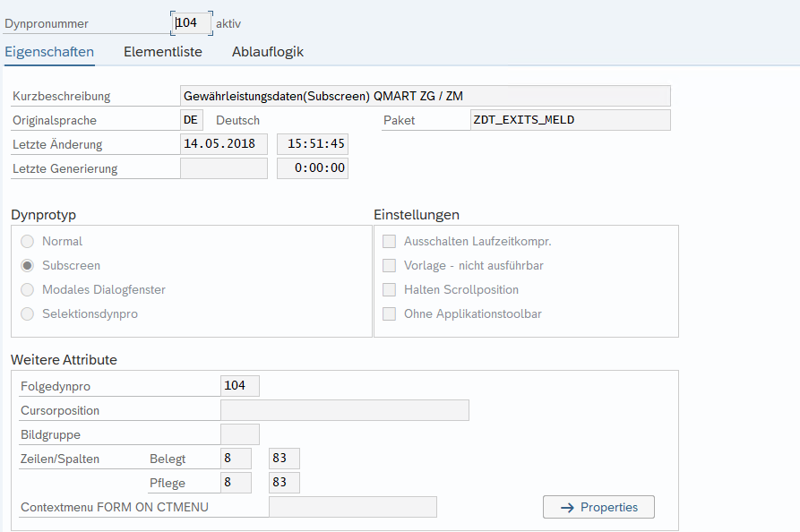

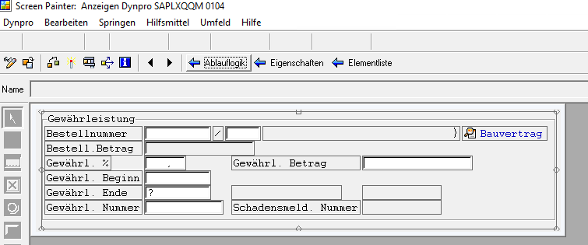

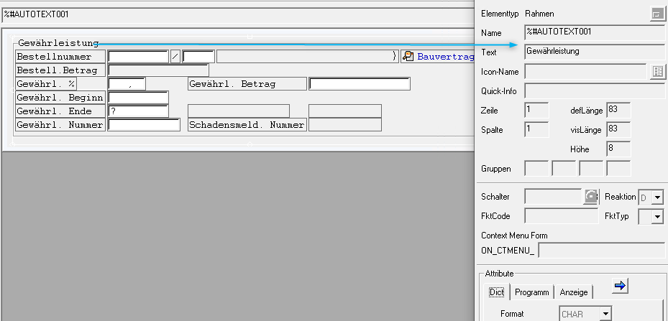

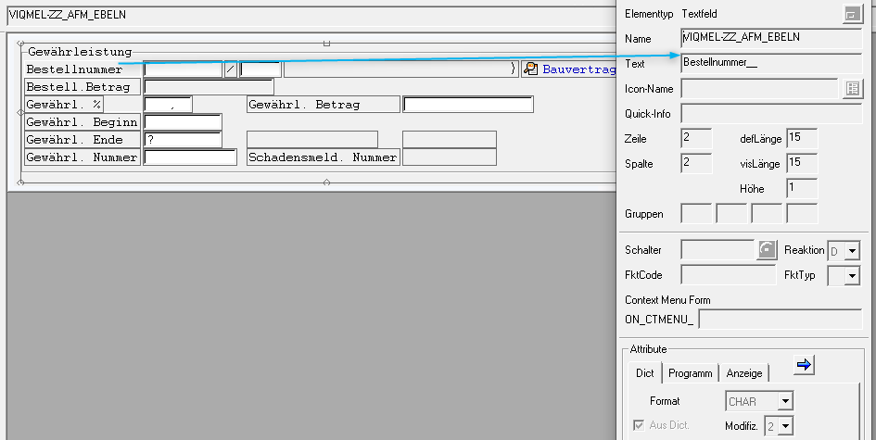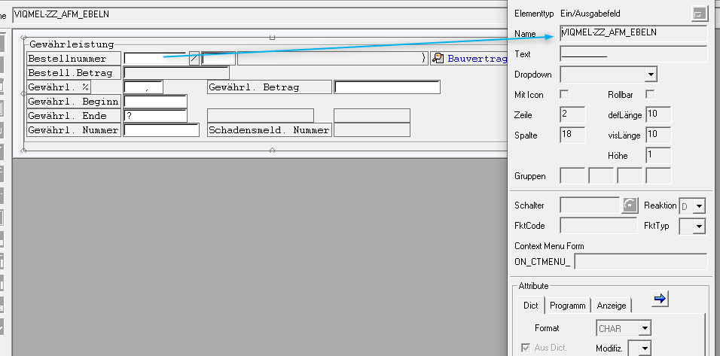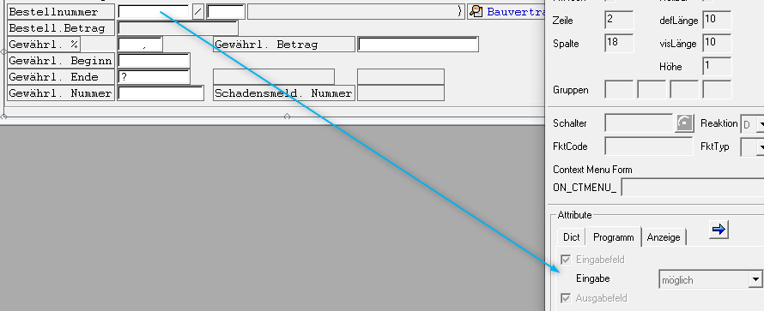

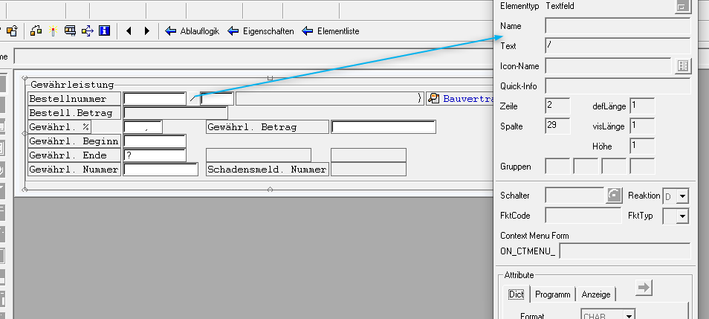

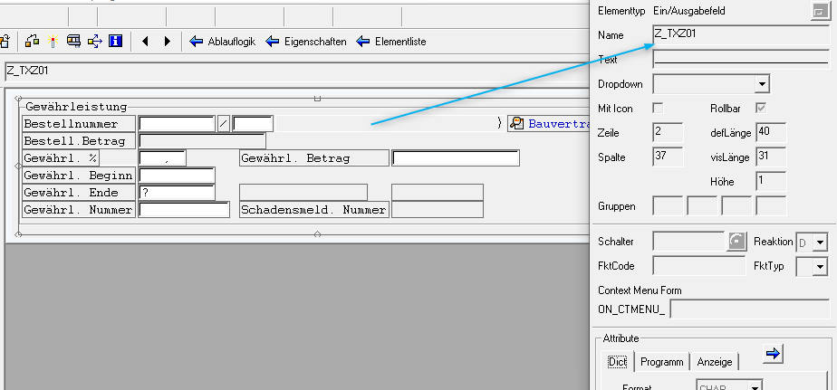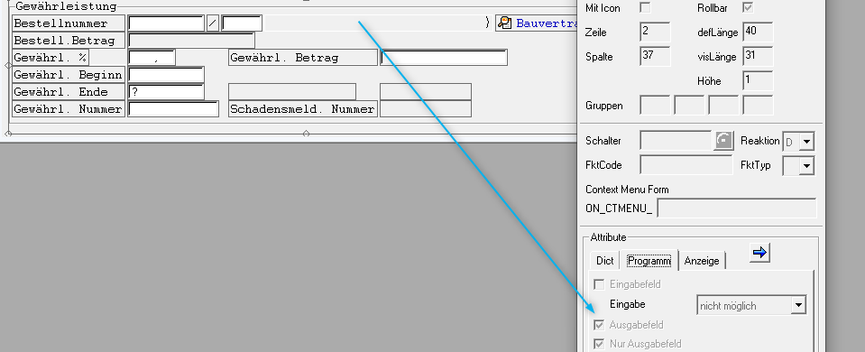

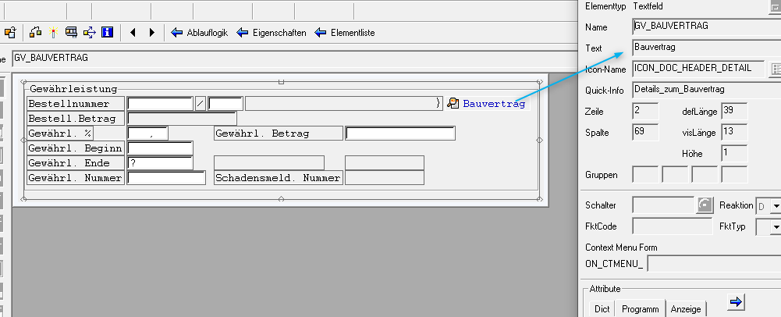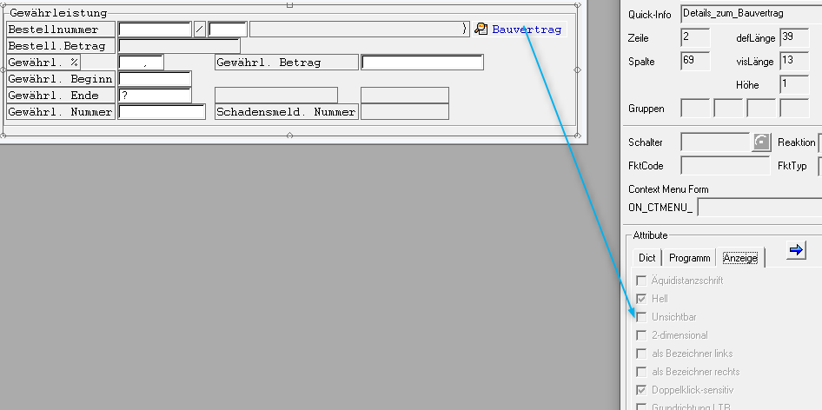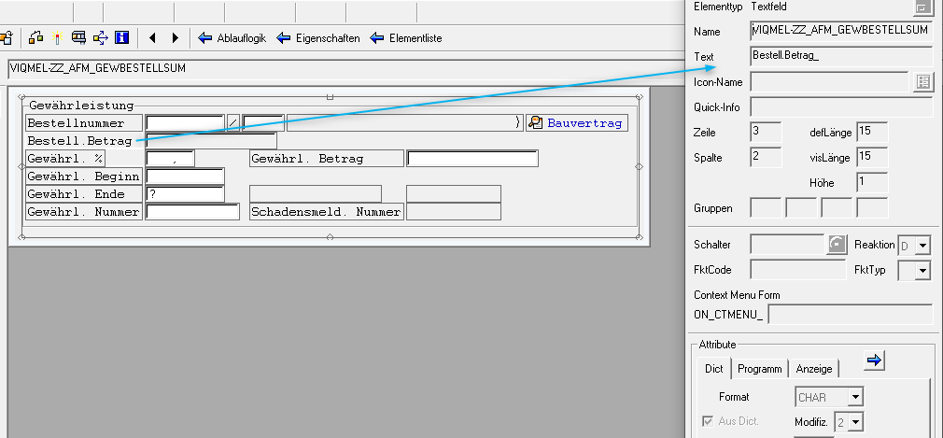

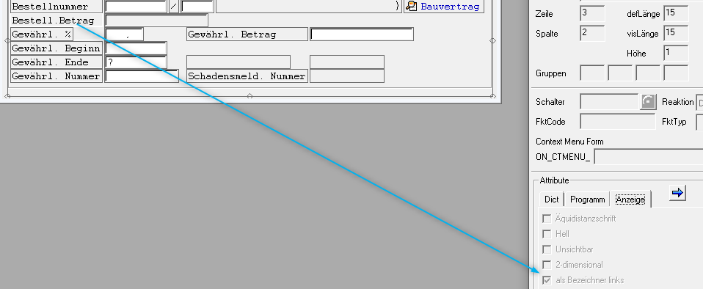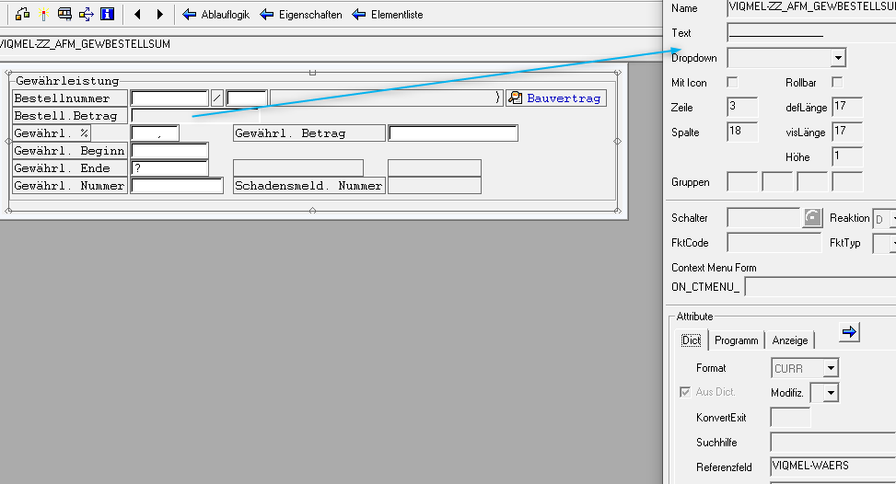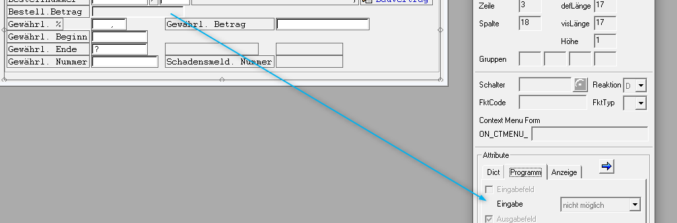

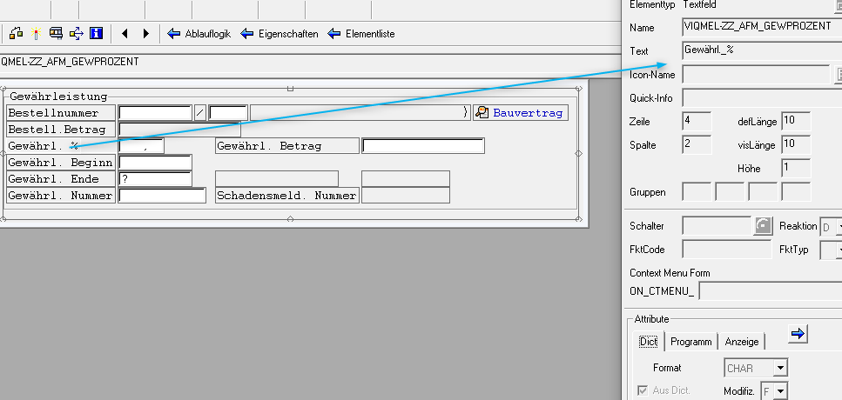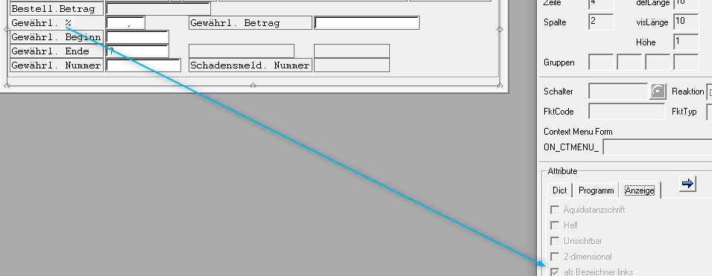

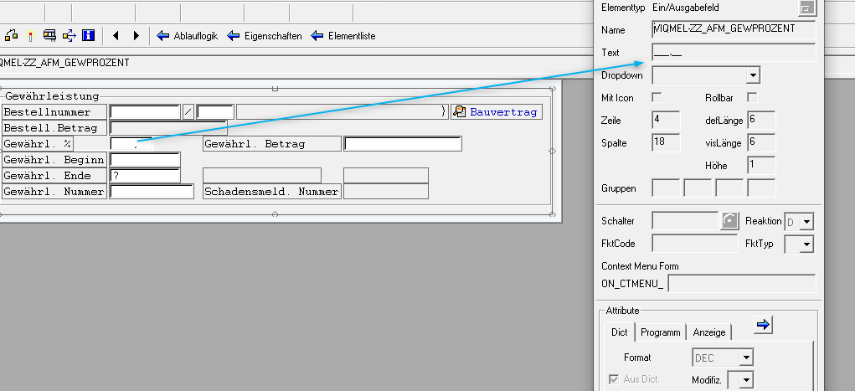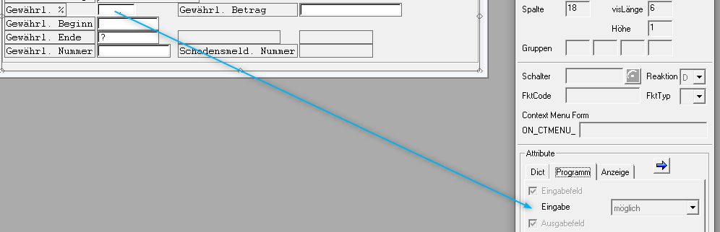

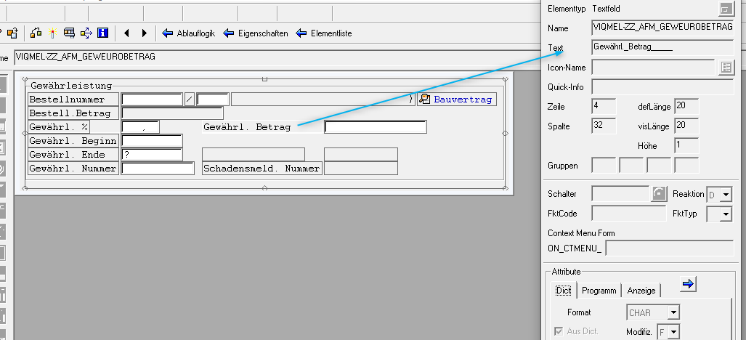

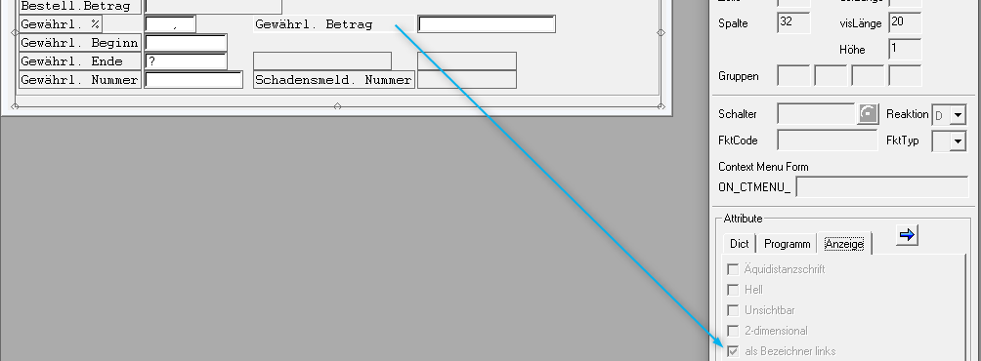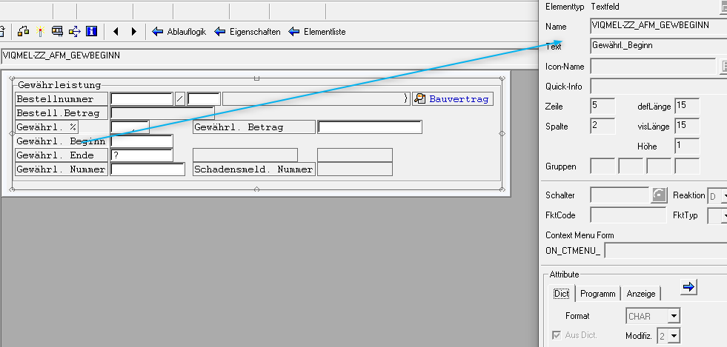

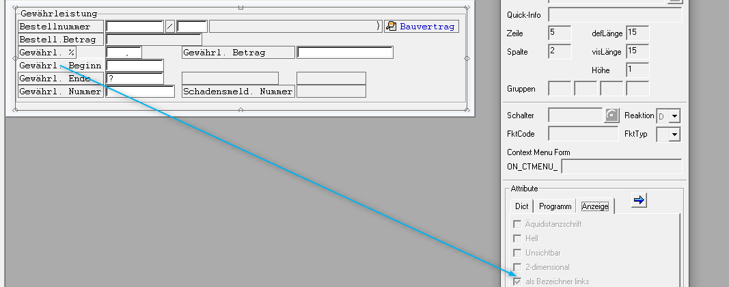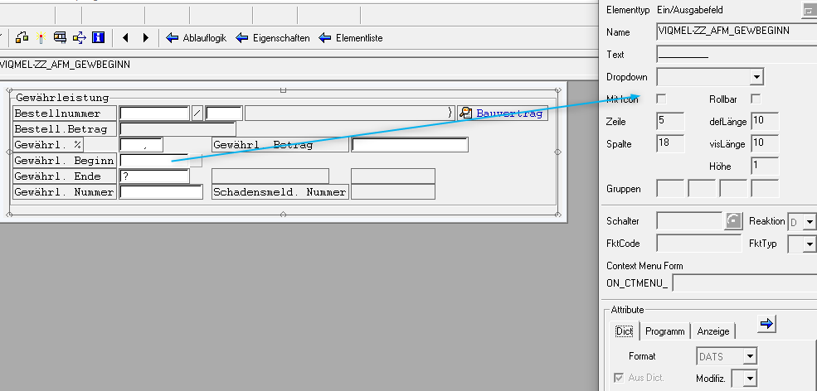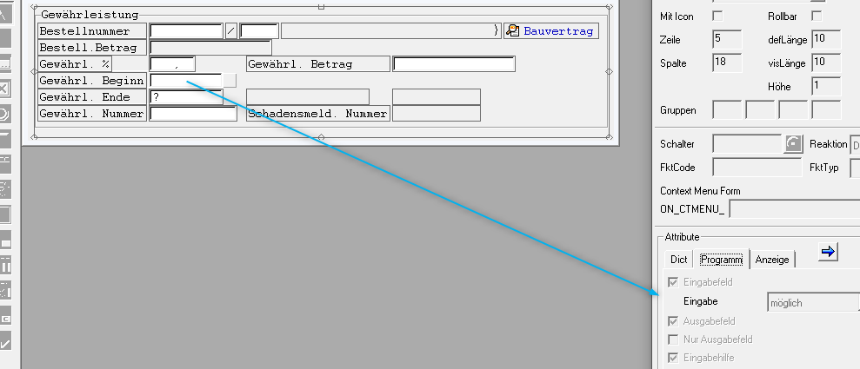

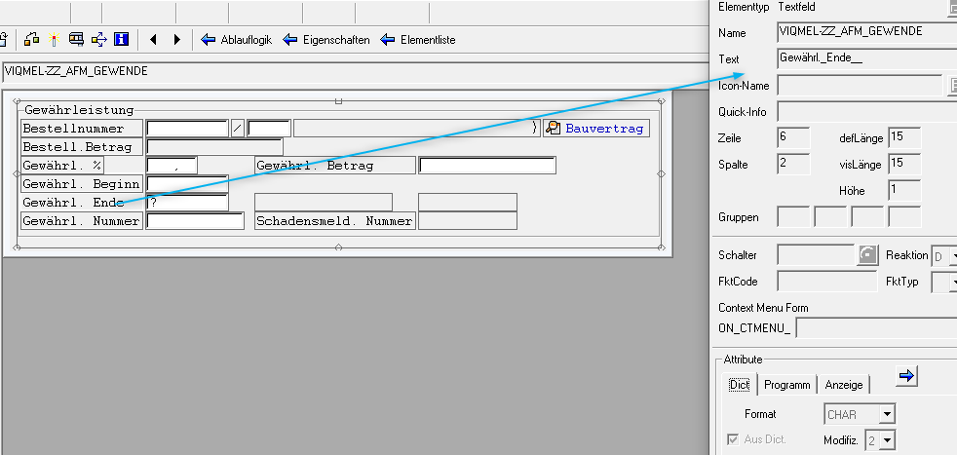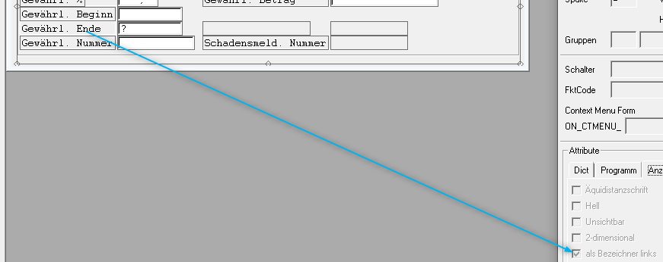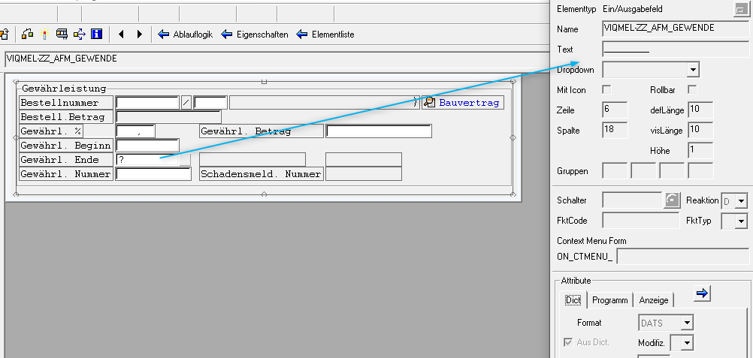

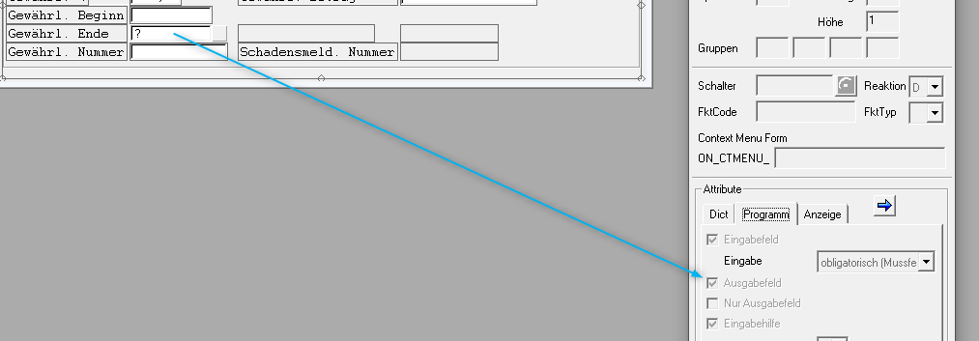

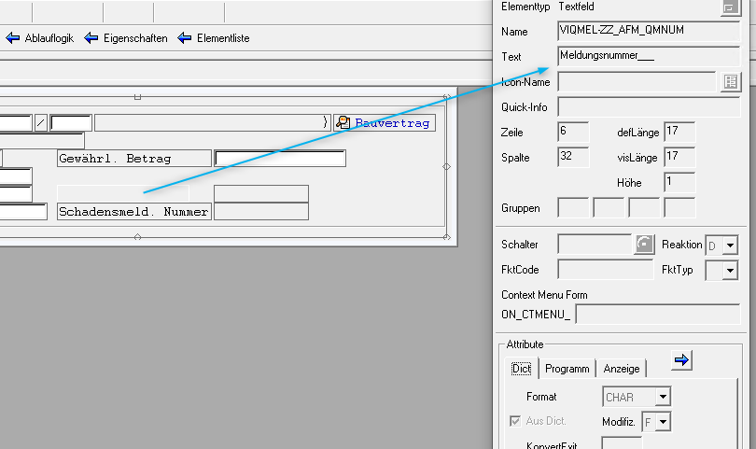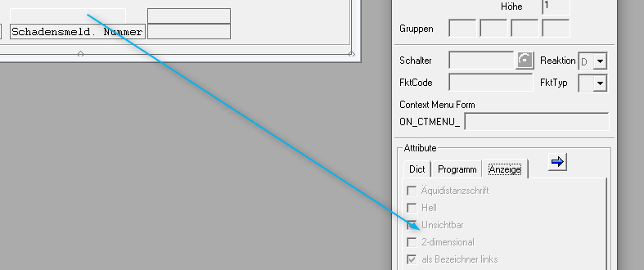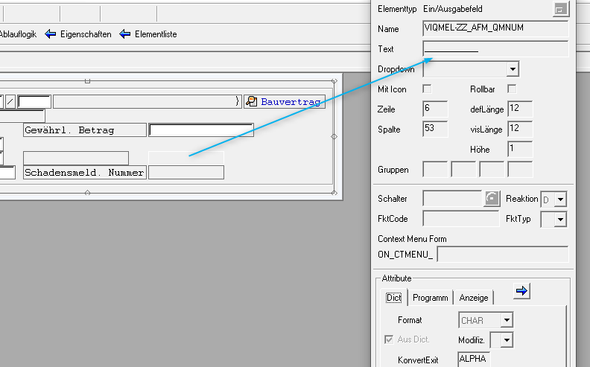

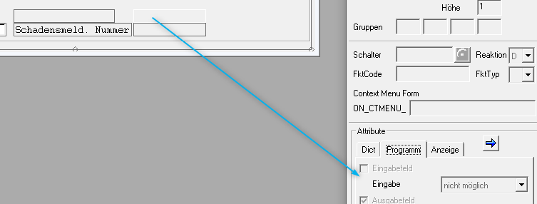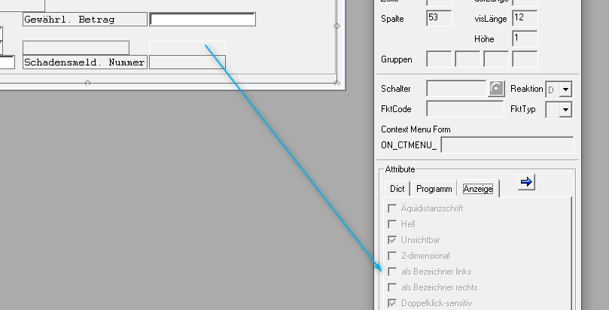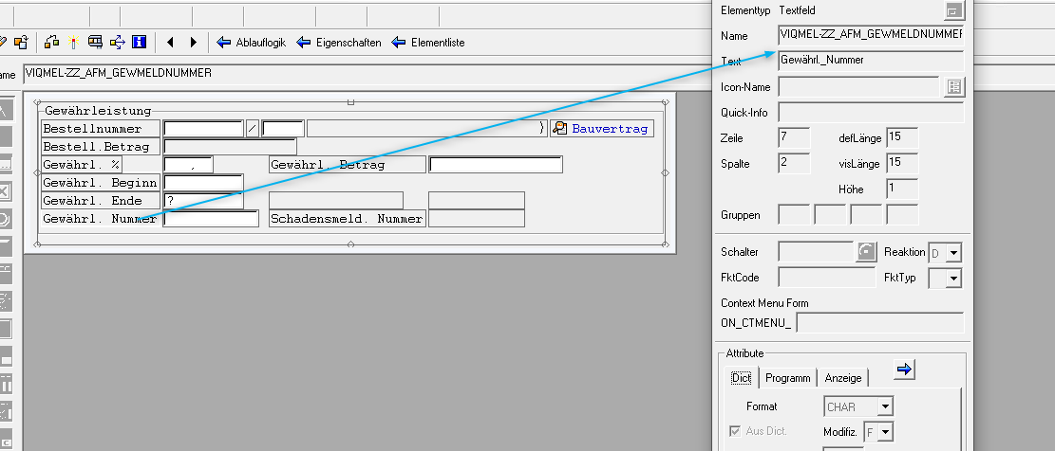

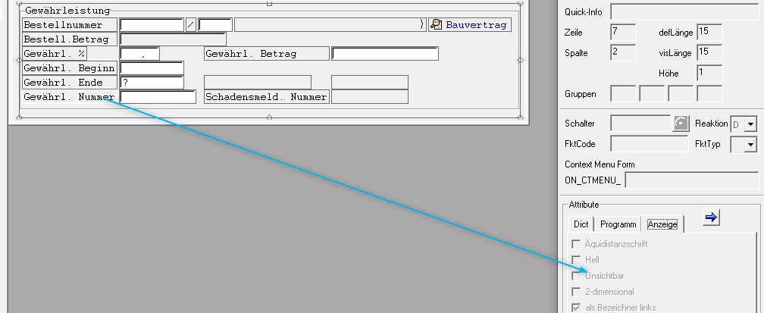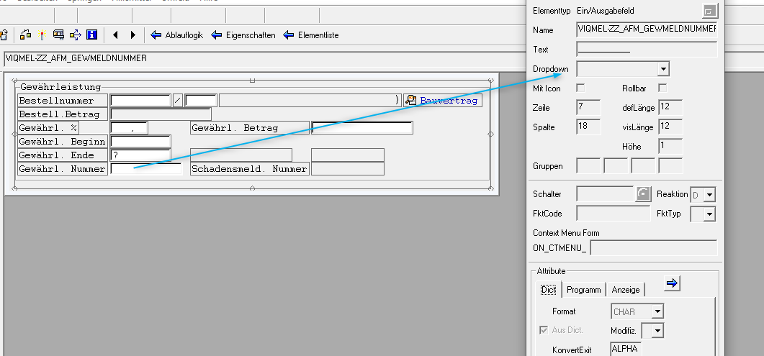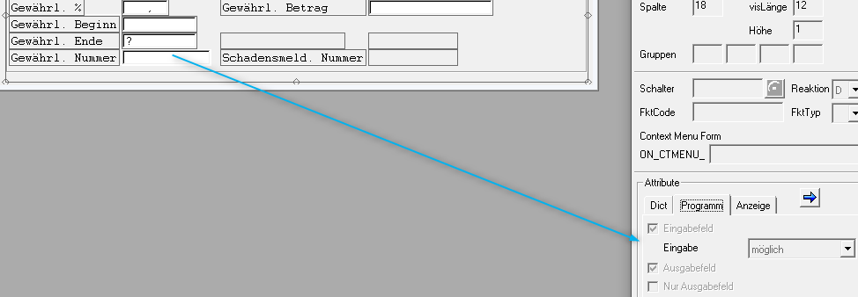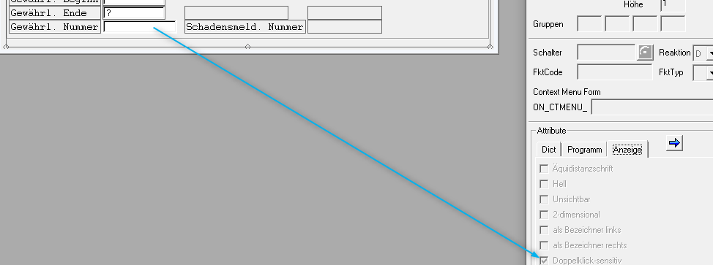

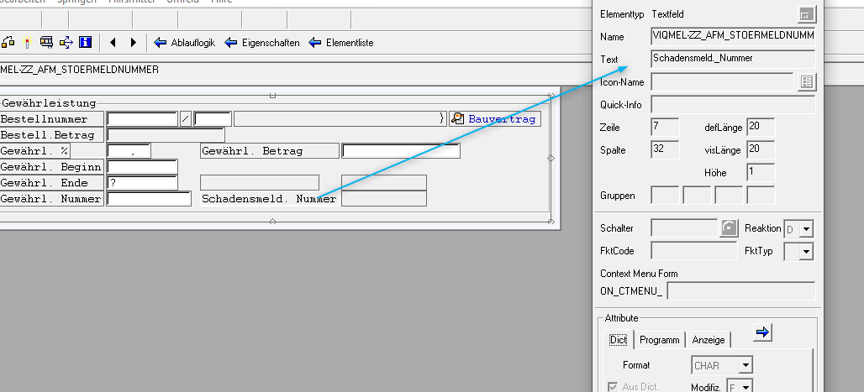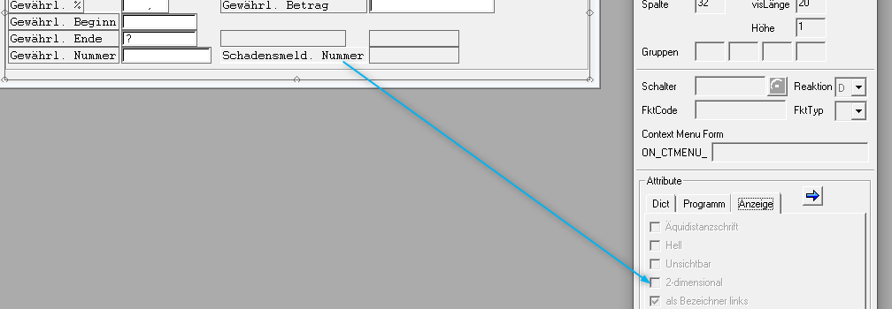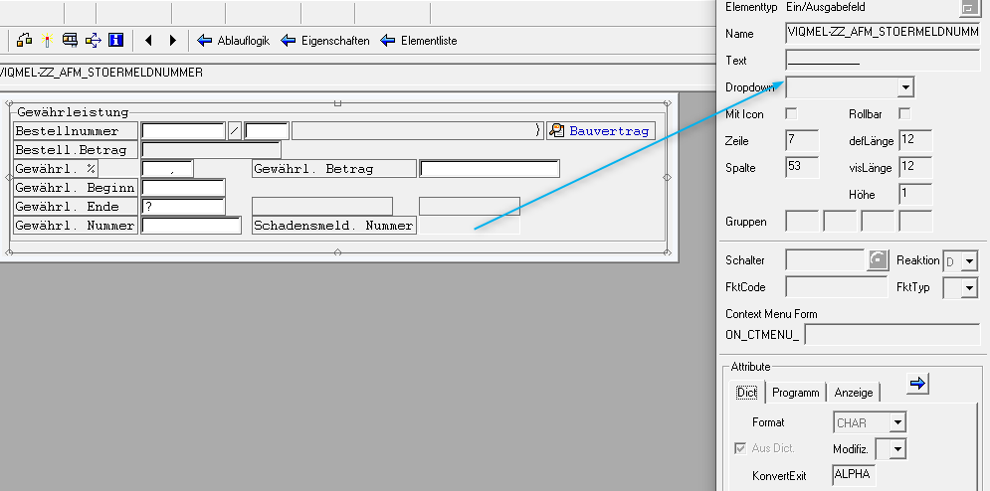

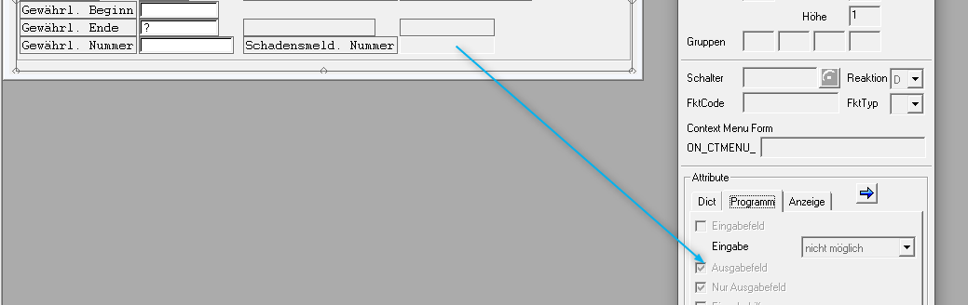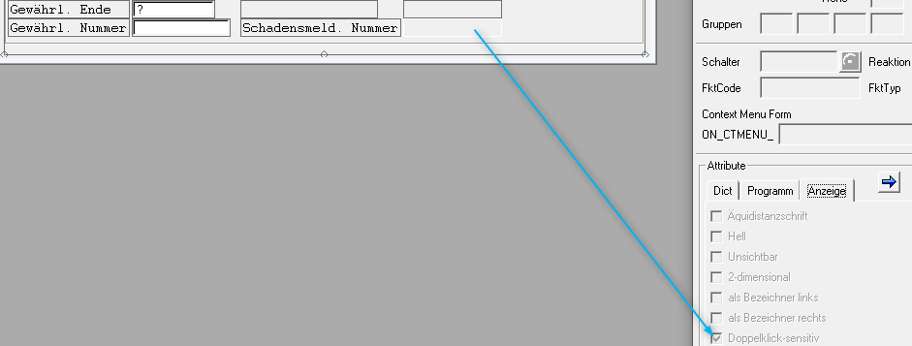

PROCESS BEFORE OUTPUT.  
*\*\*\*\*\*\*\*\*\*\*\*\*\*\*\*\*\*\*\*\*\*\**  
  
 MODULE status_0104.  
  
  
PROCESS AFTER INPUT.  
*\*\*\*\*\*\*\*\*\*\*\*\*\*\*\*\*\*\*\*\**  
  
 FIELD: viqmel-zz_afm_ebeln,  
 viqmel-zz_afm_ebelp,  
 viqmel-zz_afm_qmnum,  
*\* viqmel-zz_afm_stoermeldnummer,*  
 viqmel-zz_afm_gewmeldnummer.  
  
 MODULE user_command_0104.  
  
*\* prüft ob gewünschter Endetermin liegt vor dem Meldungsdatum.*  
 FIELD viqmel-zz_afm_gewende  
 MODULE check_enddate_gg_melddatum.  
  
 FIELD viqmel-zz_afm_gewende  
 MODULE check_enddate.  
 FIELD viqmel-zz_afm_gewbeginn  
 MODULE check_begindate ON INPUT.  
  
*\* Berechnung des Gewährleistungsbetrag*  
 FIELD viqmel-zz_afm_gewprozent  
 MODULE calc_gewbetrag ON REQUEST.  
  
 FIELD viqmel-zz_afm_geweurobetrag  
 MODULE calc_gewprozent ON REQUEST.  
  
*\*Prüft ob die Eingaben gültig sind!*  
 FIELD viqmel-zz_afm_gewmeldnummer  
 MODULE check_gew_meldung ON INPUT .  
  
 FIELD viqmel-zz_afm_gewprozent  
 MODULE calc_gewahrleistung ON REQUEST.  
 FIELD viqmel-zz_afm_geweurobetrag  
 MODULE calc_gewahrleistung ON REQUEST.

*\*----------------------------------------------------------------------\**  
*\*\*\*INCLUDE ZXQQMO07.*  
*\*----------------------------------------------------------------------\**  
  
*\*&---------------------------------------------------------------------\**  
*\*& Module STATUS_0104 OUTPUT*  
*\*&---------------------------------------------------------------------\**  
MODULE status_0104 OUTPUT.  
  
*\* SET PF-STATUS 'xxxxxxxx'.*  
*\* SET TITLEBAR 'xxx'.*  
  
 PERFORM status_0104.  
  
 LOOP AT SCREEN.  
 IF screen-group1 EQ 'BAU'.  
 IF NOT viqmel-zz_afm_ebeln IS INITIAL.  
 MOVE '1' TO screen-input.  
 ELSE.  
 MOVE '0' TO screen-input.  
 ENDIF.  
 MODIFY SCREEN.  
 ENDIF.  
 ENDLOOP.  
  
ENDMODULE.

*\*----------------------------------------------------------------------\**  
*\*\*\*INCLUDE ZXQQMI03.*  
*\*----------------------------------------------------------------------\**  
  
*\*&---------------------------------------------------------------------\**  
*\*& Module USER_COMMAND_0104 INPUT*  
*\*&---------------------------------------------------------------------\**  
MODULE user_command_0104 INPUT.  
  
 PERFORM user_command_0104.  
  
ENDMODULE.

*\*----------------------------------------------------------------------\**  
*\*\*\*INCLUDE ZXQQMF13.*  
*\*----------------------------------------------------------------------\**  
  
*\*&---------------------------------------------------------------------\**  
*\*& Form USER_COMMAND_0104*  
*\*&---------------------------------------------------------------------\**  
FORM user_command_0104 .  
  
*\* Kurztext zur Bestellnummer lesen*  
 CONSTANTS: p_parvw TYPE parvw VALUE 'LF'.  
 DATA: lcurso LIKE riwo1-curso,  
 lqmart LIKE qmel-qmart,  
 lqmtyp LIKE tq80-qmtyp,  
 p_lifnr TYPE lifnr,  
 p_parnr TYPE i_parnr.  
  
*\*&---------------------------------------------------------------------\**  
  
 SET PARAMETER ID 'ZEBELN' FIELD viqmel-zz_afm_ebeln.  
 IF NOT viqmel-zz_afm_ebeln IS INITIAL AND NOT viqmel-zz_afm_ebelp IS INITIAL.  
 SELECT SINGLE txz01 INTO z_txz01 FROM ekpo  
 WHERE ebeln = viqmel-zz_afm_ebeln AND ebelp = viqmel-zz_afm_ebelp.  
 IF sy-subrc > 0.  
 MESSAGE 'Bestellung wurde nicht gefunden' TYPE 'S'.  
 CLEAR z_txz01.  
 ENDIF.  
 ENDIF.  
  
 IF NOT viqmel-zz_afm_qmnum IS INITIAL.  
 SELECT SINGLE qmtxt INTO z_qmtxt FROM qmel  
 WHERE qmnum = viqmel-zz_afm_qmnum.  
 IF sy-subrc > 0.  
 MESSAGE 'Garantiemeldung nicht gefunden' TYPE 'S'.  
 CLEAR z_qmtxt.  
 ENDIF.  
 ENDIF.  
  
 IF NOT viqmel-zz_afm_ebeln IS INITIAL.  
 SELECT SINGLE lifnr FROM ekko INTO p_lifnr  
 WHERE ebeln EQ viqmel-zz_afm_ebeln.  
 IF sy-subrc EQ 0.  
 MOVE: p_lifnr TO p_parnr.  
 gv_parnr = p_parnr.  
 CALL FUNCTION 'PM_PARTNER_MAINTAIN'  
 EXPORTING  
*\* OBJNR = ' '*  
 parnr = p_parnr  
 parvw = 'LF'  
*\* ADRNR =*  
*\* ADR_HANDLE =*  
*\* TABIX = 0*  
*\* TABIX_OBJNR = 0*  
*\* MSGTY = 'E'*  
*\* CPD_POP_UP = 'X'*  
*\* CHECK_DEBITOR = 'X'*  
*\* IMPORTING*  
*\* COUNTER =*  
 EXCEPTIONS  
 invalid_parnr = 1  
 cpd_customer = 2  
 invalid_parvw = 3  
 parvw_unique = 4  
 OTHERS = 5.  
 IF sy-subrc <> 0.  
*\* MESSAGE ID SY-MSGID TYPE SY-MSGTY NUMBER SY-MSGNO*  
*\* WITH SY-MSGV1 SY-MSGV2 SY-MSGV3 SY-MSGV4.*  
 ENDIF.  
 ENDIF.  
 ELSE.  
 CLEAR gv_parnr.  
 ENDIF.  
  
*\*Berechnet die Basissumme für die Berechnung des Gewährleistungsbetrag*  
 CLEAR gv_effrwert.  
 IF NOT viqmel-zz_afm_ebeln IS INITIAL.  
 CALL FUNCTION 'ZFB_AFM_GET_BESTELLBETRAG'  
 EXPORTING  
 purchaseorder = viqmel-zz_afm_ebeln  
 TABLES  
 po_items1 = it_ekpo.  
 IF sy-dbcnt > 0.  
 IF NOT viqmel-zz_afm_ebelp IS INITIAL.  
 READ TABLE it_ekpo WITH KEY po_item = viqmel-zz_afm_ebelp INTO wa_ekpo TRANSPORTING po_number po_item eff_value .  
 IF sy-subrc = 0.  
 gv_effrwert = wa_ekpo-eff_value.  
 ENDIF.  
 ELSE.  
 LOOP AT it_ekpo INTO wa_ekpo.  
 gv_effrwert = gv_effrwert + wa_ekpo-eff_value.  
 ENDLOOP.  
 ENDIF.  
 ENDIF.  
 ENDIF.  
 viqmel-zz_afm_gewbestellsum = gv_effrwert.  
  
*\*&---------------------------------------------------------------------\**  
  
 CASE sy-ucomm.  
  
 WHEN 'AZOB'. *"Doppelclick auf Bestellnummer oder ?*  
  
 GET CURSOR FIELD lcurso.  
 IF lcurso = 'VIQMEL-ZZ_AFM_EBELN' OR lcurso = 'VIQMEL-ZZ_AFM_EBELP'.  
 SET PARAMETER ID 'BES' FIELD viqmel-zz_afm_ebeln.  
 CALL TRANSACTION 'ME23' AND SKIP FIRST SCREEN.  
  
 ELSEIF lcurso = 'VIQMEL-ZZ_AFM_QMNUM'.  
 SET PARAMETER ID 'IQM' FIELD viqmel-zz_afm_qmnum.  
 CLEAR: lqmart, lqmtyp.  
 SELECT SINGLE qmart INTO lqmart FROM qmel  
 WHERE qmnum = viqmel-zz_afm_qmnum.  
 SELECT SINGLE qmtyp INTO lqmtyp FROM tq80  
 WHERE qmart = lqmart.  
 IF lqmtyp = '03'.  
 CALL TRANSACTION 'IW53' AND SKIP FIRST SCREEN.  
 ELSE.  
 CALL TRANSACTION 'IW23' AND SKIP FIRST SCREEN.  
 ENDIF.  
  
 ELSEIF lcurso = 'GV_BAUVERTRAG'.  
 IF NOT viqmel-zz_afm_ebeln IS INITIAL.  
 SET PARAMETER ID 'BES' FIELD viqmel-zz_afm_ebeln.  
 CALL TRANSACTION '/AFM/BAUMOD' AND SKIP FIRST SCREEN.  
 ENDIF.  
 ELSE.  
  
 CASE lcurso.  
 WHEN 'VIQMEL-ZZ_AFM_GEWMELDNUMMER'.  
 IF fl_chkgw IS INITIAL.  
 SET PARAMETER ID 'IQM' FIELD viqmel-zz_afm_gewmeldnummer.  
 CALL TRANSACTION 'IW22' AND SKIP FIRST SCREEN.  
 ENDIF.  
 WHEN 'VIQMEL-ZZ_AFM_STOERMELDNUMMER'.  
 IF fl_chkgw IS INITIAL.  
 DATA: lt_enq TYPE TABLE OF seqg3,  
 ls_enq TYPE seqg3.  
 CLEAR: lt_enq, lt_enq[].  
*\* Sperreinträge aus der Sperrtabelle lesen*  
 CALL FUNCTION 'ENQUEUE_READ'  
 EXPORTING  
 gclient = sy-mandt  
 gname = 'QMEL'  
*\* GARG = ' '*  
 guname = sy-uname  
*\* LOCAL = ' '*  
*\* FAST = ' '*  
*\* GARGNOWC = ' '*  
*\* IMPORTING*  
*\* NUMBER =*  
*\* SUBRC =*  
 TABLES  
 enq = lt_enq  
 EXCEPTIONS  
 communication_failure = 1  
 system_failure = 2  
 OTHERS = 3.  
 IF sy-subrc <> 0.  
*\* Implement suitable error handling here*  
 ENDIF.  
 READ TABLE lt_enq INTO ls_enq WITH KEY garg+3 = viqmel-zz_afm_stoermeldnummer.  
 IF sy-subrc = 0.  
 SET PARAMETER ID 'IQM' FIELD viqmel-zz_afm_stoermeldnummer.  
 CALL TRANSACTION 'IW23' AND SKIP FIRST SCREEN. *" <-- lege ZM an aus Z4 oder bearbeitet ZM aus Z4 - nur ANZEIGE möglich !*  
 ELSE.  
 SET PARAMETER ID 'IQM' FIELD viqmel-zz_afm_stoermeldnummer.  
 CALL TRANSACTION 'IW22' AND SKIP FIRST SCREEN.  
 ENDIF.  
 ENDIF.  
 WHEN OTHERS.  
 ENDCASE.  
 ENDIF.  
  
 ENDCASE.  
  
ENDFORM.

*\*----------------------------------------------------------------------\**  
*\*\*\*INCLUDE ZXQQMI04.*  
*\*----------------------------------------------------------------------\**  
  
*\*&---------------------------------------------------------------------\**  
*\*& Module CHECK_ENDDATE_GG_MELDDATUM INPUT*  
*\*&---------------------------------------------------------------------\**  
MODULE check_enddate_gg_melddatum INPUT.  
  
 IF viqmel-zz_afm_gewende < viqmel-qmdat.  
 IF viqmel-zz_afm_gewende IS NOT INITIAL.  
 MESSAGE e474(im) WITH viqmel-zz_afm_gewende '' viqmel-qmdat . *" Gewünschtes Ende &1 &2 liegt vor dem Meldungsdatum &3 &4*  
 ENDIF.  
 ENDIF.  
  
ENDMODULE.

*\*----------------------------------------------------------------------\**  
*\*\*\*INCLUDE ZXQQMI05.*  
*\*----------------------------------------------------------------------\**  
  
*\*&---------------------------------------------------------------------\**  
*\*& Module CHECK_ENDDATE INPUT*  
*\*&---------------------------------------------------------------------\**  
MODULE check_enddate INPUT.  
  
 IF viqmel-qmart = 'ZG'. *"<-- Gewährleistungsmeldung*  
 IF viqmel-zz_afm_gewende IS INITIAL.  
 MESSAGE e483(im). *" <-- Bitte ein Bezugsdatum eingeben*  
 ENDIF.  
 ENDIF.  
  
ENDMODULE.

*\*----------------------------------------------------------------------\**  
*\*\*\*INCLUDE ZXQQMI06.*  
*\*----------------------------------------------------------------------\**  
  
*\*&---------------------------------------------------------------------\**  
*\*& Module CHECK_BEGINDATE INPUT*  
*\*&---------------------------------------------------------------------\**  
MODULE check_begindate INPUT.  
  
 IF viqmel-zz_afm_gewende < viqmel-zz_afm_gewbeginn .  
 IF viqmel-zz_afm_gewende IS NOT INITIAL.  
 MESSAGE e470(im) WITH viqmel-zz_afm_gewende '' viqmel-zz_afm_gewbeginn. *" Endtermin liegt &1 &2 vor Starttermin &3 &4*  
 ENDIF.  
 ENDIF.  
  
ENDMODULE.

*\*----------------------------------------------------------------------\**  
*\*\*\*INCLUDE ZXQQMI07.*  
*\*----------------------------------------------------------------------\**  
  
*\*&---------------------------------------------------------------------\**  
*\*& Module CALC_GEWBETRAG INPUT*  
*\*&---------------------------------------------------------------------\**  
MODULE calc_gewbetrag INPUT.  
  
 flag_gew = '1'.  
  
ENDMODULE.

*\*----------------------------------------------------------------------\**  
*\*\*\*INCLUDE ZXQQMI08.*  
*\*----------------------------------------------------------------------\**  
  
*\*&---------------------------------------------------------------------\**  
*\*& Module CALC_GEWPROZENT INPUT*  
*\*&---------------------------------------------------------------------\**  
MODULE calc_gewprozent INPUT.  
  
 flag_gew = '2'.  
  
ENDMODULE.

*\*----------------------------------------------------------------------\**  
*\*\*\*INCLUDE ZXQQMI09.*  
*\*----------------------------------------------------------------------\**  
  
*\*&---------------------------------------------------------------------\**  
*\*& Module CHECK_GEW_MELDUNG INPUT*  
*\*&---------------------------------------------------------------------\**  
MODULE check_gew_meldung INPUT.  
  
 PERFORM check_id USING 'ZG' 'ZG' viqmel-zz_afm_gewmeldnummer.  
  
ENDMODULE.

*\*----------------------------------------------------------------------\**  
*\*\*\*INCLUDE ZXQQMI11.*  
*\*----------------------------------------------------------------------\**  
  
*\*&---------------------------------------------------------------------\**  
*\*& Module CALC_GEWAHRLEISTUNG INPUT*  
*\*&---------------------------------------------------------------------\**  
MODULE calc_gewahrleistung INPUT.  
  
 IF viqmel-zz_afm_gewprozent > 100.  
 MESSAGE e530(im). *" <-- Eingaben unzulässig, bitte überprüfen Sie die Eingaben*  
 ELSE.  
 IF flag_gew = '1'.  
 viqmel-zz_afm_geweurobetrag = ( gv_effrwert * viqmel-zz_afm_gewprozent ) / 100.  
 ENDIF.  
 ENDIF.  
  
 IF viqmel-zz_afm_geweurobetrag > gv_effrwert.  
 MESSAGE e530(im). *" <-- Eingaben unzulässig, bitte überprüfen Sie die Eingaben*  
 ELSE.  
 IF flag_gew = '2'.  
 viqmel-zz_afm_gewprozent = ( viqmel-zz_afm_geweurobetrag * 100 ) / gv_effrwert.  
 ENDIF.  
 ENDIF.  
  
ENDMODULE.

Bildschirm🡪0103